Advance Haemorrhoids: Last Line – Personalized, Purposeful, Predictable and Precise Fibrosis
Parshottambhai B Patel MS , Shiv Shraddha Nursing Home, Ahmedabad, Gujarat, India

Abstract (292 words )
Statement of the Problem:
Grade III and IV highly vascular hemorrhoids with Secondary haemorrhoids - (between the anal cushions) and Circumferential and Circumferentially Protruding Haemorrhoids with external haemorrhoids is challenging problem for both surgeon and patient. Surgery is a only option
Open haemorrhoidectomy (Milligan Morgan) remains the gold standard for surgical intervention for haemorrhoids and is the still most popular technique. Other popular options are Closed hemorrhoidectomy (Ferguson) , Submucosal technique of Parks and many other
However haemorrhoidectomy is recognised as a painful procedure with a risk of significant complications and remains unpopular.
Primary and secondary haemorrhage, retention of urine, wound infection, incontinence, and anal stenosis are common.

.
The purpose of this study is
To describe a unique method called Personalized, Purposeful, Predictable and Precise Fibrosis (4PF) focusing on decreasing hemorrhoid vascularity, reducing redundant tissue, and promoting hemorrhoid fixation to the rectal wall. Method is reproducible, has short learning curve and consistently predictable result and useful in any and all type of grade III and IV highly vascular hemorrhoids with Secondary haemorrhoids - (between the anal cushions) and Circumferential and Circumferentially Protruding Haemorrhoids with external haemorrhoids. Presenting 156 patients over period of 30 years with maximum follow up of 30 years and minimum follow up of 5 years
. Conclusion & Significance:

Almost all patients are discharge after 24 hours with no need to follow up except have a problem

No case of post operative bleeding or reexploration or wound complications was reported. Even on long term study of 5 to 30 years incontinence, anal fissure, external haemorrhoids, mucosal prolapse ,recurrence of haemorrhoids, anal stenosis /stricture were not reported

This new method has a potential to replace all surgical methods available now. It has excellent short term and long term results.

Image
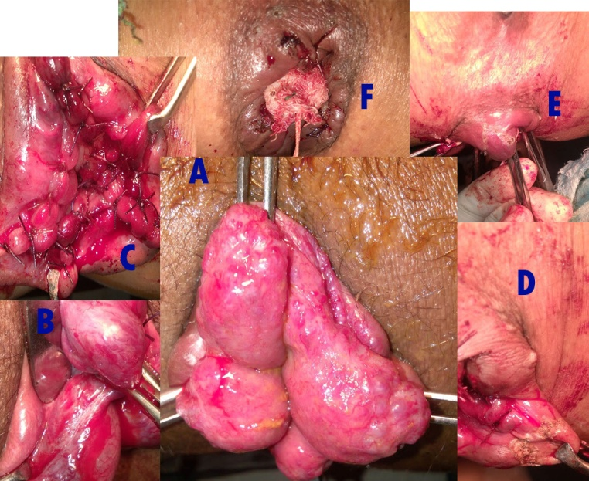

Various steps of operation
- Before, B and C –Internal Haemorrhoids, D and E -External haemorrhoids, F – Final look (Note multiple low power cauterizations with 24 gauze needles),
- Note Nothing is dissected or cut in internal Haemorrhoids except terminal part that to if needed. In external Haemorrhoid small extra tissue is cut so there are no skin tags. Goal is to decrease vascularity and induce fibrosis and fixation.
Recent Publications (minimum 5)
- Application of nanotechnology in cancers prevention, early detection and treatment July 2014 Journal of Cancer Research and Therapeutics 10(3):479-486 Shraddha P Patel, Parshottambhai Patel, Bhavesh B. Parekh
- Prevention and early detection of hereditary breast cancer Dr Shraddha Patel, Dr P. B. Patel, Kush Patel, Lav Patel
Joint Annual conference of IAPSM & IPHA, Ahmedabad 2012
- P. Pate, S. Patel et. “Modern Management of oral Pre malignant lesions – role of genetics” National conference of Indian association of surgical oncology and international symposium on advances in oncology, Jaipur, India, 2004.
- P. Patel, S. Patel, et. “DNA content as prognostic marker in patients with oral leukoplakia” International conference on Tobacco Induced diseases: Challenges for 21st century, Winnipeg, Canada, 2003.
5
Study of DNA damage with comet electrophoresis in oral mucosal cells of patients with oral squamous cell carcinoma, P B Patel MS , S P Patel MSc,ISPO Nice France 2004
6
Providing information about breast cancer Via public forums, P B Patel, S. P. Patel B.Sc. ISPO Nice France 2004

AUTHOR

- Cancer Vijay(Gujarati) – Conquering Cancer
- Hindi booklet-conquering cancer is in your hand-magic of human genetics [Cancer Vijay apnehi hathome, human genetics ka chamatkar]

- Gujarati booklet- thyroid-position like king and work like super king [Thyroid sthan rajanu kam maharajanu]

- Gujarati booklet -If you try a little conquering cancer is very easy [Jo tame thodo prayatna karoto cancer vijay to bahuj saral chhe.]

- About other 11 booklets

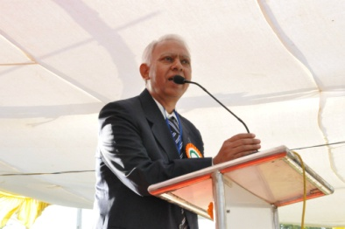Biography (150 word limit)
Parsottambhai Patel MS is Surgeon and cancer specialists. practicing last 34 years. Primary focus is on anorectal diseases, breast and head and neck cancer. Primary focus is prevention and early detection of cancer. He has written one book and more than 15 educational booklets. He has taken more then 1000 lacturs all over state of Gujarat. He is also distributing educational information with actionable information in a way which is easy to understand.
Email: cancervijay@gmail.com

Notes/Comments:

