Colon Polypectomy and Endoscopic Mucosal resection
Shahram agah, Sydney Australia

Abstract (300 word limit)
About 70%–80% of colorectal neoplasia arises from conventional adenomatous polyps. Polypectomy reduced the risk of colorectal cancer by the order of 75%–90%. 80% to 90% of polyps are smaller than 10 mm. Morphological description (considering Paris classification), Size estimation (smaller or larger than 10 mm), Relation to the surrounding mucosa: (e.g. Saddle distribution over a fold, or an invasive lesion. Safe polypectomy implies the ability to resect and completely remove a polyp while achieving hemostasis and maintaining the integrity of the colonic wall. Polyps of ≤ 6 mm can be safely removed by cold snaring. Electrocoagulation with a blend or cutting setting should be used for polyps> 10 mm. The different snare is using for the polypectomy. Try to put the polyp at 5 to 6 o’clock position at the time of resection. Small, flat sessile polyps, pedunculated polyps with very large pedicles, large flat sessile lesions or laterally spreading tumors are challenging polyps. For the first one, the cold snare is the safest method. For the second one, post-polypectomy hemorrhage is the most problems which can be prevented with endoloop or clip. For laterally spreading tumor or large sessile lesion, EMR is recommended. Injection is recommended in lesion > 10 mm in the right, > 15 mm in the left, and in both parts if a lesion is hidden behind a fold. With moderate expertise, EMR of the lesions occupies more than one-third of the circumference of the colonic wall or maximally crosses over two haustral folds. Submucosal sequential injection and piecemeal resection after 1 to 2 ml saline or gelfusion. Resect most inaccessible first. Consider removal of some normal tissues. Consider snare tip soft coagulation of removed tissues rim for reduction of recurrence.

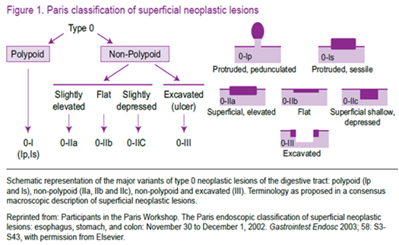
References:
1 Polypectomy. In: Waye JD, Rex DK, Williams CB, editors. Colonoscopy principles and practice. Oxford: Blackwell Scientific Publication, 2003.
2 Endoscopic Classification Review Group. Update on the Paris classification of superficial neoplastic lesions in the digestive tract. Endoscopy 2005; 37: 570-578.
3. Bourke M. Endoscopic resection of advanced mucosal neoplasia and early cancer in the colon. In: Sharma P, Reddy DN, editors. Gastrointestinal cancers: endoscopic imaging and treatment. New Delhi: Jaypee Brothers Medical Publishers, 2010.
4. GESA endoscopy handbook: Second Edition Updated: June 2017
5. Sydney International Endoscopy Symposium March 2018



Shahram Agah, is the director of endoscopy ward and Colorectal Research Center at rasoule-akram hospital, Iran University of Medical Sciences, Tehran, Iran, where he works as a professor in the field of Gastroenterology and Hepatology. His basic education and professional training have been in Iran, however, he attended at Chemnitz hospital, Germany in 2001 and Rush University, Chicago, USA in 2017 for better experience in therapeutic endoscopy and Endosonography. He has traveled to Australia to obtain more experience in advanced endoscopy (EMR and ESD) and some collaborative researches. He is the principle investigator on several clinical trials in gastrointestinal disorder.

