Everolimus plus Sorafenib as a treatment option for hepatocellular carcinoma recurrence after liver transplantation.
Aline Younes, Hidetoshi Nitta, Vincent Karam, Rodolphe Sobesky, Eric Vibert, Audrey Coilly, Teresa Maria Antonini, Daniel Cherqui, Hideo Baba, René Adam, Didier Samuel, Faouzi Saliba.
AP-HP, Hôpital Paul Brousse, Centre Hépato-Biliaire, Université Paris Sud, Unité INSERM U 935 and U 1193, Villejuif- France.

Background: Few authors reported on the outcome of patients with hepatocellular carcinoma (HCC) recurrence after liver transplantation (LT). The aim of this study is to analyze predictive factors of survival for patients after HCC recurrence and best treatment strategies.

Methods: Consecutive patients who underwent LT for HCC between 2005 and 2015 at our centre were recruited. Characteristics of patients with recurrence, modalities of treatment and outcome were collected retrospectively. Predictive factors for survival after recurrence were analyzed by Cox regression analysis.

Results: Among 306 patients underwent LT, 43 patients (14%) developed HCC recurrence with a median survival time after recurrence of 10.9 months (95%CI: 6.6-18.6). Main treatment for recurrence was chemotherapy (Sorafenib or Gemcitabine based, n=33). Survival of patients treated with Sorafenib (SOR) and everolimus (EVL) (n=19) was significantly better than that of the group treated with other strategies (n=24) (P =0.0006). Multivariate analysis demonstrated that SOR+EVL therapy and absence of dissemination at diagnosis of recurrence were independent predictive factors of prolonged survival after recurrence. Among the patient treated with EVL, survival of patients with controlled EVL blood trough levels ≥5 ng/ml was significantly better compared to those with EVL through levels <5 ng/ml (p = 0.021). Adverse events were comparable among groups treated with SOR in combination or not to EVL.
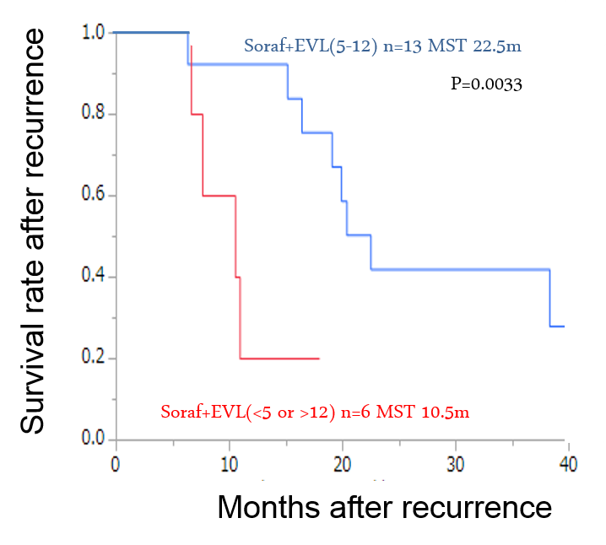
Conclusion: The combination therapy of SOR and EVL was an independent predictor for better survival after HCC recurrence. Patients with controlled everolimus trough level ≥5 ng/ml may get the best survival benefit.

Biography
Faouzi SALIBA senior author, is an Associate Professor in Hepato-Gastro-Enterology at the University of Paris IX, and is in charge of the ICU at the Hepato-Biliary Centre and Liver Transplant Unit at Paul Brousse Hospital.
Dr Saliba has conducted, and participated in several international clinical trials in the fields of transplantation, hepatology, artificial and bioartificial liver support...
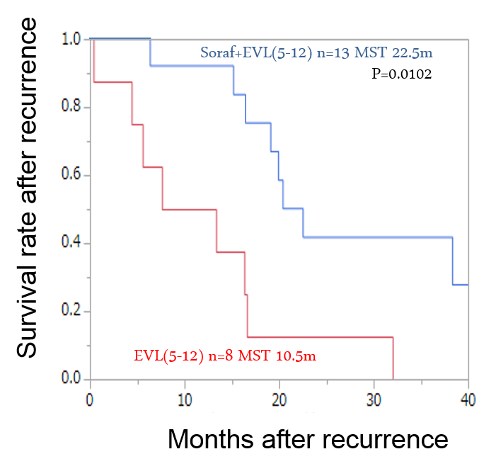
He has published over 170 original papers in official and peer-reviewed journals, book chapters and textbooks. He has presented hundreds of papers at conferences and has chaired numerous sessions at international congresses.

Aline YOUNES, is Doctor in Hepato-Gastro-Enterology graduated at he Lebanese University and worked as a fellow at the Hepato-Biliary Centre and Liver Transplant Unit at Paul Brousse Hospital.

The Hepato-Biliary centre is the first liver transplant centre in France and the third in Europe, performing more than 150 liver transplants per year and is a reference centre in this field.

References
- Cholongitas E, Mamou C, Rodríguez-Castro KI, Burra P. Mammalian target of rapamycin inhibitors are associated with lower rates of hepatocellular carcinoma recurrence after liver transplantation: A systematic review. Transpl Int 2014;27:1039–49.
- De Simone P, Crocetti L, Pezzati D, Bargellini I, Ghinolfi D, Carrai P, et al. Efficacy and safety of combination therapy with everolimus and sorafenib for recurrence of hepatocellular carcinoma after liver transplantation. Transplant Proc 2014;46:241–4.
- Gedaly R, Angulo P, Hundley J, Daily MF, Chen C, Koch A, et al. PI-103 and sorafenib inhibit hepatocellular carcinoma cell proliferation by blocking Ras/Raf/MAPK and PI3K/AKT/mTOR pathways. Anticancer Res 2010;30:4951–8.
- Masuda M, Chen W-Y, Miyanaga A, Nakamura Y, Kawasaki K, Sakuma T, et al. Alternative Mammalian Target of Rapamycin (mTOR) Signal Activation in Sorafenib-resistant Hepatocellular Carcinoma Cells Revealed by Array-based Pathway Profiling. Mol Cell Proteomics 2014;13:1429–38.
- Zavaglia C, Airoldi A, Mancuso A, Vangeli M, Viganò R, Cordone G, et al. Adverse events affect sorafenib efficacy in patients with recurrent hepatocellular carcinoma after liver transplantation: experience at a single center and review of the literature. Eur J Gastroenterol Hepatol 2013;25:180–6.

