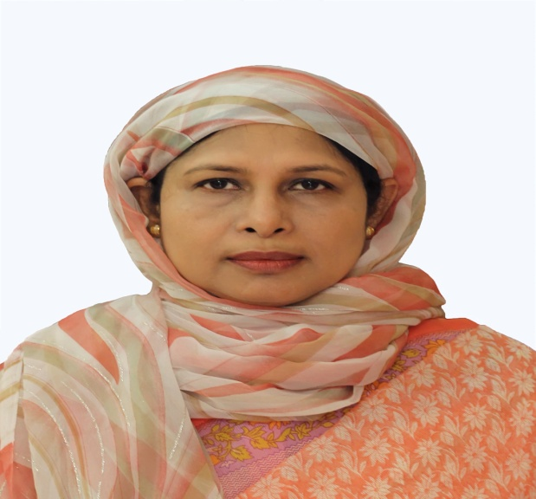
Title: ERCP in Rare Aberrant Papillas
Name: Professor Col Shaila Perveen, MCPS, FCPS(Med),FRCP(Glasgow). Classified Medicine Specialist & Senior Gastroenterologist . Army Medical College & Combined Military Hospital, Cumilla, Bangladesh
The ampulla of Vater encompasses the openings of both the common bile duct (CBD) and pancreatic duct (PD). Presently ERCP has allowed better observation of the papillae in ectopic locations. The diagnosis of ectopic papillae can be done by radiological studies also but they are expensive and not affordable by all patients so most of the cases of ectopic papillae are identified by ERCP. An ectopic location, distal to the second part, in the third or fourth parts of duodenum has been described frequently but a proximal location is rare. Only a few cases have been found to be located in the gastric, pyloric and duodenal bulb areas. Three such rare cases of anomalous ectopic ampullae discovered during the performance of ERCP were managed differently. In these three subjects one papilla was located in the pylorus and other two in the first part of the duodenum. All of them presented with features of choledocholithiasis with cholangitis. They were successfully managed by some modification in therapeutic ERCP procedures. .Therefore ectopic biliary drainage must be considered when the clinician faces difficult ERCP in whom the papilla cannot be found in its usual location. Awareness of such rare conditions can assist the gastroenterologists in effective patient management.
Biography
Prof (Col) Shaila Perveen is Interventional Gastroenterologist as well as Internal Medicine Specialist working as Professor and Departmental Head of Medicine in Army Medical College & Combined Military Hospital (CMH), Cumilla. She graduated from Sir Salimullah Medical College, Dhaka Bangladesh in 1988. She received extensive training on Internal Medicine from Bangabandhu Sheikh Mujib Medical University, Armed Forces Medical Institute , CMH Dhaka and Tan Tock Seng, Singapore. She underwent Gastroenterology training in Baldota Institute of Digestive Sciences (BIDS), Mumbai. She has good international exposure travelling to USA, Europe, Africa other than Asia.
She has 26 publications in different reputed medical journals.

Presenting Author Details:
Full Name: Shaila Perveen
Contact Number: +88 (01819294922/01769332922)
Linked in account: Colonel Shaila Perveen
Session name:Therapeutic and Diagnostic Gastroenterology
Category: Speaker

