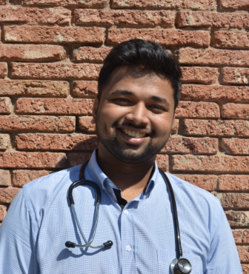
Altered microbiota via gastrectomy: a potential to cause colitis-associated carcinoma(CAC)?
Name: Tanvish Nitin Manwatkar
David Tvildiani Medical University, Tbilisi, Georgia
Human GI tract contains 10¹⁴ microorganisms that partake in immune system maturation and degradation of toxic substances, potentially altered by oxygen concentration and luminal pH. Gastrectomy is important modality for gastric cancer and obesity, ranging from sleeve- to total-gastrectomy. It alters the pH and microbiome, though studies being scant and results conflicting, it’s major driver of colitis and CAC.
A study included 12-week old diet-induced obese mice randomized to sleeve gastrectomy(SG) or sham procedure. Colonoscopy assessed colitis and tumor burden, and 16S rRNA sequencing of fecal samples conducted. Cecal-microbiota-transplant(CMT) was performed between SG and age-and weight-matched germ-free(GF) mice.
SG caused weight-loss, but colitis was more severe. Tumors were 4-fold in SG than in sham, and 16S rRNA profiling showed colitogenic taxa Akkermansia and Bacteroides. CMT from these to GF mice caused severe colitis and weight-loss, with 5-fold tumor burden.
In a cross-sectional study, patients after subtotal gastrectomy with Billroth-II reconstruction(SGB2) (n=14) and controls(n=8) were chosen. Fecal microbiome, intestinal inflammation(fecal calprotectin), gut permeability were investigated.
Compared to controls, SGB2 patients showed increased pH(similar after PPI use), loss of gastric barrier function, and abundance of Escherichia-Shigella, Streptococcus, Viellonella with reduced beneficial commensals. Oralisation of gut microbiome was noted(with Oribacterium and Mogibacterium). Fecal calprotectin increase correlated to Streptococcus abundance, and diarrhea, which also correlated to Mogibacterium abundance and high serum C-reactive protein.
In another study, fecal samples were collected from GC(gastric cancer)patients(n=20), and controls(n=22) with mean age 53.4 years. 6 samples were collected after distal gastrectomy in GC patients. Antibiotics, probiotics and PPI were prohibited since 1 month before sampling.
Results revealed GC group with increased Proteobacteria and reduced Bacteroidetes, whereas controls had higher bacteroides. Post-gastrectomy patients showed increased Escherichia/Shigella, Fusobacteria, Akkermansia and Bacteroidetes, with decreasing Proteobacteria. Also, short-chain fatty acids(SCFA) levels reduced.
Gastrectomy catalyses colitogenic transformation of gut microbiota, where Streptococcus is linked to intestinal inflammation and permeability, and Mogibacterium abundance documented in Crohn’s disease and colorectal cancer. Akkermansia are mucus-degrading, and low SCFAs affect intestinal integrity, influencing permeability and inflammation. These correlate to potential inflammation and carcinogenesis, but scant studies permit further investigations with larger study samples.

Biography:
Tanvish Nitin Manwatkar, 24 years old, is pursuing undergraduate degree in medicine (MD program) from DTMU, Georgia. His interests lie in field of gastroenterology, and in the pursuit got a chance to win a prize in London Medical Research Conference. He has taken part in other conferences as well, and looks forward to possible research opportunities.

Presenting author details:
Full name: Tanvish Nitin Manwatkar
Contact number: +995599860621
LinkedIn account: https://www.linkedin.com/in/tanvish-manwatkar-212039182
Category: oral presentation

