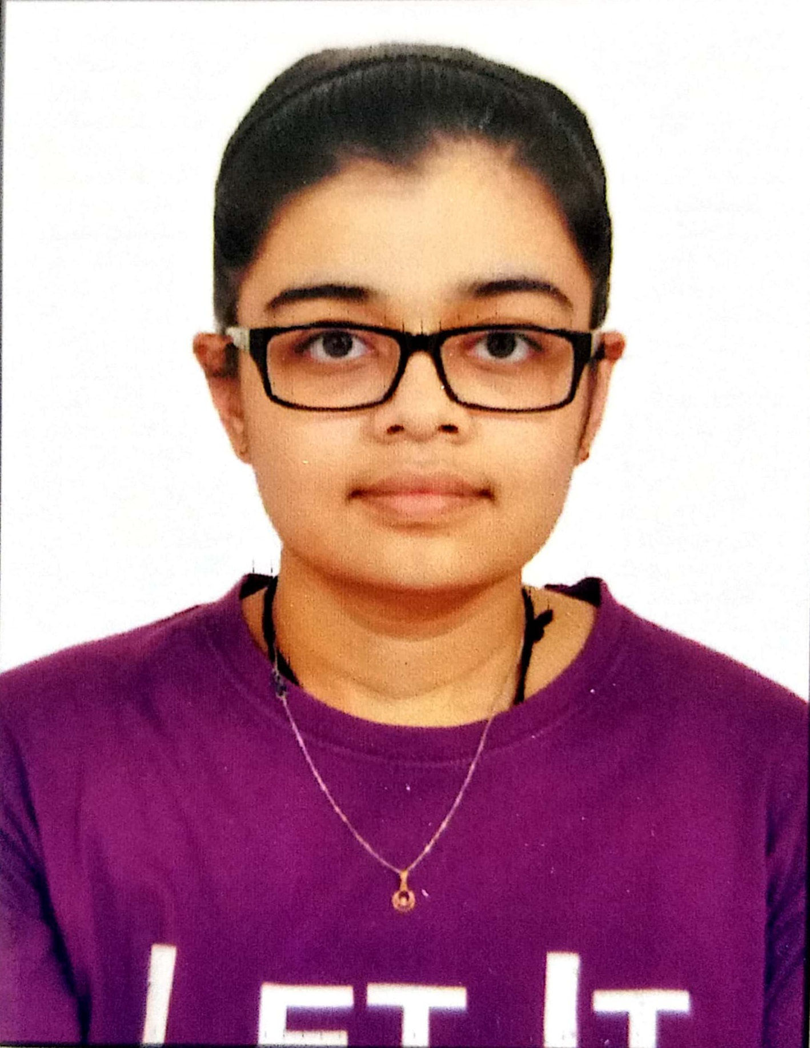

Outcomes of laparoscopic Roux-en-Y gastric bypass surgery vs laparoscopic sleeve gastrectomy in terms of weight reduction and related comorbidities

Name: Shah Zeel Mayurkumar
From: David Tvildiani Medical University, Georgia

Abstract
One of the most prevalent life-threatening conditions connected with comorbidities is obesity. Bariatric surgery is more successful than lifestyle adjustments and medications. The purpose of this meta-analysis was to compare the outcomes of laparoscopic Roux-en-Y gastric bypass (LRYGB) with laparoscopic sleeve gastrectomy (LSG) in terms of weight loss, expressed as percentage of excess weight loss (%EWL) and related comorbidities such as Type 2 Diabetes Mellitus, Hypertension and Dyslipidemia. Using data from 23 studies (N=1671, BMI= 47.2±15.6 kg/m2) who experienced LRYGB and 20 studies (N=1114, BMI=47.3±7.1 kg/m2) who experienced LSG to appraise the difference in %EWL. In addition, two prospective cohort studies comparing LRYGB (N=1085, BMI=45.5 ± 6.1 kg/m2) and LSG (N=2202, BMI=44.6 ± 5.7 kg/m2) for the alleviation of obesity-related comorbidities were described. The results of Study 1 showed no significant difference in % EWL when comparing LRYGB (%EWL was 62.58% at ≥5 years and 63.52% at ≥10 years). and LSG(53.25% at ≥5 years), and the Study 2 compared LRYGB with LSG and discovered a substantial difference in the alleviation of obesity-related comorbidities, particularly hypertension and dyslipidemia. Based on this, both procedures yielded excellent results in terms of weight loss, remission improvement, and improvement of obesity-related comorbidities. LRYGB, on the other hand, was more successful than LSG in remission of comorbidities like hypertension and dyslipidemia.

Biography
Shah Zeel Mayurkumar, 23 years old, born and raised in India. She has been pursuing an undergraduate degree in medicine (MD program) from DTMU, Georgia. Her scholarly interests have always centered on deciphering the processes that govern how and why things operate in the realm of medicine. As she is preparing to begin her career as a medical doctor, She has yet to formally settle on a project. However, She has been motivated to do research that will enable her to comprehend medicine at a fundamental level and to apply these new insights to higher levels of operation.

Presenting author details
Name: Shah Zeel Mayurkumar
Contact No: +995 599860613
Linked In account: https://www.linkedin.com/in/zeel-shah-800ba1212
Category: Oral presentation

