Relationship Between Weight and Glucose Using Math-Physics Medicine

Gerald C. Hsu, eclaireMD Foundation, USA

Abstract (300 word limit)

Background and Aim:
This paper investigates the relationship between weight and glucose, based on 13,480 data covering 2,245 days (1/1/2012 - 2/24/ 2018) from a diabetes patient’s 1.5 million statistics.

Material and Method:
Health conditions prior to 2012 vs. after 2012:
Weight - 210 lbs. vs. 166.9-193.8 lbs.
BMI - 31 vs. 24.65-28.65
Max. PPG - 380 mg/dL vs. 52-280 mg/dL
Average PPG - 280 mg/dL vs. 126.5 mg/dL
A1C – above 10.0% vs. 6.5%

This 4-year research project utilized advanced mathematics, finite element modeling, signal processing, big data analytics, statistics, and artificial intelligence.

Results:
Among the 5 FPG’s influential factors, weight is the most dominant one, contributing ~90%. Weight and FPG have a high correlation of 84%. In spatial analysis, 93% of the total collected data is covered by a +/- 20% band around a “skewed line”. This “relationship band” stretched from point A (24.5, 95) to point B (27.2, 150) on a map with coordinates of x=BMI and y=glucose.

However, among the PPG’s 15 influential factors, weight is not the dominating factor. Instead, the combined effect of carbs/sugar intake and post-meal exercise contributes 81% of PPG formation. Weather and measurement time delay count for 14% and the other factors impact 5%. Weight and PPG have a low correlation (from 9% to 36%). In spatial analysis, 86% of the total collected data covers by a +/- 20% band centering around a “horizontal” PPG line of 127 mg/dL.

Conclusion:
The results show that 93% of FPG data are directly related to weight according to a “fixed” slope. However, 86% of PPG data are kept within a horizontal range from 102 mg/dL to 152 mg/dL because of carbs/sugar intake and post-meal exercise, but not from weight (Figure 1).
.

Images
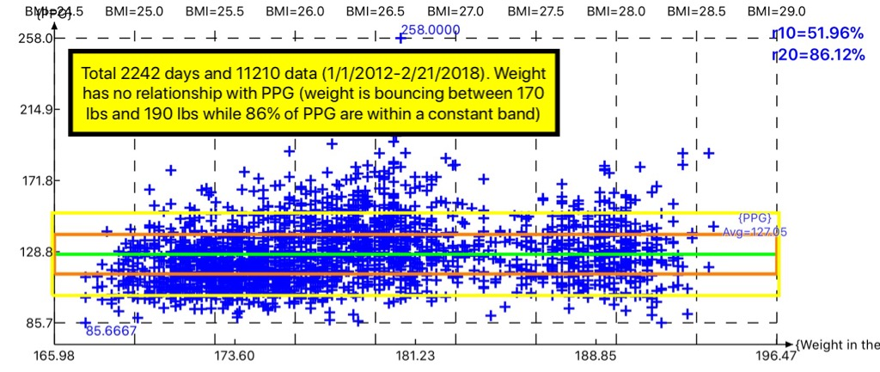

Figure 1: PPG Data results

Recent Publications (minimum 5)

1. Hsu, Gerald C. (2018). Using Math-Physical Medicine to Control T2D via Metabolism Monitoring and Glucose Predictions. Journal of Endocrinology and Diabetes, 1(1), 1-6. Retrieved from http://www.kosmospublishers.com/wp-content/uploads/ 2018/06/JEAD-101-1.pdf

2. Hsu, Gerald C. (2018). Using Signal Processing Techniques to Predict PPG for T2D. International Journal of Diabetes & Metabolic Disorders, 3(2),1-3. Retrieved from https://www.opastonline.com/wp-content/uploads/2018/06/using-signal-processing-techniques-to-predict-ppg-for-t2d-ijdmd-18.pdf

3. Hsu, Gerald C. (2018). Using Math-Physical Medicine and Artificial Intelligence Technology to Manage Lifestyle and Control Metabolic Conditions of T2D. International Journal of Diabetes & Its Complications, 2(3),1-7. Retrieved from http://cmepub.com/pdfs/using-mathphysical-medicine-and-artificial-intelligence-technology-to-manage-lifestyle-and-control-metabolic-conditions-of-t2d-412.pdf

4. Hsu, Gerald C. (2018). A Clinic Case of Using Math-Physical Medicine to Study the Probability of Having a Heart Attack or Stroke Based on Combination of Metabolic Conditions, Lifestyle, and Metabolism Index. Journal of Clinical Review & Case Reports, 3(5), 1-2. Retrieved from https://www.opastonline.com/wp-content/uploads/2018/07/a-clinic-case-of-using-math-physical-medicine-to-study-the-probability-of-having-a-heart-attack-or-stroke-based-on-combination-of-metabolic-conditions-lifestyle-and-metabolism-index-jcrc-2018.pdf

5. Hsu, Gerald C. (2018). From Weight Management via Diabetes Control to Cardiovascular Risk Reduction Advances in Obesity, Weight Management & Control, 8(4),1-4. Retrieved from http://medcraveonline.com/AOWMC/AOWMC-08-00249.pdf

 Biography (150 word limit)
Gerald C. Hsu received an honorable PhD in mathematics and majored in engineering at MIT. He attended different universities over 17 years and studied seven academic disciplines. He has spent 20,000 hours in T2D research. First, he studied six metabolic diseases and food nutrition during 2010-2013, then conducted research during 2014-2018. His approach is “math-physics and quantitative medicine” based on mathematics, physics, engineering modeling, signal processing, computer science, big data analytics, statistics, machine learning, and AI. His main focus is on preventive medicine using prediction tools. He believes that the better the prediction, the more control you have.

The author has not received any financial assistance from any organization.
Email: g.hsu@eclaireMD.com

Notes/Comments:

