A Case Study of Investigation and Prediction of A1C Variances Using Math-Physical Medicine

Gerald C. Hsu, eclaireMD Foundation, USA

Abstract (300 word limit)
Introduction:
In this case study, the author analyzed, predicted, and interpreted a type 2 diabetes (T2D) patient’s hemoglobin A1C variances based on three periods utilizing math-physical medicine approach.

Method:
There are four hemoglobin A1C checkup results at the same hospital:
6.7% on 4/9/2017
6.1% on 9/12/2017
6.9% on 1/26/2018
6.5% on 6/29/2018

The author selected three equal-length periods of five months and observed three measured A1C changes as follows:
Period A (4/1/2017 - 8/31/2017): -0.6%
Period B (9/1/2017 - 1/31/2018): +0.8%
Period C (2/1/2018 - 6/30/2018): -0.4%

He applied math-physical medicine techniques to analyze three A1C variances contributed by fasting plasma glucose (FPG) via weight change (gain or loss) and colder weather effect on FPG as well as A1C variances contributed by postprandial glucose (PPG) via changes of carbs/sugar intake, post-meal walking, and warmer weather temperature on PPG.

Results:
Figure 1 shows various time-series analysis results on weight, glucose, food, and exercise during these three periods. Based on the author’s previous publications of adjusted A1C contributions by FPG and PPG along with the prediction models of glucose and A1C, Table 1 displays a step-by-step detailed calculation on how to derive the patient’s A1C variances.

As shown, his predicted A1C variances completely match the lab test results from the hospital.

Conclusion:
The A1C case study focused on three periods of approximately 460 days, which contained about 1,380 meals and big data including exercise, weather, traveling, sickness, etc. This study demonstrates the degree of precision on predicting and interpreting the patient’s A1C variances. Once patients master the skill of understanding and predicting the forthcoming A1C lab test results, their overall T2D condition can then be under control.

Images
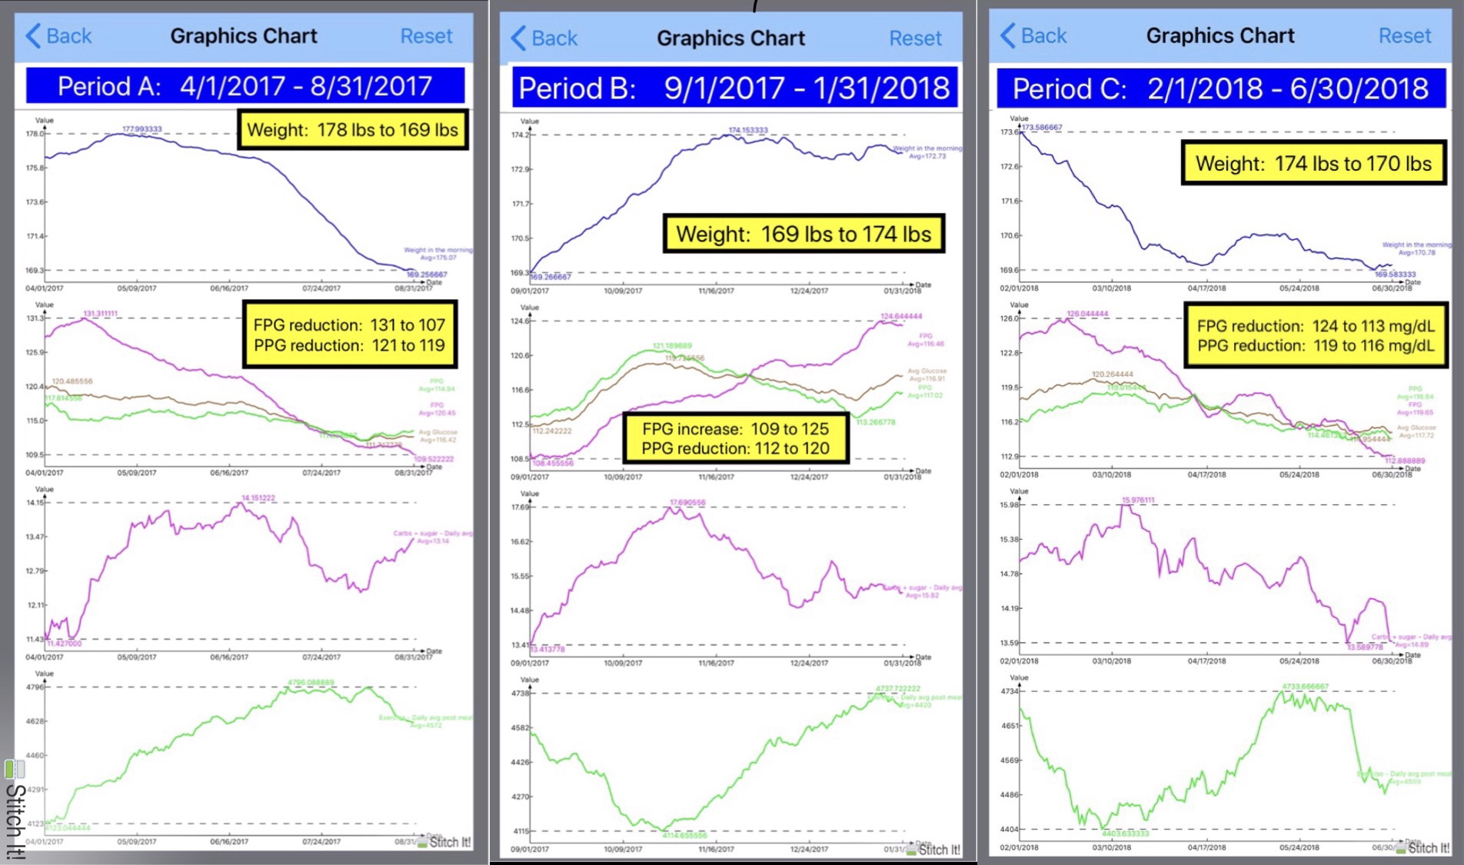

Figure 1: Three Periods of Weight, FPG, PPG, Daily Glucose, Carbs/Sugar Intake, Post-Meal Walking

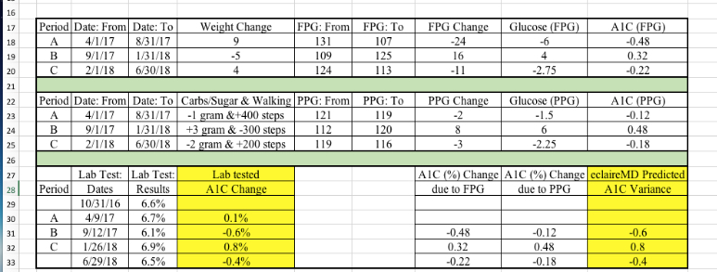

Table 1: Calculation of A1C Variances

 Biography (150 word limit)
Gerald C. Hsu received an honorable PhD in mathematics and majored in engineering at MIT. He attended different universities over 17 years and studied seven academic disciplines. He has spent 20,000 hours in T2D research. First, he studied six metabolic diseases and food nutrition during 2010-2013, then conducted research during 2014-2018. His approach is “math-physics and quantitative medicine” based on mathematics, physics, engineering modeling, signal processing, computer science, big data analytics, statistics, machine learning, and AI. His main focus is on preventive medicine using prediction tools. He believes that the better the prediction, the more control you have.

The author has not received any financial assistance from any organization.
Email: g.hsu@eclaireMD.com

Notes/Comments:

