Merkel Cell Carcinoma: From Pathobiology to Clinical Management
P Umar Farooq Baba, Plastic Surgeon, SKIMS, Srinagar, India

Abstract (300-word limit)
Merkel cell carcinoma (MCC) is an infrequent, rapidly growing skin neoplasm that carries a greater probability of regional lymph node involvement, and a grim prognosis in advanced cases. While it is seen predominantly in old age in sun-exposed body parts, the prevalence varies among different races and geographical regions. Merkel cell polyomavirus and UV radiation-induced mutations contribute to its etiopathogenesis. The clinical presentation of MCC lacks pathognomonic features and is rarely considered highly at the time of presentation. Histopathological examination frequently reveals hyperchromatic nuclei with high mitotic activity, but immunohistochemistry is required to confirm the diagnosis. Sentinel lymph node biopsy (SLNB) and imaging are advised for effective staging of the disease. Multimodal management including surgery, radiation therapy, and/or immunotherapy are deployed. Traditional cytotoxic chemotherapies may result in an initial response, but do not result in a significant survival benefit. Checkpoint inhibitors have dramatically improved the prognosis of patients with metastatic MCC, and are recommended first-line in advanced cases. There is a need for well-tolerated agents with good safety profiles in patients who have failed immunotherapies.
Image
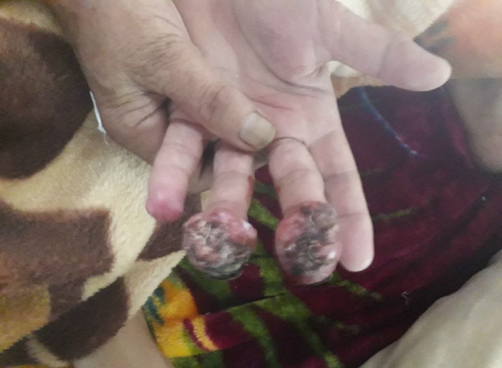
Figure: Merkel cell carcinoma involving the middle and ring fingers of the left hand of a 76-year-old
female.
Recent Publications (minimum 5)
- Patel, P.; Hussain, K. Merkel Cell Carcinoma. Clin. Exp. Dermatol. 2021, 46, 814–819. [CrossRef] [PubMed].
- Monteiro, A.; Gouveia, E.; Garcez, D.; Donato, S.; Martins-Branco, D.; Marques, J.; Nunes, H.; Passos, M.J.; Clara, A.I.; Moreira, A. Challenges of new approaches in metastatic merkel cell carcinoma. Case Rep. Oncol. 2020, 13, 501–507. [CrossRef] [PubMed]
- Tam, M.; Luu, M.; Barker, C.A.; Gharavi, N.M.; Hamid, O.; Shiao, S.L.; Nguyen, A.T.; Lu, D.J.; Ho, A.S.; Zumsteg, Z.S. Improved survival in women versus men with merkel cell carcinoma. J. Am. Acad. Dermatol. 2020, 84, 321–329. [CrossRef]
- Schmults, C.D.; Donigan, J.M.; Park, S.; Blitzblau, R.; Farma, J.M.; Patel, T.; Aasi, S.Z.; Ghosh, K.; Puzanov, I.; Alam, M.; et al. NCCN Clinical Practice Guidelines in Oncology (NCCN Guidelines®) Merkel Cell Carcinoma Version 1.2021—February 18, 2021; National Comprehensive Cancer Network: Plymouth Meeting, PA, USA, 2021.
- Stege, H.M.; Bradfisch, F.; Fleischer, M.I.; Mohr, P.; Ugurel, S.; Terheyden, P.; Thiem, A.; Kiecker, F.; Leiter, U.; Becker, J.C.; et al. Retrospective multicentre analysis of the outcome of a re-induction with immune checkpoint inhibitors in advanced merkel cell carcinoma. SN Compr. Clin. Med. 2020, 2, 2202–2207. [CrossRef]
.

 Biography (150-word limit)

P Umar Farooq Baba
MBBS, MS, MCh.
Board-certified Plastic, Reconstructive and Microsurgeon, working as Associate Professor in Sher-i-Kashmir Institute of Medical Sciences (SKIMS), Srinagar, India. Areas of interest are reconstructive and microsurgery, hand surgery, cleft and faciomaxillary, burn management and rehabilitation and wound care and research. Has 36 publications in various peer reviewed journals. Editorial Board Member of our institutional journal. In-charge of academics and research of post-doctoral and National Board fellows of our department. Life-time member of Association of Plastic Surgeons of India, National Academy of Burns-India, Indian Society for Surgery of Hand, British Burn Association, Asia Pacific Burn Association, European Burn Association, Diabetic Foot Society of India. Editorial Board member and a reviewer of several national and international journals of repute. Work as a team member. Always keen on teaching and learning.

Email: drumar397@mail.com

Notes/Comments:

Presenting author details
Full name: Dr P Umar Farooq Baba
Contact number:91-9419081397
Twitter account: @UmarFarooqBaba
Linked In account: P Umar Farooq Baba
Session name/ number: Skin Infections and Skin Cancers
Category: Poster presentation

