Title: Case Series Report of Sever Phytophotodermatitis in Herat Regional Hospital, Herat City — Afghanistan, April – May 2018
Author: Bashir Ahmad Barakzaie, MD, MPH
Dermatology Consultant, Dermatology Department
Herat Regional Hospital, Herat City – Afghanistan
Cell Phone/Whatsup/Imo: 0093700422661
Email: bashir_barakzaie@yahoo.com
Background:
Phytophotodermatitis — Topical exposure to plant-derived substances may also cause a phototoxic reaction termed phytophotodermatitis. Phytophotodermatitis occurs most commonly after exposure to limes and other plants. Other citrus fruits contain furocoumarins and may infrequently cause a phytophotodermatitis. Although generalized phototoxic reactions secondary to the ingestion of plants are rare, we admitted 17 cases of severe cutaneous reaction following ingestion of certain plants as a vegetable.
Observation:
During April – June 2018, 17 patients 5 (29.4%) men and 12 (70.6%) female, admitted to the dermatology department of our hospital for severe reaction in sun-exposed areas following ingestion of a particular plants called Shorak in local language (Salsa Rigid)as eatable vegetable food. 6 (35.2%) of patients were from Herat Province and the rest 11(64.8%) from Badghis. Both Herat and Badghis patients were all from the districts and rural areas, all were illiterate with only one just traditional semi-literate. The age ranged 2-56 years with an average of 22 years. The hospital staying time was between 1 – 17 days with an average length of stay of 5.9 days. The face was involved in all patients (100%), hands, feet, and necks affected by 64.7%, 53%, and 5.3% respectively. Only 1 patient (5.8%) face was involved alone. No patient had lesion elsewhere in the body without face involvement. Although, no mortality case reported, severe morbidity and disfiguring requiring skin graft seen in 4 cases and fingers amputation observed in one patient.

Key Message:
Even though phytophotodermatitis in particularly severe form is rare in other countries, it is still highly prevalent in our community leading to life long, disfiguring and disabilities. Hence, Strong efforts by policy-makers are required to deal with this public health challenge. We have already launched a massive media campaign and the links are available at YouTube.

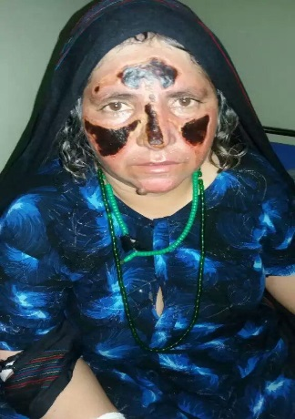
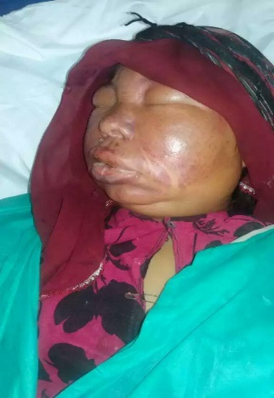
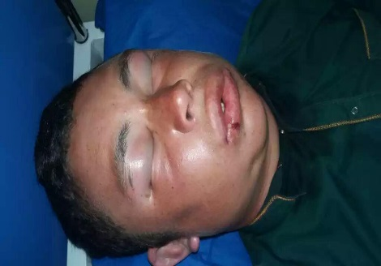
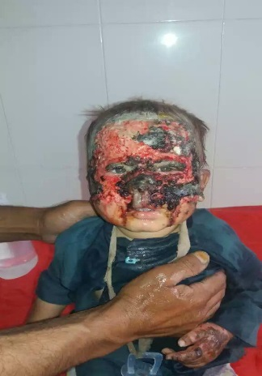
Fig 4: 2 Years old Female with Facial and Hand Involvmen
Fig 1: 55 Years old Female with Facial and Hand Involvment
Fig 2: 35 Years old Female with Facial and Hand Involvment
Fig 3: 18 Years old Male with Facial and Hand Involvment

