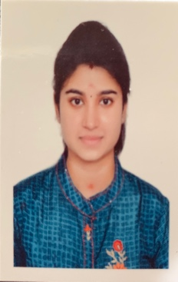
TITLE : A rare pigmentary disorder of the groin – LICHEN PLANUS PIGMENTOSUS INVERSUS

NAME: Dr.V.Vilashini
Chettinad hospital and research institute, Kelambakkam, tamilnadu, India

INTRODUCTION: Lichen planus is a common inflammatory dermatoses that presents in a variety of morphologic patterns. Lichen planus pigmentosus, a disease of unknown etiology runs a insidious prolonged course, characterized by small dark brown macules on sun exposed areas that merge to form large hyper pigmented patches. Lichen planus pigmentosus inversus is characterized by hyper chromic , asymptomatic to mildly pruritic well defined macules and plaques affecting intertriginous areas , most commonly axilla and groin in Caucasian patients. Herein I report a 45 year old female diagnosed with lichen planus pigmentosus inversus mimicking intertrigo.

MATERIALS AND METHODS:

CASE REPORT-
A 45 year old married woman, a known case of epilepsy and optic neuritis on treatment, presented with chronic itchy dark brown macules which then merged to form dark hyper pigmented lichenified plaques in intertriginous areas of groin for the past one year. Woods lamp was done to exclude erythrasma .Patients’s thyroid levels were normal. . Based on the clinical presentation diagnosis of intertrigo was done and patient was treated with anti fungals and emollients. But the patient failed to show any clinical improvement. Hence skin biopsy was done. Histopathology findings were consistent with Lichen planus pigmentosus.

DISCUSSION : Hence Lichen planus pigmentosus inversus also should be considered a differential diagnosis of cutaneous pigmentation exclusively located in the flexural and intertriginous areas .

BIOGRAPHY : Vilashini.V has completed her undergraduate M.B.B.S., in PSG IMSR , Coimbatore and is currently pursuing first year post graduation in M.D.,Dermatology in Chettinad hospital and research institute, kelambakkam , Tamilnadu, India.

PRESENTING AUTHOR DETAILS:

FULL NAME: V.Vilashini Santhoshkumar

CONTACT NUMBER : 9962602819

SESSION NAME : clinical dermatology

CATEGORY: POSTER PRESENTATION

