The Heart Face Filler for Facial Aesthetics and Facial Rejuvenation

Jeong, Jae Hoon M. D.

Aesthetic Medicine & Anti-Aging Medicine, THE PRETTY YOUNG CLINIC, Seoul, Korea

Background: Facial aging is a multifactorial process. The signs of facial aging are characterized by skin discoloration, lines, sagging skin along the jawline and loss of volume. Not only for the facial aesthetics, but also for the facial rejuvenation the hyaluronic acid fillers can be one of the treatment of choices. The author would like to introduce the Heart Face Fillers, a name of combination of filler procedures based on anatomical and aesthetical logics.

Methods: The author named and described the combination of volume augmentation in anterior cheek, lateral cheek and chin with hyaluronic acid filler as the Heart Face Fillers with the related meaning of heart shaped face which is a symbol of healthy, young and beautiful face. The filler for pointed chin is also necessary to make the face contour slim and well balanced. For the total of 5 patients, this combination of filler procedures performed into some or all of 3 parts of face according to the patient's need to volumize and reshape their faces.

Results: Only one session per patient has been enough to be carried out with the patient’s high satisfaction and aesthetic outcome. Average time of procedures per patient has been 15 minutes. The average parts of face needed has been 1.8 parts to achieve the heart shaped face.

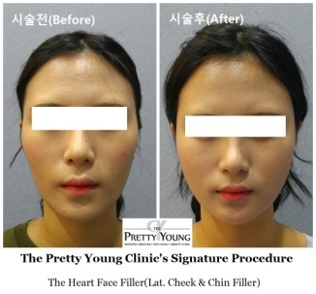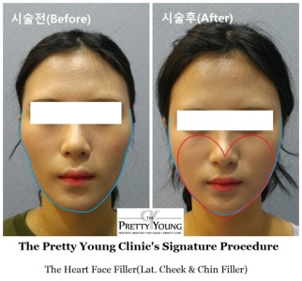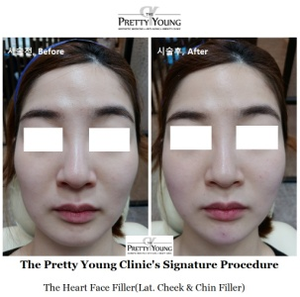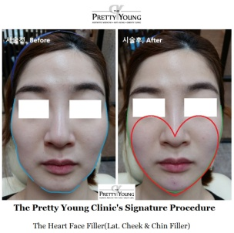

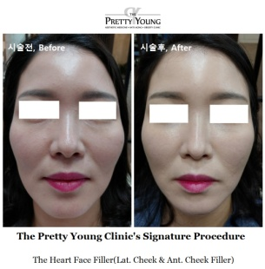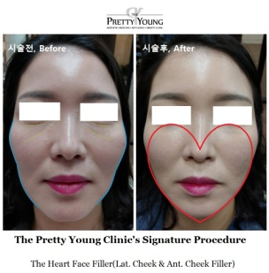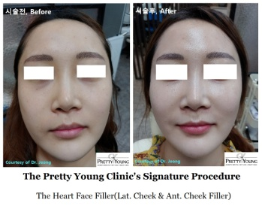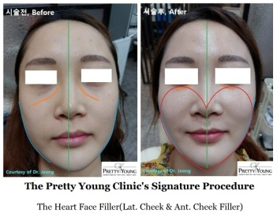

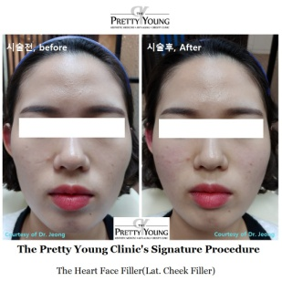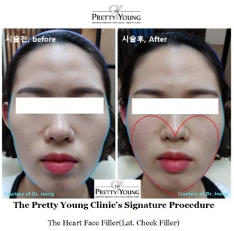

Conclusions: The Heart Face Filler is associated with an increased feeling of attractiveness, look younger and healthier, and an increase in self-esteem. The Heart Face Filler is safe, effective and simple to perform for facial aesthetics and facial rejuvenation with high patient satisfaction and excellent aesthetic outcome.

Keywords: Anti-Aging, Facial Rejuvenation, Heart Face Fillers, Hyaluronic Acid, Facial Filler

Biography
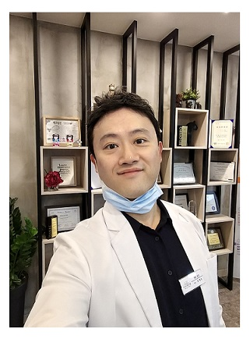
Jeong, Jae Hoon M.D.
Aesthetic Medicine & Anti-Aging Medicine, THE PRETTY YOUNG CLINIC, Seoul, Korea
- Education
M.D., Pusan National University Medical School
- Residency
Residency, Korea University Medical Center, Seoul, Korea
- Licensure
Medical Doctor(M.D.), Korean Medical Association
- Board Certification
Board Certified, KAFM
Board Certified, The American Board of Anti-Aging/Regenerative Medicine (ABAARM)
- Hospital Affiliations
Korea University Medical Center, Seoul, Korea
E-mail : theprettyyoung@naver.com

