Possibility for use as a cosmeceutical material of reduction-responsive monoolein cubic phase containing epidermal growth factor.
Jin-Chul Kim‡ ¹, Dae Sung Yoo‡ ², Kyeongnan Kwon¹, Tae Hoon Kim ¹ Si Jun Park ², Sun A Choi ² and Si Won Lee²

¹ Department of Medical Biomaterials Engineering, College of Biomedical Science and Institute of Bioscience and Biotechnology, Kangwon National University, Chuncheon, Kangwon-do, Republic of Korea
² R&D Center, 114-6, Central town-ro, Yeongtong-gu, Suwon-si, Gyeonggi-do , 16506 Korea
‡ Contributed equally to this work.

Abstract
Monoolein can be eaten without causing an immune response to the human body and is used as an emulsifier in food and pharmaceutical fields. When monoolein is contacted with excess water, a cubic phase is spontaneously formed. Water channels with diameters of 2 nm to 10 nm cross each other and pass through the cubic phase, while the water channels are separated by a monoolein bilayer. These water channels encompass hydrophilic compounds and the monoolein bilayer can carry hydrophobic compounds. Cubic phase nanoparticles are small in size and have a high affinity for lipid filling between the cells of the skin, so they can penetrate through the intercellular pathways of the skin.
Reduction-responsive monoolein cubic phase was designed by immobilizing alginate and cystamine in the water channel of the cubic phase. The light scattering intensity of cystamine/alginate and alginate/EGF mixture solution were measured to investigate the crosslinking degree and the complex coacervation. Lipid bilayers and water channels, characteristic of cubic phase, were found on the TEM micrograph. According to the differential scanning calorimetric study, the phase transition occurred at 63.2℃ and it decreased significantly upon the inclusion of STAC and cystamine. Almost the same phase transition temperature was observed by polarized optical microscopy. The release degree of EGF loaded in the cubic phase increased as GSH concentration increased. It also increased with increasing pH value. Furthermore, the cubic phase did not show any skin irritation or mucosal irritation, in clinical tests.

Image

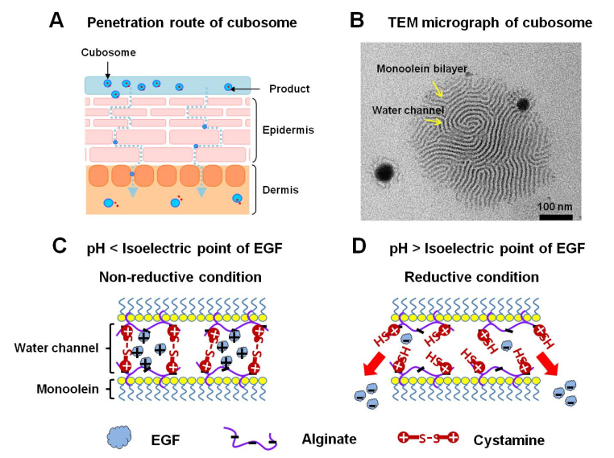

Recent Publications (minimum 5)
- Min Hui Wang and Jin-Chul Kim (2016) Thermo-triggerable self-assembly comprising cinnamoyl polymeric beta cyclodextrin and cinnamoyl Pluronic F127. Colloids and Surfaces B: Biointerfaces 142(1): 148-158
- Hee Jin Seo and Jin-Chul Kim (2014) 7-Acetoxycoumarin Dimer-Incorporated and Folate-Decorated Liposomes: Photoresponsive Release and in Vitro Targeting and Efficacy. Bioconjugate Chemistry 25(3): 533-542
- Min Hui Wang and Jin-Chul Kim (2014) Light-and temperature-responsive liposomes incorporating cinnamoyl Pluronic F127. International Journal of Pharmaceutics 468(1): 243-249
- Dae Sung Yoo et al (2016) Antiaging Effects of Musa sapientum L. (Banana) Leaf Extract. Korean Society for Biotechnology and Bioengineering Journal 31(2): 126-134
- Si Jun Park et al (2015) Continuous irradiation with a 633-nm light-emitting diode exerts an anti-aging effect on human skin cells. Inter. Journal of molecular medicine 35:383-390

Biography
Jin-Chul Kim is a full professor in the Kangwon national university (Department of Medical Biomaterials Engineering, College of Biomedical Science and Institute of Bioscience and Biotechnology), South Korea. One of his research interests is stimuli-responsive drug delivery system.
Email: jinkim@kangwon.ac.kr

Notes/Comments:

