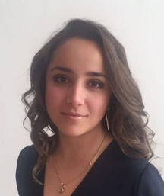
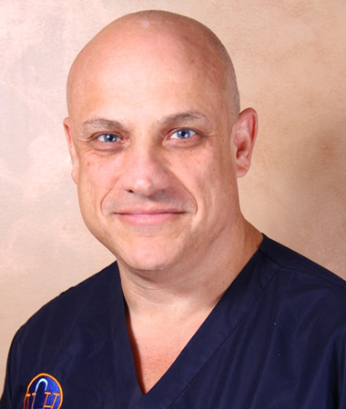
Title: Ulcerated Basosquamous Cell Carcinoma on Shoulder
Case Report and Review of Literature
Andrea Merino-Ruisánchez, PT^{1,2}
Joseph Varon, MD, FACP, FCCP, FCCM, FRSM^{1,2,3,4,5}
¹Dorrington Medical Associates, Houston, Texas, USA
²Universidad Popular Autonoma del Estado de Puebla (UPAEP), Puebla, Mexico
³Professor of Acute and Continuing Care
⁴The University of Texas Health Science Center at Houston, Clinical Professor of Medicine, The University of Texas Medical Branch at Galveston
⁵Chief of Critical Care Services, United Memorial Medical Center, Houston, Texas, USA

Basosquamous cell carcinoma (BSC) is a rare, and potentially aggressive, skin neoplasm with features of both basal cell carcinoma (BCC), and squamous cell carcinoma (SCC) with a transition zone and a non-specific clinical presentation. We recently saw a 57-year-old gentleman who presented ulcerated BSC on the right shoulder reaching the acromion with a polymicrobial infection. Microscopical analysis showed a transition zone between BCC and SCC. A Periodic acid-Shiff-Fungus special stain was negative for fungal organisms. BSC represents less that 5% of all non-melanoma skin tumors. The incidence is less than 2% but the true incidence may be higher due to rarity and difficulty of diagnosis. This neoplasm is most commonly found on head and neck on 82-97% of cases. In 2005, the World Health Organization defined BSC as a term used to describe BCC that is associated with squamous differentiation. Prompt recognition of BSC is important in order to aggressively treat and predict the prognosis.

Biography
Andrea Merino-Ruisanchez is a physician in training from the Universidad Popular Autonoma del Estado de Puebla (UPAEP) in Mexico. Following a clinical Psychology diplomate, she developed a keen interest in dermatology. She has presented internationally data on the prevalence of dermatologic and ophthalmic manifestations in systemic lupus erythematous. She is certified in “Good Clinical Practices” by the NIDA Clinical trials network.
Dr. Joseph Varon is the Chief of Critical Care at United Memorial Medical Center in Houston, Professor of Medicine, Surgery and of Emergency Medicine at several universities in Mexico, the Middle East and Europe. He is a reviewer for multiple journals and serves as Editor-in-Chief for Critical Care and Shock and Current Respiratory Medicine Reviews. With Dr. Carlos Ayus, he co-described the hyponatremia associated to extreme exercise syndrome also known as “Varon-Ayus syndrome”. Dr. Varon has lectured in over 56 different countries and has contributed more than 750 peer-reviewed journal articles, 10 full textbooks, and 12 dozen book chapters to the medical literatura along with Professor Luc Montagnier (Nobel Prize Winner for Medicine in 2008).

Presenting author details
Full name: Andrea Merino-Ruisanchez
Contact number: (+52-1)22-25-63-39-91
Twitter account: @andreameru22
Linked In account: www.linkedin.com/in/andrea-merino-71b778150
Session name/Number: Skin Cancer
Category: Oral presentation

