Kimura Disease: Rare Manifestations in Unusual Populations

Aljoharah A Alshaikh¹*, Hebah M Musalem¹, Lin M Tuleimat¹, and Saad M Alajlan²
- Alfaisal University, P.O Box 50927, Riyadh 11533, Saudi Arabia
2- Department of Dermatology, King Faisal Specialist Hospital and Research Center. P.O Box 3354, Riyadh 11211, Kingdom of Saudi Arabia
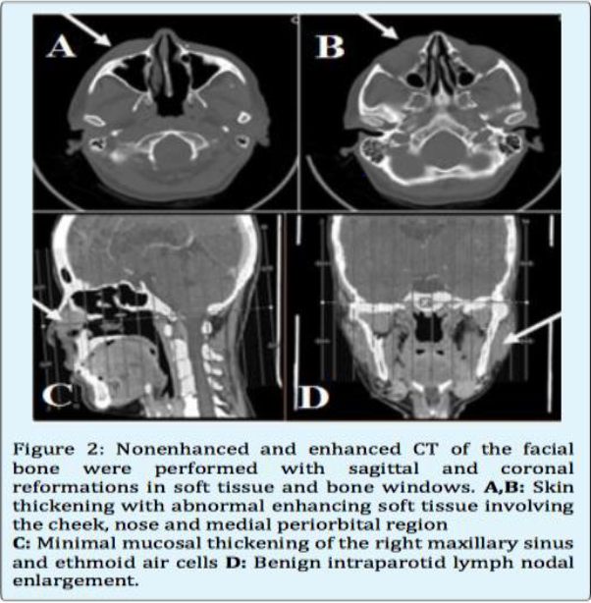
*Corresponding author: Aljoharah Alshaikh, Alfaisal University, P.O Box 50927, Riyadh 11533, Saudi Arabia, Tel: 0096650 858 5860; E-mail: Aljoharah.alshaikh@gmail.com

Abstract

Kimura disease (KD) is a benign, rare, and chronic inflammatory disorder with an angiolymphatic proliferation of unknown etiology involving subcutaneous tissues, affecting a population sporadically. It is most common in middle-aged Asian men, as it is endemic in china and Japan. Herein, we present a medically free 40 years old Saudi female, with unusual clinical, radiological and histopathological manifestations of KD presented with extended facial swelling from the right to the left cheek with a bluish and firm mass in the center of the hard palate. Additionally, a solitary soft lymph node swelling was found in the anterior triangle of the neck. CT scan of the head and neck showed an area of nodularity and fat stranding in the left lower cheek. Histologically, hyperplastic changes of lymphatic tissues were viewed. Treatment with prednisolone showed transient improvement, thus Cyclosporine was suggested since it has a significant potential in decreasing the recurrences and the flare-ups of KD. Adequate reporting and documentation of those cases in the literature are strongly required to establish clear guidelines for the diagnosis and management of KD among Middle Eastern population.

Image

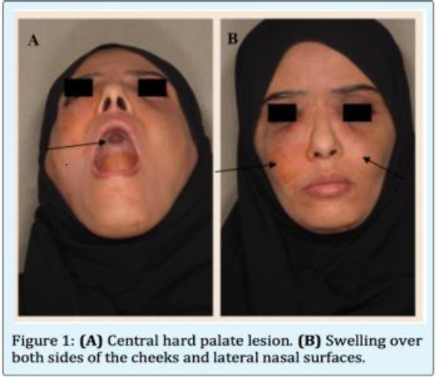

Recent Publications

- Kapoor, Nimmi S., James P. O'neill, Nora Katabi, Richard J. Wong, and Jatin P. Shah. "Kimura disease: diagnostic challenges and clinical management." American Journal of Otolaryngology 33.2 (2012): 259-62. Web.
- Iqbal, Banyameen, Komal Sawaimul, and Tushar Kambale. "Kimura′s disease embedding radial artery: A very rare presentation." Journal of Cancer Research and Therapeutics 11.4 (2015): 1031. Web.
- Kottler, Diane, StPhane Bar Te, Gaelle Qu Reux, Saskia Ingen-Housz-Oro, Sylvie Fraitag, Nicolas Ortonne, Lydia Deschamps, Michel Rybojad, B Atrice Flageul, B Atrice Crickx, Anne Janin, Martine Bagot, and Maxime Battistella. "Retrospective Multicentric Study of 25 Kimura Disease Patients: Emphasis on Therapeutics and Shared Features with Cutaneous IgG4-Related Disease." Dermatology 231.4 (2015): 367-77. Web.
- Alghamdi, Fares, Talal Al-Khatib, Hani Marzouki, and Mohammed Algarni. "Kimura disease. No age or ethnicity limit." Saudi Medical Journal 37.3 (2016): 315-19. Web.
- Fouda, Mohamed Ashraf, Osama Gheith, Ayman Refaie, Mohamed El-Saeed, Adel Bakr, Ehab Wafa, Mona Abdelraheem, and Mohamed Sobh. "Kimura Disease: A Case Report and Review of the Literature with A New Management Protocol." International Journal of Nephrology 2010 (2010): 1-4. Web.

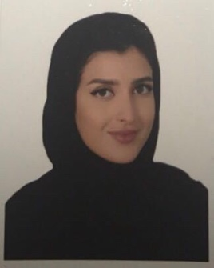 Biography:

Aljoharah Alshaikh is a Medical Intern. Graduated from Alfaisal University Class of 2017. Dr. Aljoharah is one of the head organizers of Alfasial University Dermatology club, and a member of The Saudi Society of Dermatology and Dermatologic Surgery. Moreover, she is known to have a passion in presenting rare cases publicly in the field of dermatology in an attempt to increase awareness amongst the field and improve management guidelines in such cases. Therefore, the talent of public speaking came in very handy. A research experience of a period of 2 years has vastly improved her skills and allowed her to gain a great deal of experience. Hence, in a period of 4 months this paper was finalized and submitted for publication taking into consideration the duration required to attain the patient’s consent.
Email: aljoharah.alshaikh@gmail.com

