The Outcome of Using Topical Sirolimus in Capillary Malformations Among patients in King Faisal Specialist Hospital: Case Series

Hebah M Musalem¹*, Aljoharah A Alshaikh¹, Lin M Tuleimat¹, and Saad M Alajlan²
1 Alfaisal University, P.O Box 50927, Riyadh 11533, Saudi Arabia
2 Department of Dermatology, King Faisal Specialist Hospital and Research Center. P.O Box 3354, Riyadh 11211, Kingdom of Saudi Arabia
*Corresponding author: Hebah Musalem, Alfaisal University, P.O Box 50927, Riyadh 11533, Saudi Arabia, Tel: 00966533112656 E-mail: Hebamusallam91@gmail.com

Abstract
Objective: To reinforce the efficacy and safety of combining topical Sirolimus with pulsed dye laser (PDL) in managing capillary malformation, as port wine stain (PWS); aiming for better clinical clearance.
Summary of Background Data: Sirolimus, a mammalian target of rapamycin (mTOR) inhibitor was approved by the FDA in 2015 for lymphangioleiomyomatosis (LAM). Recently, Sirolimus has been added to the treatment of vascular anomalies in King Faisal Specialist Hospital (KFSH), which raised interest to investigate its efficacy in capillary malformations, such as PWS. Since the market is lacking commercial topical preparations, pharmacists in KFSH were encouraged to formulate topical Sirolimus.
PWS is a congenital, progressive capillary malformation of skin, occurs on the face, neck and body as a flat lesion. PDL is the current treatment of choice for PWS.
Methods: Review of retrospective documents for a total of 5 cases regarding port wine stain that were treated with Pulse Dye Laser (PDL) initially, followed by the addition of 0.5% -1% topical Sirolimus as a Dual Therapy (PDL and Topical Sirolimus).
Results: PDL therapy reflected insufficient improvement (0% up to 55%) and frustrating side effects following multiple sessions over many years. On the other hand, the Dual Therapy reflected significant clearance by an average of 20% in shorter duration and minimized the intolerable side effects of using PDL alone.
Conclusions: We propose implementation of topical Sirolimus in managing PWS and other capillary malformations. Furthermore, prospective studies should be conducted regarding safety and efficacy of using Dual Therapy for managing PWS.

Image
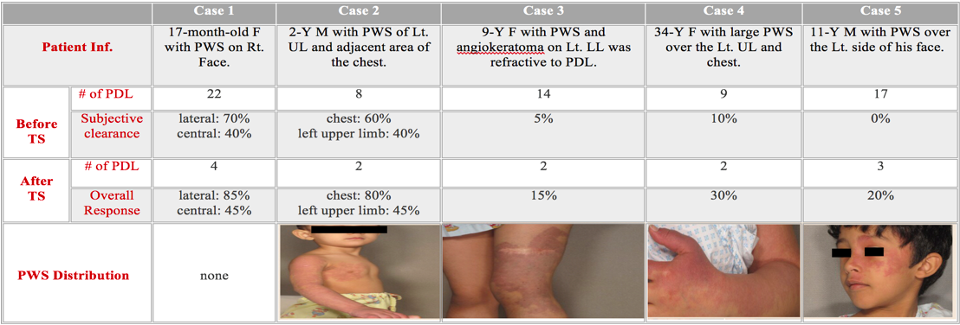

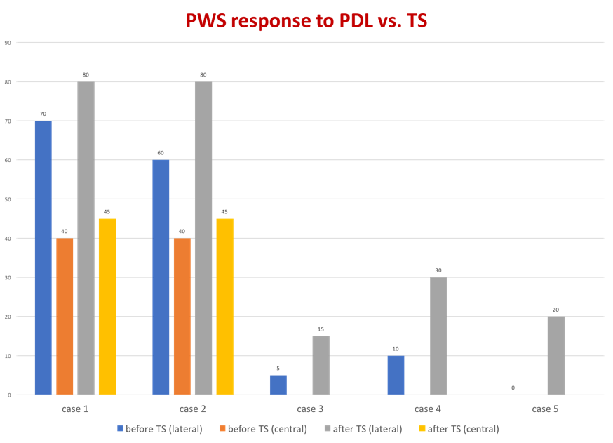

Recent Publications
- Loewe, R., Oble, D. A., Valero, T., Zukerberg, L., Mihm, J., Martin C, & Nelson, J. S. (2010). Stem cell marker upregulation in normal cutaneous vessels following pulsed-dye laser exposure and its abrogation by concurrent rapamycin administration: Implications for treatment of port-wine stain birthmarks. Journal of Cutaneous Pathology, 37 Suppl 1, 76-82. doi:10.1111/j.1600-0560.2010.01520.x
- Enjolras O. Vascular malformations. In Bolognia J, ed. Dermatology, 2nd ed. New York: Mosby, 2003; 1615.
- Yu HY, Chen DF, Wang Q, Cheng H. Effects of lower fluence pulsed dye laser irradiation on production of collagen and the mRNA expression of collagen relative gene in cultured fibroblasts in vitro. Chin Med J (Engl) 2006; 119: 1543.
- Sivarajan V, Maclaren WM, Mackay IR. The effect of varying pulse duration, wavelength, spot size, and fluence on the response of previously treated capillary vascular malformations to pulsed-dye laser treatment. Ann Plast Surg 2006; 57: 25.
- Madke, B. (2013). Topical rapamycin (sirolimus) for facial angiofibromas. Indian Dermatology Online Journal, 4(1), 54-57. doi:10.4103/2229-5178.105488

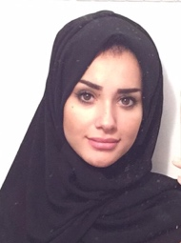

Biography:

Hebah Musalem is a Medical Intern. Graduated as a first honors from Alfaisal University Class of 2017. Dr. Hebah is one of the head organizers of Alfaisal Dermatology club, and a member of The Saudi Society of Dermatology and Dermatologic Surgery. She has a background in pharmacology and pharmaceutical science for 4 year where she studied pharmacy in one prestigious university in the middle east. During her Journey in Alfaisal University, pre-clinical phase, she was nominated to be the head of Treasury committee of the medical student association for 2 years in a row. Dr. Hebah with her unique communication skills and leadership spirit was able to established a great number of sponsorships with well-known companies and clinics in the capital of Saudi Arabia. In addition, she joined the summer teaching campus for junior medical students in where she had to give class in basic medical topics. Also, she volunteered in the night teaching sessions in the cadaver labs of anatomy, and she successfully delivered her enriched pharmaceutical knowledge to her colleagues when she joined the research laboratory skills session. During her clerkship, Dr. Hebah focused on clinical research and participated in writing multiple papers with great consultants from different department, especially dermatology Department. She is known to have a passion in presenting rare cases publicly in the field of dermatology in an attempt to improve management. She was a presenter in dermatological international conferences and other. Nonetheless, her participation in awareness campaigns and community work in public places in especial medical events worth to be mentioned. Therefore, the talent of public speaking and leadership came in very handy. A research experience of a period of 3 years has vastly improved her skills and allowed her to gain a great deal of experience. Hence, in a period of 3 months this paper was finalized and submitted for publication. Currently, she is working on many manuscripts which will be submitted to prestigious journals for publication.
Email: hebamusallam91@gmail.com

