The use of complementary medicine among acne valguris patients: cross sectional study
Sumayyah I Alrefaie, MD, KAU Hospital, Jeddah, SA.

Abstract

Background: Acne vulgaris is a very common disease, and several modalities are used to manage the condition. Among those is Complementary Alternative Medicine (CAM). This study aims to evaluate the prevalence of CAM usage among acne vulgaris patients, and to determine possible factors associated with its adoption over the prescribed modern medicines.

Methods: A cross-sectional survey, conducted during an acne awareness campaign at King Abdulaziz University Hospital (KAUH), in Jeddah, Saudi Arabia. The survey was conducted between January 21st and 28th 2016.

Results: A total of 658 subjects were interviewed of which 68% were female. 72% reported a positive past-history of acne. The most common acne type described was Comedonal, and “face” was the site most frequently affected (90.7%). Among all acne sufferers, 77% admitted using CAM. Honey was the most common CAM type used by 53.4%, followed by yogurt (43.4%). Both gender and past history of side effects to medical treatment were associated with CAM use, but the levels of education were not associated.

Conclusions: CAM users were mainly middle-aged females; their high levels of education did not lower the CAM adoption rates. Their choices could have been driven by cultural beliefs and boundaries embedded in the community.
Image
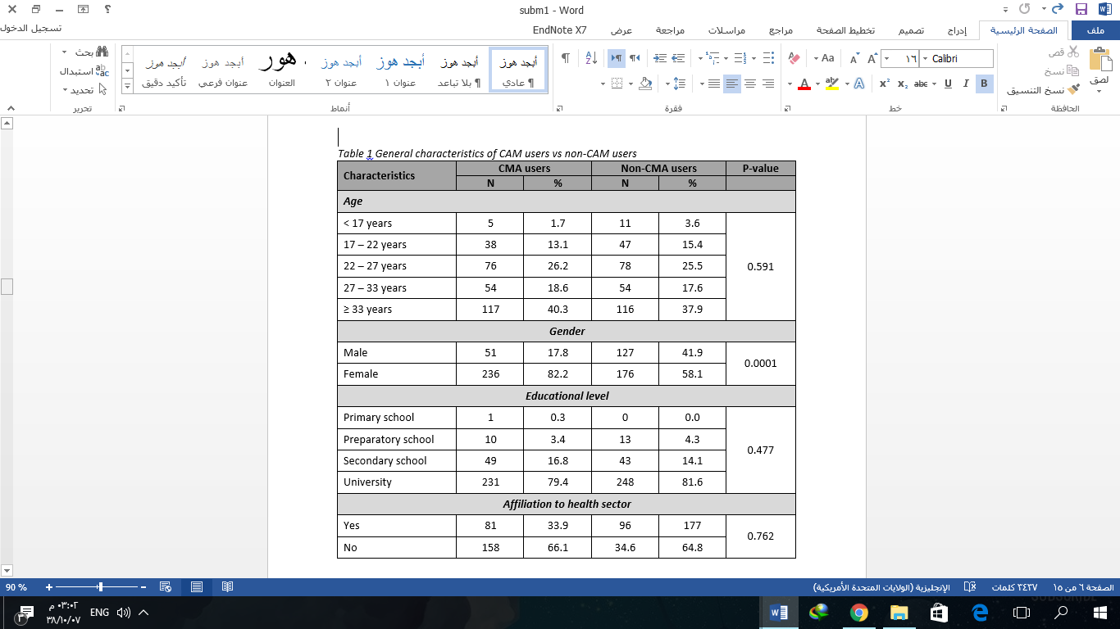
Recent Publications

- Al-Agha, A., & Alrefaie, S., & Ahmed, I., & El Derwi, D. Effect of Regular Physical Activity on Metabolic Control in Pediatric Age Group with Type 1 Diabetes Mellitus. Endocrinology & Metabolic Syndrome. 4:2 (2015). http://dx.doi.org/10.4172/2161-1017.1000174 .

 Biography
Sumayyah I Alrefaie has completed her MBBS in 2015 at the age of 24 years from King Abdulaziz University, recently is a teaching assistant at department of dermatology in King Abdulaziz University hospital in Jeddah. She is interested in dermatology researches and has done many researches before in different fields and specialties of medicine , some were presented at local conferences and other published in well-known journal.
Email: s.alrefaie@hotmail.com

Notes/Comments:

