Efficacy and safety of Terbinafine 500mg per day in patients with dermatomycoses: A retrospective survey
Dr Dhiraj Dhoot
Manager, Medical services, Glenmark Pharmaceuticals Ltd, India.
Abstract:
Statement of the problem:
Dermatomycoses are the most common fungal infections globally. Both, topical and systemic antifungals are used to treat dermatomycoses. However, recently, clinical failure and relapses have been observed with terbinafine in patients with dermatomycoses with increase in incidence of Terbinafine resistance in India. The principle reasons may include low plasma concentration and incomplete cure which are very common following 2 weeks therapy with 250mg/day of Terbinafine. Hence there was need for different treatment strategy while using terbinafine. We conducted this survey with the aim of evaluating the efficacy and safety of terbinafine 500mg/day in treatment of patients with dermatomycoses.
Materials and Methods:
It was a retrospective questionnaire based survey. Dermatologists involved in the management of superficial fungal infections and maintaining the patients’ clinical record were identified through “SCRIP intelligence” database. Each doctor was given survey questionnaire booklet containing survey forms. Clinical response was graded according to the improvement in the affected lesion. Mycological cure was defined as negative microscopy under KOH examination and a negative culture in Sabouraud’s dextrose agar. Patients were divided in to three groups depending on the duration of therapy, group A – Terbinafine 500mg for 2 weeks, group B – Terbinafine 500mg for 4 weeks and group C – Terbinafine 500mg for 6 weeks.
Result:
Total 50 doctors completed the survey involving 440 patients. In group A, out of 194 patients, 87% (n=169) patients showed very good response. In group B, out of 211 patients, 92% (n=194) of the patients showed very good response with >75% improvement in their lesion. In group C out of 35 patients, 80% (n=30) patients showed very good response (Fig. 1). ADRs of mild to moderate intensity related to Terbinafine were seen in 57 patients (Fig.2).
Conclusion:
Our survey indicates that terbinafine 500mg/day was efficacious and safe in the treatment of patients with dermatomycoses.

Fig. 1 – Efficacy - % of improvement in all groups
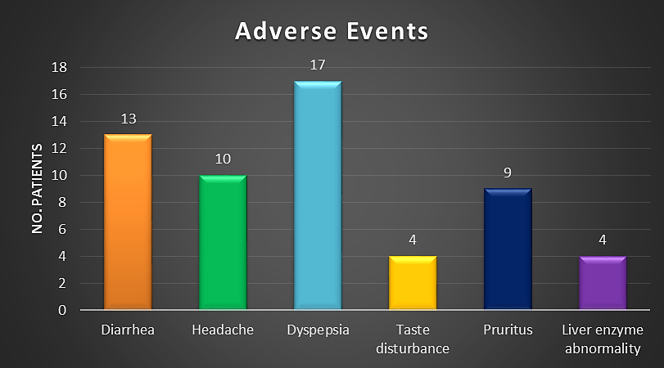
Fig. 2 – Safety – Adverse events

Dr. Dhiraj Dhoot is Manager, Medical Services in Glenmark Pharmaceuticals Ltd based in Mumbai in India. He heads all the divisions catering to dermatological and cosmoceuticals business in India. He had spent more than 4 years in Glenmark. He had done MD in Paediatrics.

