Title: PUVA - Induced Skin Cancer in Dark-Skin Patient, case report
Authors: Ahmed Aljaber¹, Youssef Binamer², MD, FRCPC, DABD, FAAD
Affiliations: ¹Medical intern, ²Consultant dermatology, King Faisal Specialist Hospital and Research Center, Riyadh, Saudi Arabia

Abstract: Non-melanoma skin cancer (NMSC) is the most common cancer worldwide. Many risk factors have been identified, e.g. Genetic factors, ethnicity, skin-type, and iatrogenic. The main iatrogenic causes are radiation and drugs, mainly immunosuppressive medications and oral Psoralen-Ultraviolet A (PUVA). It is well documented in literature that exposure to more than 250 sessions of oral PUVA can predispose to skin cancer. However, this was reported in patients with fair skin and was not reported in skin of color patients.
We are reporting to the best of our knowledge, for the first time a case of PUVA-induced basal cell carcinoma in a type-4 skin patient, after receiving 400 sessions.

Images:

Fig-1: Multiple nodules on arms (CTCL) with lentigines on trunk
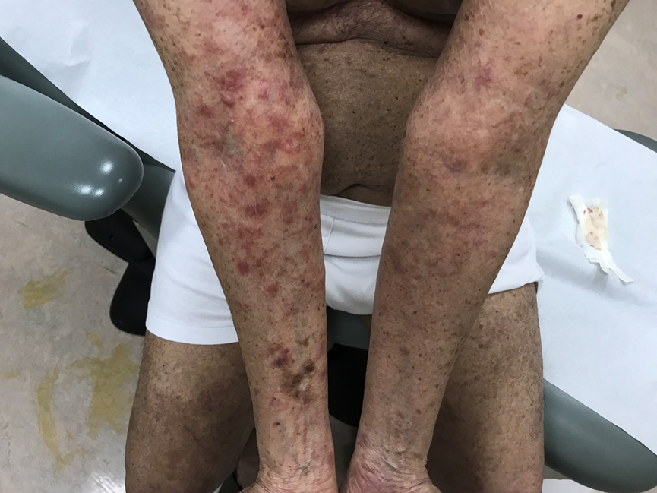

Fig-2: Multiple lentigines on trunk with basal cell carcinoma

