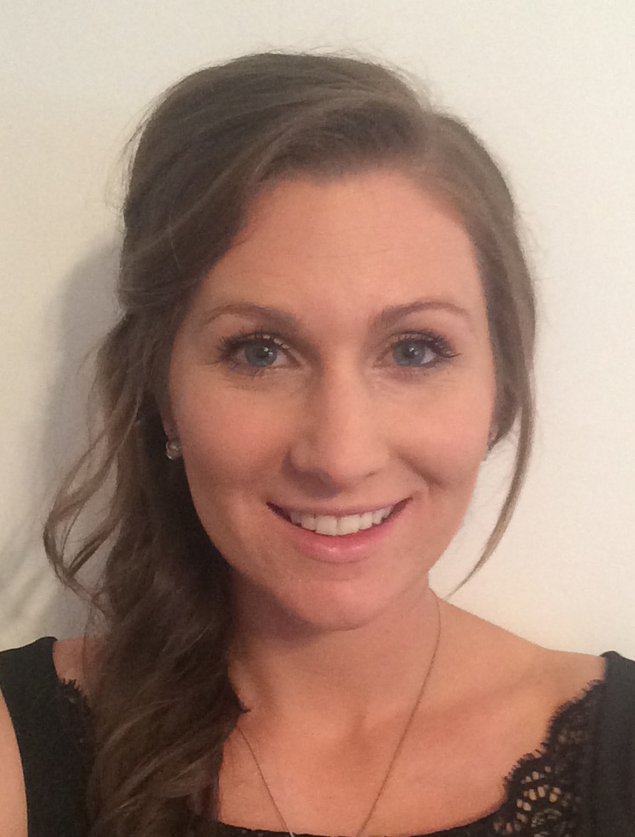

Title: Adequate completion of radiology request forms at Newcastle Dental Hospital. (A two-cycle audit)
Clare Lowe BSc BDS MFDS RCSed
Newcastle Dental Hospital, Newcastle-Upon-Tyne, United Kingdom

Objective: The usefulness of a radiological examination and its report can be reduced significantly if the clinical background and specific problem to be answered is not given in the request. Inadequate information can lead to mistakes in patient identification and delay in returning reports to the correct destination. The aim of this audit was to assess current request forms to determine if sufficient information was provided. The audit aims to ensure the quality of care provided to patients, and to identify ways to assist clinicians to provide adequate information when requesting a report.

Methods: Data was randomly collected from 53 patient records where a radiological request was made from the Oral Surgery department using the current request forms. Forms were analysed against eight criteria and recorded as either ‘criteria met’ or ‘criteria not me’. Data was recorded on a collection table and analysed to determine what percentage of radiology request forms could be deemed ‘adequate’, and when not, what were the failing criteria? A new form was then constructed considering the failings of the first cycle of data collection. The new radiology request form was then used for a period of 3 months and a second cycle of data collected.

Results: The first cycle of the audit revealed that 0% of request forms met the standard set, with 100% of forms omitting at least one of the criteria measured. Following the implementation of the redesigned form, the second cycle revealed that 70% of all forms met all criteria and could be deemed as adequate.

Conclusion: The new request form has dramatically improved the way the forms are completed. Marked improvement was noted in the information provided by clinicians on the new forms, showing that the new design helps to prompt clinicians to provide adequate information for reports to be generated.

Biography
Clare Lowe is currently in the first year of her Dental Core Training at Newcastle Dental Hospital. She graduated from the University of Aberdeen in June 2016 with a Bachelor of Dental Surgery degree, and then went on to complete the diploma of Membership to the Faculty of Dental Surgery of the Royal College of Surgeons of Edinburgh in November 2017.
Presenting author details
Full name: Clare Lowe
Contact number: (+44)7732784004
Session name/ number: Oral Surgery / Radiology
Category: Oral presentation/ Poster presentation

