Anterior loop connector fixed partial denture – a case report

Alok Dwivedi PhD, MDS, Faculty of Dentistry, Najran University, Kingdom of Saudi Arabia

Abstract
Replacement of anterior teeth with ridge defect and diastema is a complex challenging scenario with regards to prosthesis as well as esthetics. Different aesthetic treatment options such as implant supported restoration, conventional fixed partial denture and removable partial denture need be explored in treating such a patient. Problems posed may include drifting of teeth into edentulous areas which may reduce available pontic space, whereas diastema existing before an extraction may result in excessive mesiodistal dimension of pontic space. In such cases, loop connectors may be used to maintain the diastema in a planned fixed prosthesis. This article aims to describe the procedure for the fabrication of a loop connector fixed partial denture to restore an excessively wide anterior edentulous space in a patient with existing spacing between the maxillary anterior teeth.
Key words:

Anterior edentulous space, diastema, loop connector

IMAGES

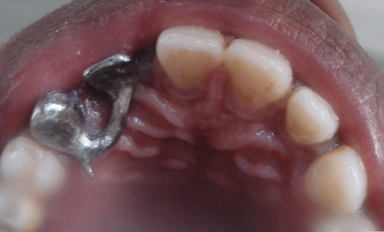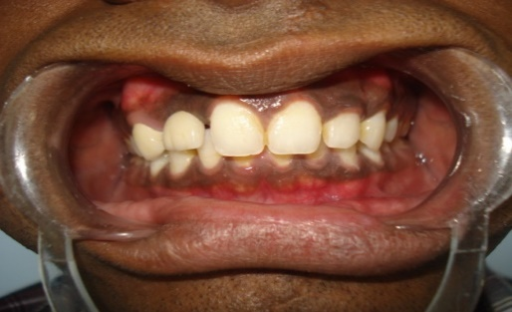

Recent Publications
- “Comparison of stress transmission’s characteristics of Ball and socket & short coping type over denture retainer designs under dynamic loading conditions’’june 2002, vol.2 In the journal of Indian prosthodontic society ( SPECIALITY JOURNAL )
- “Photoelastic Evaluation and Comparison of Stress Transmission characteristics of Two Different overdeture Retainer Designs Under Dynamic Loading Conditions. – An In Vitro Study, BhavNagar University’s Journal Of Dentistry, Vol 3,Issue 1 Dec-jan2013
- Comparison Of Flexural Strength of various autopolymerzing acrylic resins after microwave post polymerization treatment- An In Vitro Study Bhav Nagar University’s Journal Of Dentistry, Vol 3,Issue 1 Dec-jan 2013
- ’’Quantitative evaluation and comparison of stress transmission characteristics of of Bar-Clip and Short Coping overdenture retainer designs under dynamic condition’’ Journal of contemporary dental practice March-April 2013( PUB MED INDEXED )
- "Theories of Impression making and their rationale incomplete denture prosthodontics" Journal of Orofacial Reasearch, jan-march 2013, 3(1)

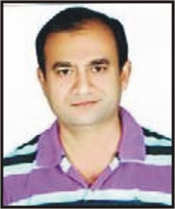

Dr. Alok Dwivedi has completed his PhD from Vir Bahadur Singh Purvanchal Vishvavidyalaya, JaunPur, India. MDS at the age of 28 years from Devi Ahilya Vishva Vidyalaya Indore (M.P.) India

He is currently working as senior lecturer in Faculty of Dentistry, Najran University, Saudi Arabia. He has

Published 10 papers in reputed journals and has been serving as a reviewer in journals of repute. He

has a vast experience in academics and clinical dentistry with a passion for research.
Email: at1970c@yahoo.co.in

Full name: Alok Dwivedi
Passport No-T9972192
Faculty of Dentistry, Najran University:
Designation: Senior Lecturer
Country: Saudi Arabia
Mobile number +966550904375
Email: at1970c@yahoo.co.in
Category- Oral Presentation

