Clinical evaluation of air polishing with erythritol powder followed by ultrasonic calculus removal versus conventional ultrasonic debridement and rubber cup polishing for the treatment of gingivitis: A split-mouth randomized controlled clinical trial

Magda Mensi, Section of Periodontics, School of Dentistry, Department of Surgical
Specialties, Radiological Science and Public Health, University of Brescia, Brescia, Italy
U.O.C. Odontostomatologia – ASST degli Spedali Civili di Brescia, Brescia, Italy

Eleonora Scotti Section of Periodontics, School of Dentistry, Department of Surgical
Specialties, Radiological Science and Public Health, University of Brescia, Brescia, Italy
U.O.C. Odontostomatologia – ASST degli Spedali Civili di Brescia, Brescia, Italy

Annamaria Sordillo Section of Periodontics, School of Dentistry, Department of Surgical
Specialties, Radiological Science and Public Health, University of Brescia, Brescia, Italy

Matteo Dalè Section of Periodontics, School of Dentistry, Department of Surgical
Specialties, Radiological Science and Public Health, University of Brescia, Brescia, Italy

Stefano Calza Department of Molecular and Translational Medicine, University of Brescia, Brescia, Italy

Abstract

Gingivitis represent one of the most common pathology about oral soft tissue due to biofilm accumulation [1]. Mechanical biofilm removal is the key treatment for gingivitis. Traditional protocol involve manual and mechanical instrument, followed by polishing with rubber cup and abrasive paste [2]. Currently, air polishing with eritritoli powder can be a suitable option for plaque removal, with higher comfort and saving time [3]. Plaque disclosing agents can help patients and clinician to remove biofilm efficiently, especially in areas of difficult access [4]. For research purposes, plaque disclosing can also be used for photography software analysis and computer plaque quantification [5]. Recently, a new protocol has been introduced, involving a plaque disclosing agent and air polishing with erythritol powder for biofilm removal, followed by site-specific ultrasonic instrumentation for calculus removal. This protocol is known as Guided Biofilm Therapy® (GBT). The aim of the study was to evaluate the efficacy of air polishing followed by ultrasonic calculus removal (A+US) for the resolution of gingivitis in terms of reduction in bleeding on probing (BoP) at 2 and 4 weeks,
compared with conventional full-mouth ultrasonic debridement followed by rubber cup with abrasive paste (US+P). Secondary aims were the evaluation of Residual Plaque Areas (RPA), treatment time and patient comfort/satisfaction, and plaque index change at 2 and 4 weeks. Both treatments showed a significant reduction in BoP and PI. At 4 weeks, A+US seems to reach a statistically significant lower BoP (8.7% [6.9;10.9] vs. 11.6% [9.3;14.4], p < 0.0001) and PI (10.7% [8.9; 13.0] vs. 12.3% [10.2; 14.9], p=0.033). Moreover, A+US treatment time lasted on average 9.2% less than US+P (p < 0.0001) and was the preferred treatment for a significantly higher number of patients (73.2% vs. 17.1%, p=0.0001).
Images

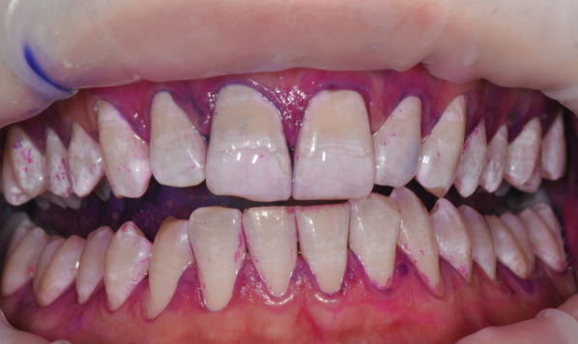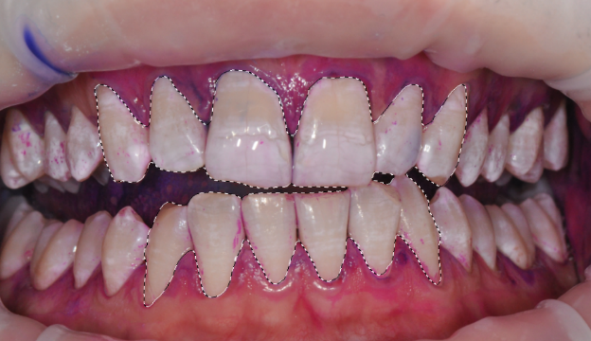
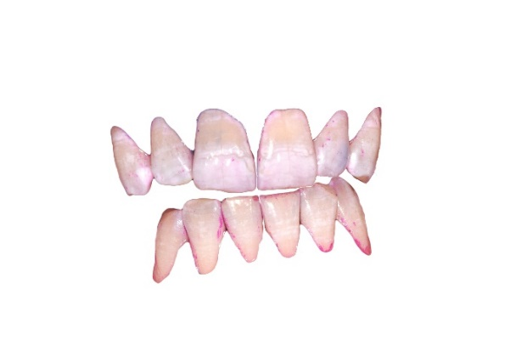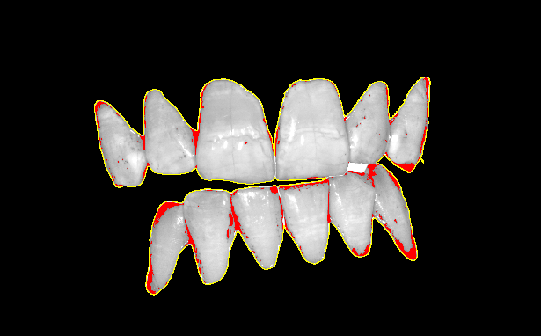

Figure 1: The clinical image(A) was uploaded on a drawing tablet, and the clinical crowns were selected. The cropped selections(B) were transferred to ImageJ software, and converted into RGB stacks (C). Through colour threshold function,the grey shades corresponding to the disclosing agent were selected (D), and the RPA was calculated.

Publication

1 Chapple ILC, Van der Weijden F, Doerfer C, et al. Primary prevention of periodontitis: managing gingivitis. J Clin Periodontol. 2015;42 (Suppl. 16):S71-S76. https://doi.org/10.1111/jcpe.12366
2 Kumar P, Das SJ, SonowalST, ChawlaJ. Comparison of Root Surface Roughness Produced By Hand Instruments and Ultrasonic Scalers: An In vitro Study. J Clin Diagn Res. 2015;9(11):ZC56-ZC60.https://doi.org/10.7860/JCDR/2015/13744.6828
3 Müller N, Moëne R, Cancela JA, Mombelli A. Subgingival airpolishing with erythritol during periodontal maintenance: randomized clinical trial of twelve months. J Clin Periodontol.
2014;41(9):883-889. https://doi.org/10.1111/jcpe.12289
4 Mensi M, Scotti E, Sordillo A, Agosti R, Calza S. Plaque disclosing
agent as a guide for professional biofilm removal: A randomized controlled clinical trial. Int J Dent Hyg. 2020;18(3):285-294.https://doi.org/10.1111/idh.12442
5 Smith RN, Rawlinson A, Lath D, Elcock C, Walsh TF, Brook AH. Quantification of dental plaque on lingual toothsurfacesusingimageanalysis: reliability and validation. J Clin Periodontol. 2004;31(7):569-573. https://doi.org/10.1111/j.1600-051X.2004.00523.x

Biography
Matteo Dalè is a dentist who collaborates with Dr. Magda Mensi in Section of periodontics, School of Dentistry in University of Brescia. From the beginning he finalized his studies in the use of the GBT method, applied both in professional field and for research studies.

Email: matteo.dale1993@gmail.com

