FRAME IT - Workshop 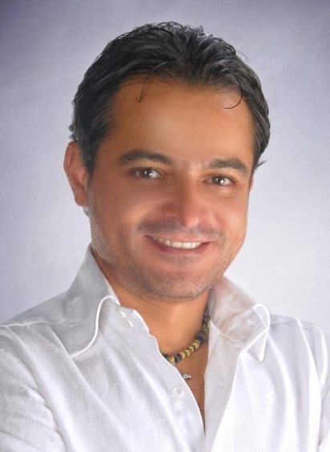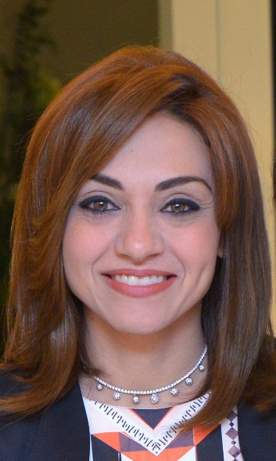
Dr. Malak Nagi*
Dentist, Alexandria, Egypt
Dr. Mai Ramadan
Dermatologist, Alexandria, Egypt
As a dentist you must keep in mind that you are creating a piece of art with each case you are treating. Frame it is a course that gives you the fundamental keys for creating a beautiful frame for your patients’ teeth using Botulinum Toxin A and dermal fillers. The course will cover several topics including; facial anatomy for various cosmetic applications, Botulinum Toxin A (mechanism of action, proper storage, preparation, indications, contraindications, precautions for use, proper management of complications and injection techniques), dermal fillers (characteristics of various fillers available in the market and pain management options), Hyaluronic acid filling agents (indications, contraindications, precautions for use, proper management of complications and injection techniques), as well as the role of Golden Ratio in facial esthetics. By the end of the course, the participant should be able to manage basic cases that need a fine touch to reach optimal esthetic results.

Biography
Malak Nagi has completed his BSc in Dental Medicine and Oral Surgery at 1995 from Alexandria University and DDS in Pedodontics at 1998 from Alexandria University, Egypt. He is the owner of Malak Nagi Dental Clinic in Alexandria. He is a board member of Alexandria Oral Implantology Association and International College of Dentists “Region 29”. He is a lecturer in facial esthetics “botox & fillers”. Mai Ramadan has completed her BSc in Medicine at 2003 from Alexandria University and MSc in Dermatology at 2010 from Alexandria University, Egypt. She is the owner of Royal Cosmetic Center in Alexandria. She is a member of the European, Egyptian and Alexandria Societies of Dermatology and Venereology. She is also a lecturer in facial esthetics “botox & fillers”. Both have presented “FRAME IT” Workshop together in Stars Meeting 2016 and Dubai Implantarium 2016.
Corresponding author details*
Full name: Malak Nagi Zaki Guirguis
Contact number: +20 1002320006
Email: malaknagi@gmail.com
Category: Oral presentation and Live demonstration on patient

