
TITLE: PERIODONTITIS AND CANCER: DOES A LINK EXIST?
AUTHOR AND SPEAKER - MR KISHAN M SHETH
KING’S COLLEGE LONDON DENTAL SCHOOL, LONDON, UK
ABSTRACT FOR ORAL PRESENTATION

ABSTRACT:
The purpose of this presentation is to carefully analyse the research findings to date regarding a potential link between periodontitis and carcinogenesis; evaluate, critically review and explore the variety of potential study confounders and study criteria differences which suppress the accuracy and validity of the relationship claims being made; gain an appreciation of the biological plausibility of mechanisms which could be underpinning the relationship between the two diseases; and finally to conclude whether the current level, findings and quality of research is accurate in supporting the existence of the periodontitis – cancer link. I will assess the potential link between periodontitis and several cancerous tumour types, and analyse the evidence regarding the biological plausibility for the potential association between periodontitis and cancer.

The strongest association is present between periodontitis and oral cancer since each of the three studies looked into show a statistical link between both diseases.

The International burden of cancer has risen every year, a trend that has been paralleled by the increase in periodontitis cases. Research undertaken by GLOBOCAN (2012) states there were 7.6 million global cancer cases in 2008, and in 2012 there were 14.1 million global cancer cases, an increase of 84%. Although there is a lack of recent statistical data related to periodontitis cases, between the years 1997 and 2005, there was an increase of 27% of adults aged between 35 and 44 who had periodontal pocket depths greater or equal to 4 millimetres (Dye, 2012).

RELEVANT BIOLOGICAL PLAUSABILITY OF THE PROPOSED DISEASE RELATIONSHIP:
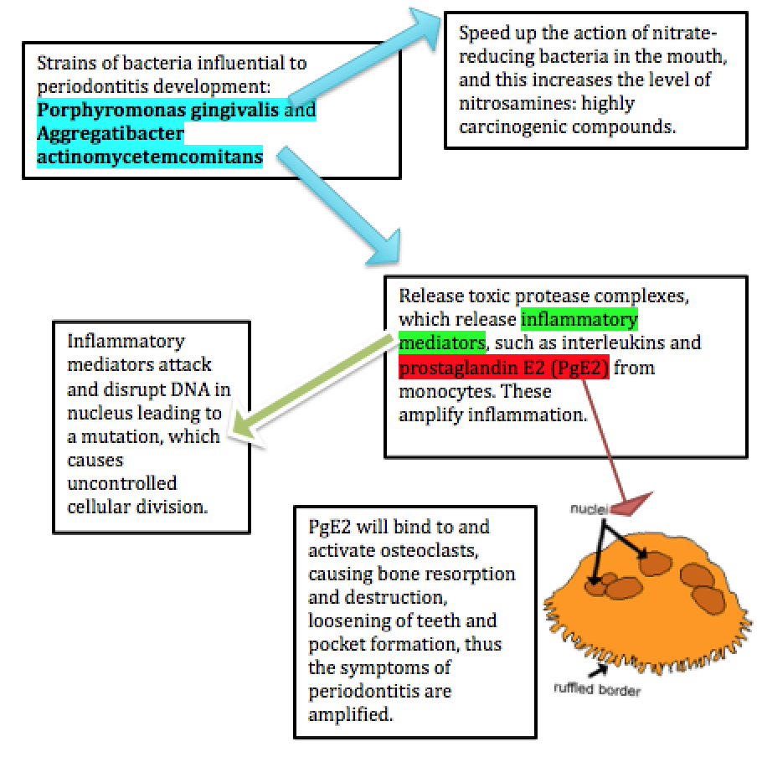

SPEAKER BIOGRAPHY:

Kishan has published in several internationally renowned dental magazines, as well as having recently been accepted into his first international peer reviewed journal, the Journal of Dental Health, Oral Disorders and Therapy. He has presented work at 2 national conferences and has also lectured alongside PhD level students in the past for the London Materials' Society on the topic of MI dentistry. He was recently asked to give interviews for the British Dental Journal and Dental Town. Over the past two years, he has been working on a publication with Dr. Mandeep Ghuman entitled 'Periodontitis and Cancer: is there a link?' Aside from dentistry, he is a choreographer and lead dancer for the London based Shri Academy of Dance, as well as being a senior partner. He loves dancing and acting and has co-choreographed for the Diwali Show for two years running!

ADDITIONAL DETAILS:

Full name – Kishan Sheth
Contact number – 07903584600
Session name – Periodontitis and Cancer: is there a link? An evidence based account and analysis of the research so far
Linkedin account - https://uk.linkedin.com/in/kishan-sheth-b7241297
Category – oral presentation (poster available too)

Previous publications:
Sheth K (2014), Stress in Dentistry, European Dental Students’ Association publication, 13-15
Sheth K (2015), Pressures facing Dentists – stress management – what’s all the fuss about? Dental Town, 18-20
Sheth K, Patel A, Sharma S (2015), Periodontal systemic effects, King’s Crown, 5-7
Quinlin K, Sheth K (2016), the Dancing Dentist, British Dental Journal, 22-24
Sheth K (2016), Antibiotics will be the death of modern medicine, Journal of Dental Health, Oral Disorders and Therapy
Sheth K (2014), Ethical selling in Dentistry, King’s Crown, 12-15

