
Title: Case Report: Type V Cardiorenal Syndrome complicating a progressive wild-type transthyretin amyloidosis (ATTRwt)
Author Names: Shaun Khanna, Henry Chen, Aditya Bhat, Kum Wah Ho, Winny Varikatt, Gary Gan
Blacktown Hospital, NSW, Australia
Systemic amyloidosis is a disease that causes extracellular deposition of misassembled proteins in various organs causing dysfunction. Wild-type Transthyretin amyloidosis (ATTRwt) accounts for 18% of all cases of cardiac amyloidosis.
We describe a case of a 73-year-old African gentleman who frequently presented to our facility with recurrent episodes of CCF. There was progressive deterioration noted in his left ventricular systolic function and worsening diastolic dysfunction (E’E of 18) leading to a RV biopsy. The biopsy results revealed the diagnosis of cardiac amyloid disease with typical apple green birefringence under polarized light. See Figure 1. He was followed up in haematology clinic and diagnosed with ATTRwt amyloidosis.
He has multiple other comorbidites including of VT arrest requiring AICD insertion, atrial arrhythmias, cirrhosis, portal hypertension complicated by recurrent ascites and chronic kidney disease (secondary to Type V Cardio Renal Syndrome). During his last admission, he was inotrope dependant which unfortunately failed to improve his renal function, subsequently becoming anuric (Cr 643 umol/L) with uremic complications. He passed away within weeks of this episode.
Cardiac Amyloidosis carries a significant heart failure and arrhythmia burden, with a median survival of 13 months. Echocardiograph typically showed concentric wall thickening and abnormal myocardial sparkling texture. See Figure 2. Definitive diagnosis remains via endomyocardial biopsy. Type 5 Cardio-renal syndrome is a poorly understood entity that further worsens the prognosis in these patients. Further studies are required in both ATTRwt and CRS to improve morbidity and mortality.
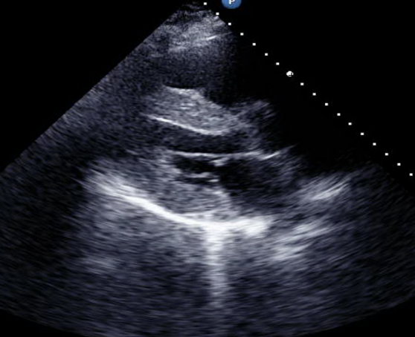
Biography
Dr. Shaun Khanna has completed his MBBS in 2016 from Bond University and is currently completing his Master of Medicine (Advanced) with the University of Sydney. He has a current appointment with Blacktown Hospital as a medical officer and as a conjoint lecturer with the University of Western Sydney. He is heavily involved in research with interests in arrhythmias and cardiovascular imaging.

Presenting author details
Full name: Shaun Khanna
Contact number: (+61) 401852696
Email: shaunkhanna@hotmail.com
Session name: World Cardiology Summit 2019: Feb 28-March 01, 2019. Osaka Japan
Category: E-Poster Presentation

