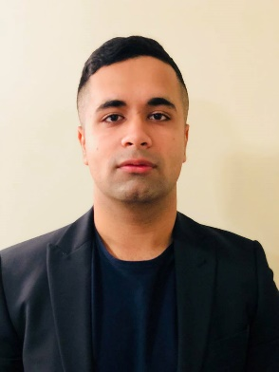
Title: A rare but life threatening cause of syncope
Authors: Shaun Khanna, Kartheek Garikapati, Henry Chen, Aditya Bhat, Gary Gan
Blacktown Hospital, NSW, Australia
Left Ventricular non-compaction (LVNC) is rarely seen in the clinical setting with prevalence described as affecting approximately 8 – 12 patients per million per year.
Here, we explore a case of a 63-year-old gentleman who presented to our facility after a cardiac syncope. His examination and ECG were completely normal. Other investigations; CT Brain, MRI DWI, EEG and CT Coronary Angiogram (CTCA) were all normal as well. He subsequently had a transthoracic echocardiogram (TTE) which showed normal left cavity size with mild impaired systolic function and marked LVH with anteroseptal hypokinesis.
The patient subsequently had an inpatient cardiac MRI done to delineate a cause of the syncope. The results of the Cardiac MRI indicated regional left ventricular non-compaction in the mid-distal lateral wall and apex, with the greatest ratio of non-compacted to compacted myocardium (NC:C): 4.3. See Figure 1 & 2.
The patient’s syncope was considered arrhythmogenic and hence went on to have an automated implantable cardioverter-defibrillator (AICD) insertion for primary prevention. The patient was subsequently discharged with outpatient follow-up with a Cardiac Geneticist.
LVNC is a congenital cardiomyopathy results in a spongy myocardium and deep trabeculations in the myocardial wall. Echocardiographic criterias developed by Chin, Jenni and Stöllberger, assess trabeculations, LV wall thickness and NC:C ratio of >2: 1. Peterson has described diagnosis of LVNC using CMR. The ratio of noncompacted myocardium to compacted myocardium during diastole should be greater than 2.3 (sensitivity of 86% and specificity of 99%).
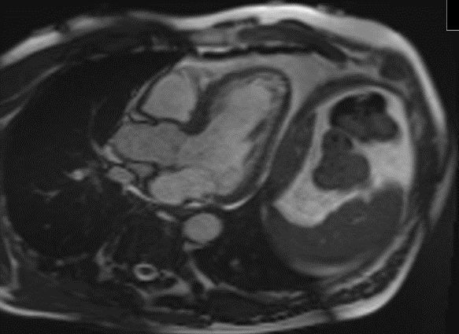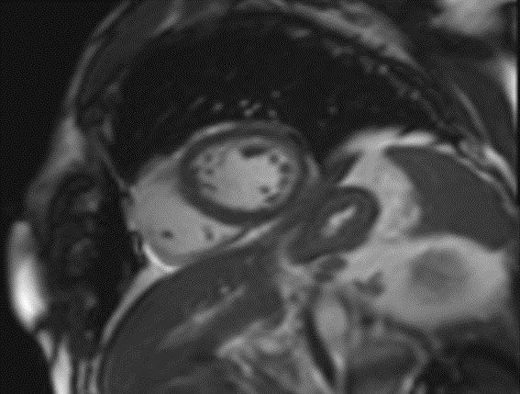

Biography
Dr. Shaun Khanna has completed his MBBS in 2016 from Bond University and is currently completing his Master of Medicine (Advanced) with the University of Sydney. He has a current appointment with Blacktown Hospital as a medical officer and as a conjoint lecturer with the University of Western Sydney. He is heavily involved in research with interests in arrhythmias and cardiovascular imaging.

Presenting author details
Full name: Shaun Khanna
Contact number: (+61) 401852696
Email: shaunkhanna@hotmail.com
Session name: World Cardiology Summit 2019 – Feb 28-March 01 2019 Osaka Japan
Category: E-Poster Presentation

