A Case of Congenitally Corrected Transposition of Great Arteries in a Young Adult Filipino
Cristina Tabucan, MD, Ospital ng Makati, Philippines

We described a 20-year old Filipino male who came in at the emergency room presenting with dyspnea. He was previously asymptomatic, with no limitations in physical activity until three months prior to admission, he started to experience progressive dyspnea. Chest radiograph showed biventricularly enlarged heart with accentuated pulmonary vascular markings. A 12 lead electrocardiogram showed multifocal tachycardia, biatrial enlargement, left ventricular hypertrophy and PACs. A transthoracic 2D echocadiogram revealed that the aorta arises from the morphological right ventricle and the pulmonic trunk arises from the morphologic left ventricle. The systemic right ventricle was dilated and the ejection fraction preserved with good wall motion and function. A large ventriculoseptal defect was seen. A cardiac CT angiogram was done and confirmed the diagnosis. Our case was diagnosed with acute decompensated heart failure secondary to congenitally corrected transposition of great arteries. Transposition of Great Arteries (TGA) is the second most common cyanotic congenital heart disease. However its rare form known as congenitally corrected transposition of great arteries (cc-TGA) occurs only in 1:33,000 of population who can reach adulthood acyanotic despite unrepaired state. In the Philippines, its occurrence remains underreported and to date, case study regarding cc-TGA has not been published. Loop diuretics, aldosterone antagonist, beta blockers and digitalis glycoside were the medications used to control symptoms of our patient. Long term complication of unrepaired TGA often presents as heart failure due to volume overload, arrhythmia due to enlarged chambers, early onset stroke, infection and myocardial infarction due to rhythm disorders and inflammation.
Preventive management of complications using diuretics, beta blockers, anticoagulation are among the identified goals of treatment. Definitive management is still surgical correction which requires timely intervention in order to prevent long term
complications of the disease.
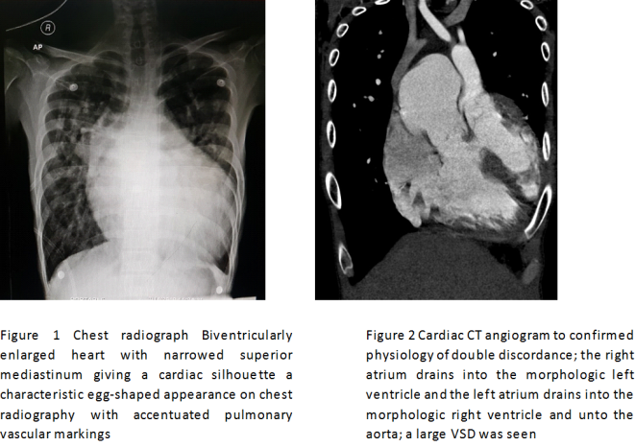

Presenting author details
Full name: CRISTINA S. TABUCAN, MD, MPM-HSD
Contact number: +639 988 0575
Twitter account @CristinaTabucan
Session name/ number:
Category: (Oral presentation)

Biography


Cristina Tabucan is a second year medical resident from Ospital ng Makati under the Department of Internal Medicine. She finished her Doctor of Medicine at Pamantantasan ng Lungsod ng Maynila. She took her Master in Public Health Major in Systems Development at the Development Academy of the Philippines. Her expertise and interest in the field of Cardiology was rooted from her previous experience as a Doctor to Barrio serving rural area and urban poor communities. Her passion to learn as well as inquisitiveness is an important asset in helping different stakeholders from the grassroots.
She is interested in pursuing career in Cardiology post medical residency training in order to bring back service to the community especially to the doctorless rural communities in her province.

