A case of congenitally corrected transposition of great arteries in a young adult Filipino
Cristina Tabucan, MD, Ospital ng Makati
J. Bernardo, MD, F. Cuenca, MD, Ospital ng Makati

We described a 20-year old Filipino male who came in at the emergency room presenting with dyspnea. He was previously asymptomatic, with no limitations in physical activity until three months prior to admission, he started to experience progressive dyspnea. Chest radiograph showed biventricularly enlarged heart with accentuated pulmonary vascular markings. A 12 lead electrocardiogram showed multifocal tachycardia, biatrial enlargement, left ventricular hypertrophy and PACs. A transthoracic 2D echocadiogram revealed that the aorta arises from the morphological right ventricle and the pulmonic trunk arises from the morphologic left ventricle. The systemic right ventricle was dilated and the ejection fraction preserved with good wall motion and function. A large ventriculoseptal defect was seen. A cardiac CT angiogram was done and confirmed the diagnosis. Our case was diagnosed with acute decompensated heart failure secondary to congenitally corrected transposition of great arteries. Transposition of Great Arteries (TGA) is the second most common cyanotic congenital heart disease. However its rare form known as congenitally corrected transposition of great arteries (cc-TGA) occurs only in 1:33,000 of population who can reach adulthood acyanotic despite unrepaired state. In the Philippines, its occurrence remains underreported and to date, case study regarding cc-TGA has not been published. Loop diuretics, aldosterone antagonist, beta blockers and digitalis glycoside were the medications used to control symptoms of our patient. Long term complication of unrepaired TGA often presents as heart failure due to volume overload, arrhythmia due to enlarged chambers, early onset stroke, infection and myocardial infarction due to rhythm disorders and inflammation.

Preventive management of complications using diuretics, beta blockers, anticoagulation are among the identified goals of treatment. Definitive management is still surgical correction which requires timely intervention in order to prevent long term complications of the disease.
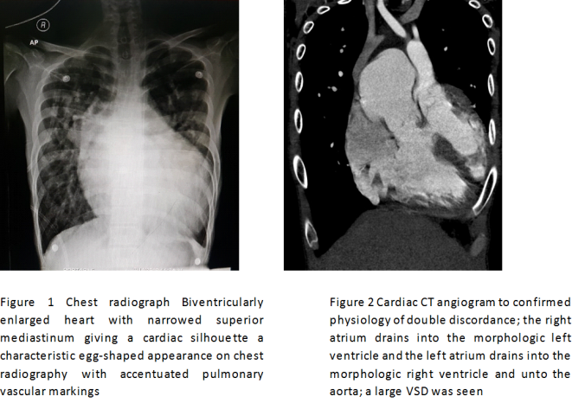

Filippov, A. et al (2016) Management of Systemic Right Ventricular Failure in Patients with Congenitally Corrected Transposition of the Great Arteries. American Heart Association, Inc. Circulation. 134:1293–1302

FusterV, et al. ACC/AHA/ ESC Guidelines for management of patients with atrial fibrillation. American College of Cardiology. 2001; 38: 1266

Jara, R and Anonuevo Philippine General Hospital Patched” Adult Congenital Heart Disease” 2nd edition. 2016. PGH

Kasper et al, Harrison’s Principle of Internal Medicine 19th edition. Mc Graw Gill Publishing. 2016

Mann et al. Braunwald’s Heart Disease 10th Edition A textbok of Cardiovascular Medicine. Elsevier Saunders. 2015

