Recurrent third-trimester abortion in a young female: Rare presentation of Mid-aortic syndrome.

Aniket Patil¹, Mehak Trikha², Vaibhav Patil³, Dinesh C. Gupta⁴

1-Junior Resident, department of Medicine, D Y Patil Hospital & Medical College, Navi Mumbai

2-Junior Resident, department of Medicine, D Y Patil Hospital & Medical College, Navi Mumbai

³⁻

4- Professor, department of Medicine, D Y Patil Hospital & Medical Collge, Navi Mumbai.

Abstract
A 26 year old multigravida female had a three pregnancies complicated by hypertensive disease requiring meticulous evaluation of the same. Mid-aortic syndrome secondary to non specific aorto arteritis was diagnosed when hypertension persisted postpartum. She was treated successfully with aorto stent graft. Due to the chronicity of the changes the patient did not require medical management.

Key Words: abortion,hypertension, mid aortic syndrome, pregnancy, stent,

Introduction
The mid-aortic syndrome is a clinical condition generated by segmental narrowing of the abdominal or descending thoracic aorta. It might be either a congenital abnormality in the development of aorta or one of several acquired conditions such as infection, obliterative panarteritis, neurofibromatosis, retroperitoneal fibrosis, fibromuscular dysplasia, mucopolysaccharidosis and Takayasu's arteritis. We are presenting a case of 26-years old female with recuurent abortions and hypertension during the onset of pregnancy and unrecognized before the gestation middle aortic syndrome.The patient was diagnosed with MAS secondary to nonspecific aortoarteritis on the basis of clinical, radiological diagnosis. Because of rarity of this syndrome, only ridiculous evidence exists with regard to the treatment. Single cases of surgery and interventional treatment with stent-graft placement have been reported, as well as good outcomes with only medical management. She had successful endovascular mid-aortic syndrome repaired with CP covered stent. The blood pressure decreased from 180/100 mmHg to 130/80 mmHg after the procedure.

.

Case Report
A 26-year-old female presented to D Y Patil hospital with the chief complaints of bilateral lower limb claudication with decreasing claudication distance for the past 10 months. There was history of pregnancy induced hypertension and two consecutive abortions in the third trimester. The third pregnancy was terminated with the diagnosis of non specific aortoarteritis. There was no history of fever, breathlessness, bleeding, transient visual obscurations, syncopal attacks, postprandial abdominal pain, lower limb ulcers, Raynaud's phenomenon, alopecia, or photosensitivity

On admission, she was afebrile, had tachycardia with a pulse rate of 90 beats per minute. Her right and left brachial blood pressures was 180/100 mmHg. Her lower limb blood pressure was not recordable. There was a bruit heard over the abdomen. There were feeble bilateral femoral pulses. Popliteal, dorsalis pedis, and posterior interosseus pulses were absent. The skin examination was normal. Her fundus examination was insignificant. Neurological examination was normal.
Laboratory investigations showed following results: Complete blood count, liver, renal function tests, random blood sugar, and urinalysis were normal. The Westergen erythrocyte sedimentation rate (ESR) was raised with normal CRP level. Her serum was negative for rheumatoid factor, antinuclear factors, anti-phospholipid antibodies, and antineutrophil cytoplasmic antibodies. Hypercoagulable workup did not reveal factor v Leiden. Protein C, Protein S, and antithrombin three levels were normal. No prothrombin gene mutation was detected. The complement factors C3 and C4 were normal. The hepatitis B antigen, HIV, and venereal disease research laboratory was negative. The tuberculin skin test was negative. Thyroid function test and coagulation profile were normal. Chest radiography and echocardiography were normal. Renal Doppler showed patent arteries with turbulent blood flow of low velocity reading, Ultrasonography of abdomen, and pelvis showed diffuse narrowing of the aorta at the level of superior mesenteric artery. Computed tomography (CT) angiography of the great vessels revealed critical narrowing narrowing of upper abdominal aorta with post post stenotic dilatation suggestive of mid aortic syndrome. PET-CT scan revealed no abnormal activity at thr site of narrowing of aorta, to suggest any active inflammatory pathology. There was no significant metabolically active disease seen elsewhere in the body.
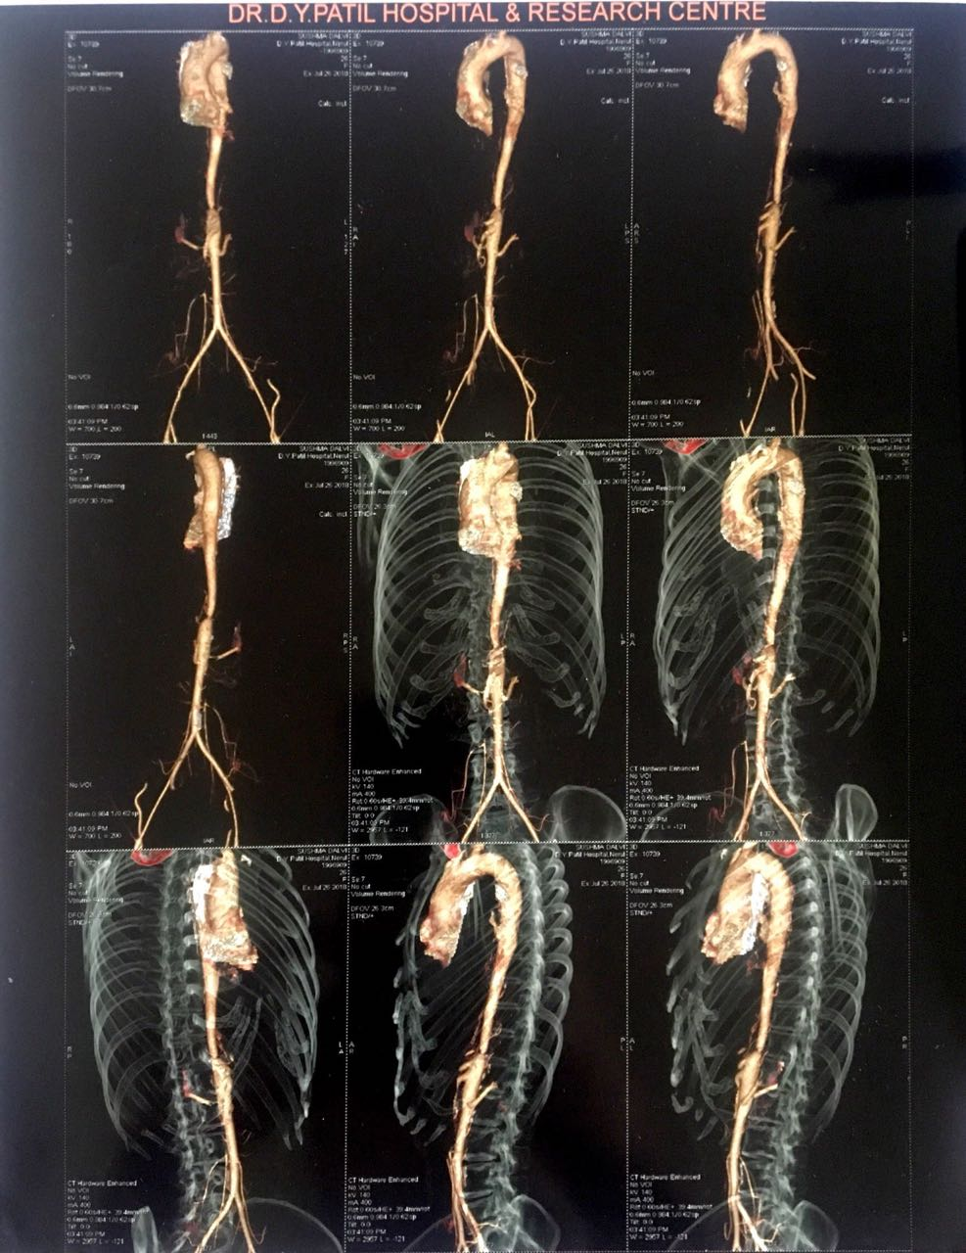

Figure 1
CT angiogram showing narrowing of the abdominal aorta.

Figure 2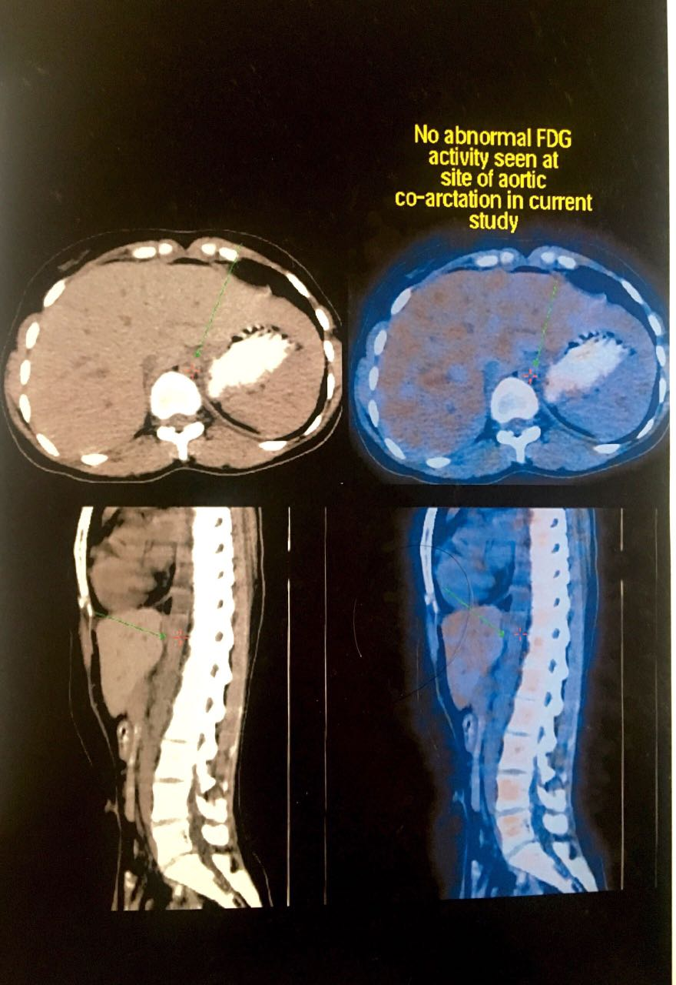

The patient was taken up for dilatation and stenting of the abdominal aorta following which the patient is doing fine. Her lower limb pulses are well felt. Blodd pressure is 120/80mmHg and does not require antihypertensives.

Discussion
The middle aortic syndrome (MAS) is an uncommon lesion characterized by severe aortic narrowing in the descending thoracic aorta, abdominal aorta, or both.[1,2] MAS was first described by Sen et al. in 1963.[5] Although the etiology of MAS is not well known, congenital, inflammation, developmental disorder, and infection are thought to be some of the causes.[1,5] The disease is an important cause of hypertension in children and young adults and is associated with a high morbidity and mortality. It typically presents as severe hypertension in young patients who have weak or absent femoral pulses and an abdominal or lower back bruit.[4,5,6] MAS has been described in Takayasu arteritis, fibromuscular dysplasia, a number of genetic diseases, such as neurofibromatosis, mucopolysaccharidosis, Williams syndrome, Turner syndrome, Alagille syndrome, and congenital rubella syndrome.[4,6]
The diagnosis of this rare syndrome is made by computed tomography, magnetic resonance imaging, or angiography.[6]
Non-specific aortoarteritis (NSAA) also known as Takayasu’s arteritis is a chronic, autoimmune, and potentially progressive inflammatory disease of large vessels with a preference for the aorta and its major branches.[3] It was first described in Japan in the mid 20th century and has subsequently become a specific established entity, particularly with improved diagnostic facilities, interventional modalities and cardiovascular surgical techniques.
Females are affected in 80–90% of patients with NSAA, mostly in the second and third decades of life. Early diagnosis with proper medical or surgical management is essential for good prognosis Since 1980, percutaneous transluminal angioplasty has been used for treating these vascular lesions, the most common indication being uncontrolled hypertension with angiographic evidence of stenosis and pressure gradients. The incidence of major complications is around 3-13 %. Failure is often due to unfavourable angiographic morphology. Restenosis is frequently observed and it mostly occurs in patients with residual stenosis and pressure gradients [7]
Causes of recurrent fetal losses include genetic factors, endocrine causes, autoimmune disorders such as antiphospholipid antibody syndrome and uterine causes. MAS has rarely been reported as an etiologic risk factor for recurrent fetal losses. Pistorius et al. reported a case of an isolated aortoilliac TA where a 30-year-old woman had acute limb ischemia complicated by second trimester abortion. Subsequently, the woman was found to have aortoiliac Takayasu disease.[8]
Pregnancy as such has no effect on the evolution of the disease;however, its peak incidence is in second and third trimesters. Thus, such patients warrant special attention during the peripartum period owing to the likelihood of development of complications such as hypertension, multiple organ dysfunction, and stenosis hindering regional blood flow leading to restricted intrauterine fetal growth and low birth weight in babies [9–11]. Delay in diagnosis is quite common, so patients often conceive without prior knowledge of having NSAA, or having initiated specific treatment against it [7]. Ideal management for pregnant patients with this disease still poses a stringent challenge, especially in the light of movement towards multicentric LVV research across the world, coupled with the recent availability of levitating pool of targeted drugs. An interdisciplinary collaboration of obstetricians, cardiologists, rheumatologists, and neurologists is often necessitated for an optimal maternal and fetal prognosis.

Our case is unique in the sense that Mid aortic syndrome was due to nonspecific aortoarteritis manisfesting as recurrent abortions and PIH. She was managed with surgical intervention. NSAA not requiring streroid therapy is a rare presentation. Hence surgical management without medical therapy is instituted in chronic NSAA with successful results.

CONCLUSION.
MAS is a rare cause of uncontrolled hypertension with poor outcome if left untreated. Surgical correction is both feasible and effective in MAS. There is a need to promptly and correctly diagnose uncontrolled hypertension in young adults.
Pregnancy with MAS presents as an onerous medical condition which has to be diagnosed and managed meticulously.

Conflicts of interest
There are no conflicts of interest.

References
1. Uwabe K, Okada O, Harada M. Ascending to descending aorta bypass for middle aortic syndrome. Circ J. 2007;71:1162–3. [PubMed]
2. Sen PK, KInare SG, Engineer SD, Parulkar GB. The middle aortic syndrome. Br Heart J. 1963;25:610–8. [PMC free article] [PubMed]
3. Saab F, Giugliano RP, Giugliano GR. Takayasu arteritis in a young woman: A 4-year case history. Tex Heart Inst J. 2009;36:470–4. [PMC free article] [PubMed]

4. Uwabe K, Okada O, Harada M. Ascending to descending aorta bypass for middle aortic syndrome. Circ J. 2007;71:1162–3. [PubMed]
5. Sen PK, KInare SG, Engineer SD, Parulkar GB. The middle aortic syndrome. Br Heart J. 1963;25:610–8. [PMC free article] [PubMed]
6. Alehan D, Kafali G, Demircin M. Middle aortic syndrome as a cause of dilated cardiomyopathy. Anadolu Kardiyol Derg. 2004;4:178–80. [PubMed]
[7] A. P. L. Assad, T. F. Da Silva, E. Bonfa, and R. M. R. Pereira, “Maternal and neonatal outcomes in 89 patients with Takayasu Arteritis (TA): comparison before and after the TA diagnosis,” The Journal of Rheumatology, vol. 42, no. 10, pp. 1861–1864, 2015
8. Pistorius MA, Jego P, Sagan C, Noel S, Dupas B, Planchon B. Arterial embolic manifestations in the legs revealing isolated aorto-iliac Takayasu's disease. J Mal Vasc. 1993;18:331–5. [PubMed]
[9] Y. Beilin and H. Bernstein, “Successful epidural anaesthesia for a patient with Takayasu’s arteritis presenting for caesarean section,” Canadian Journal of Anaesthesia, vol. 40, no. 1, pp. 64– 66, 1993.
[10] S. Kathirvel, S. Chavan, V. K. Arya et al., “Anesthetic management of patients with Takayasu’s arteritis: a case series and review,” Anesthesia and Analgesia, vol. 93, no. 1, pp. 60–65, 2001.
[11] V. Suri, N. Aggarwal, A. Keepanasseril, S. Chopra, R. Vijayvergiya, and S. Jain, “Pregnancy and Takayasu arteritis: a single centre experience from North India,” Journal of Obstetrics and Gynaecology Research, vol. 36, no. 3, pp. 519–524, 2010.

