Acyanotic Taussig – Bing Heart
Ramachandran Muthiah
Morning Star hospital, Marthandam, Kanyakumari District, India
Abstract
“Taussig-Bing Heart” is a form of DORV characterized by subpulmonary VSD, double conus and side- by- side great arteries. It was first described in 1949 by Helen B.Taussig and Richard J.Bing at John Hopkins hospital, Baltimore in a 5.5 year old girl. Richard Van braagh differentiated it from transposition of great arteries in which pulmonary-mitral continuity is present, but it is absent in Taussig-Bing heart. The dilated pulmonary artery overrides the ventricular septum and pulmonary stenosis does not occur. The VSD is due to an abnormality of distal conal free walls, lies to the left of crista supraventricularis and above or antero-superior or postero-superior to the septal band. Subsequently described a spectrum of Taussig-Bing hearts depending on the overriding of pulmonary artery as right sided, intermediate, left-sided and malalignment of infundibular septum is a fundamental requisite to define these hearts as “Taussig-Bing complex”. A 14-year old acyanotic boy, presented with severe left-sided AV valve regurgitation due to rheumatic process. resulting in heart failure and bradycardia. ECG revealed left sided morphologic RVH as evidenced by a loss of septal Q waves in left precordial leads, suggesting ventricular inversion and a congenital high grade AV block. Echocardiography revealed the primary origin of both L-transposed great arteries from the left-sided morphologic right ventricle, suggesting a ‘double-outlet morphologic right ventricle’ with ‘double discordance’ and a subpulmonary VSD of Taussig-Bing type. Left AV valve replacement with intraventricular repair is preferred in this child since the malformation is consistent with Taussing-Bing type of DORV with L-transposition.
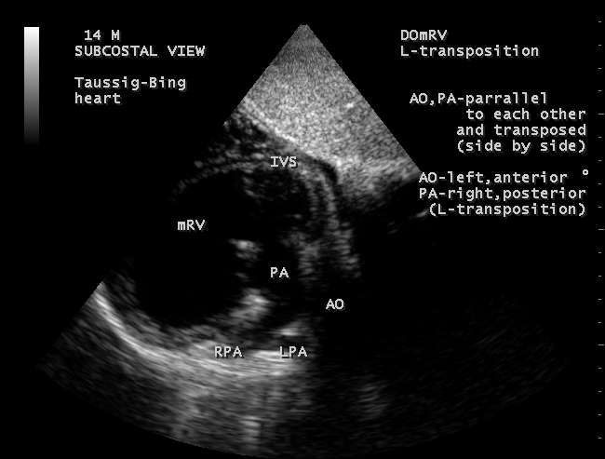

Subcostal view-short sweep

the primary origin of great vessels from the morphological right ventricle (mRV) and it is side-by-side (L-transposition)

PUBLICATIONS
1. Muthiah, R. (2018) Native Aortic Valve Endocarditis—A Case Report. Case Reports in Clinical Medicine, 7, 483-504.
2.Muthiah, R. (2018) Tropical Coronary Artery Disease and Arrhythmogenic Potentials—The Changing Pattern towards Endomyocardial Fibrosis—An Analysis. Case Reports in Clinical Medicine, 7, 397-429.
3. Muthiah, R. (2018) Isolated Patent Ductus Arteriosus in an Elderly Female, Aged 65 Years—A Case Report. Case Reports in Clinical Medicine, 7, 352-379
4. Muthiah, R. (2018) Ebstein’s Anomaly—An Overview. Case Reports in Clinical Medicine, 7, 90-125.
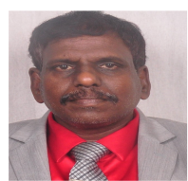
5. Muthiah, R. (2017) Rheumatic Giant Left Atrium—An Overview. Case Reports in Clinical Medicine, 6, 164- 195.

Biography
Ramachandran Muthiah, Consultant at Zion hospital, Azhagiamandapam and Morning Star hospital, Marthandam, Kanyakumari District, India.. Completed primary education at Anaan vilai in keezhkulam and secondary education at Concordia Higher secondary school, Pootteti. MBBS in 1988 (Madurai Kamaraj), M.D. in 1996, D.M. in 2003 Dr.MGR Medical University, Chennai, 6 months course in Interventional cardiology at Batra Hospital, New Delhi in 2006 ( Ministry of health, Govt of India). Worked as medical officer in Rural health services for 5 years (keezhachekkarakudi, Aryappapuram Primary health centres, ESI hospital, Singanallur, coimbatore), teaching category as Assistant Professor at Madras, Coimbatore and Thoothukudi medical colleges. Published papers in Cardiosource, American College of Cardiology Foundation, Case Reports in Clinical Medicine (SCIRP) and Journal of Saudi Heart Association.
Presenting author details
Full name: Ramachandran Muthiah
Contact number: +91 7598755201
Session name/ number: Congenital heart disease & pediatric cardiology
Category: Oral presentation (Webinar)
Contact details
E mail : cardioramachandran@yahoo.co.uk

Landline +914651 203014 (relative house) Palaninta vilai, Keezhkulam-629193,
Kanyakumari District, Tamil nadu state, India
Passport No:P8925619

