Title:ASD device closure of an 86 year old patient under TTE guidance:A very rare survival suitable for device closure,to be closed or not
Rameshwar L Bishnoi,Fortis Hospital,INDIA
Abstract
Introduction:Natural course of isolated ostium secondum ASD varies from spontaneous closure to enlarging defect size and increasing symptoms with age.Ostium secondum ASD ≥8mm in diameter and other types of ASD are unlikely to close spontaneously.
Case:An 86 year old male patient with chief complaints of shortness of breath and easy fatiguability is found to be having large(21mm) ostium secondum ASD.On TTE defect size of 21mm with left to right shunt seen and all rims are found to be sufficient.Color Doppler across tricuspid valve showed severe tricuspid regurgitation with pressure gradient of 95 mm hg.His Cath study revealed patient's suitability for closure.Under fluoroscopic and TTE guidance ASD closure done with 24 mm device successfully and on first day of echo no residual shunt as well as TR pressure gradient reduced to 46 mm hg.On 6 month follow up he is doing well.
Conclusion:In our best of knowledge this is first ever reported eldest patient whose ASD closed percutaneously .Patient with less functional impairment and less elevated PAP has better outcome.According to literature, with age continuous increase in symptoms,RV remodelling and increase PAP occurs.ASD closure must be done early after diagnosis even in adults with advanced age.Device closure being less invasive and having fewer complications even in elders.

Image:
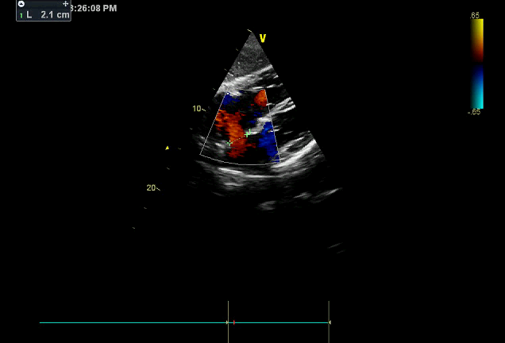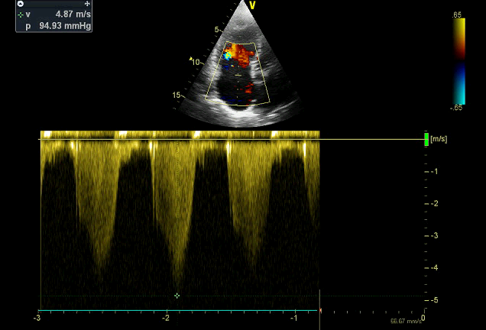
IMAGE 1&2:PREPROCEDURE ECHOCARDIOGRAM
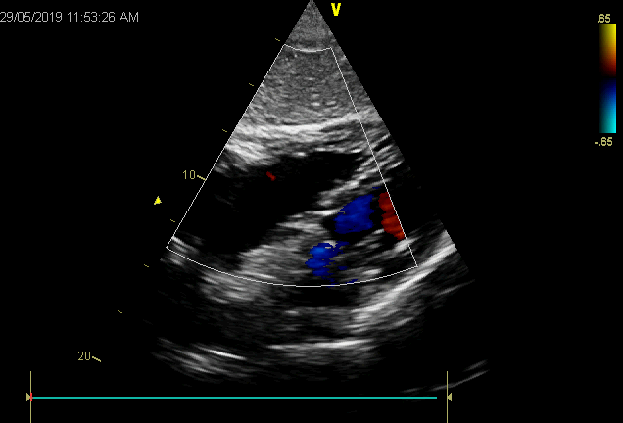
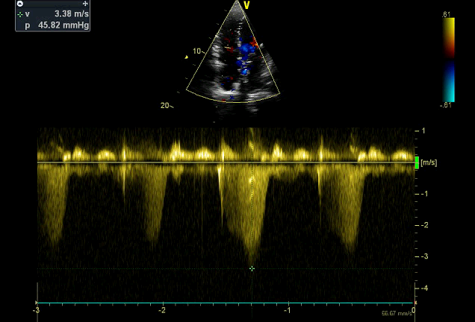

- Full Name: RAMESHWAR LAL BISHNOI
- Personal Email: brameshwar29@gmail.com
- Mobile Number:+919785505988
- Linked In:
- Facebook: brameshwar29@gmail.com
- Session Name/ number:poster presentation
- Category: (Oral presentation/ Poster presentation)
- Date of Birth:01/05/1979
- Postal Address: B 247,2ND FLOOR,DERAWAL NAGAR,DELHI,INDIA,110009

References
1. McMahon CJ, Feltes TF, Fraley JK, et al. Natural history of growth of secundum atrial septal defects and implications for transcatheter clo-sure. Heart. 2002;87:256–259.
2.Swan L, Varma C, Yip J, et al. Transcatheter device closure of atrial septal defects in the elderly: technical considerations and short-term outcomes. Int J Cardiol. 2006;107:207–210.
3. Elshershari H, Cao QL, Hijazi ZM. Transcatheter device closure of atrial septal defects in patients older than 60 years of age: immediate and follow-up results. J Invasive Cardiol. 2008;20:173–176.
4.Spies C, Hijazi ZM. Transcatheter Closure of Secundum Atrial Septal Defects in the Elderly. Korean Circ J. 2009;39:47–51.
5. Yalonetsky S, Lorber A. Comparative changes of pulmonary artery pressure values and tricuspid valve regurgitation following transcatheter atrial septal defect closure in adults and the elderly. Congenit Heart Dis. 2009;4:17–20.

