Feasibility, Safety, and Effectiveness of a Novel Mobile Application in Cardiac Rehabilitation

Irene Nabutovsky PhD Candidate. The Department of Health Systems Management, Faculty of Health Sciences, Ariel University, Israel & Cardiac Prevention and Rehabilitation Institute, Leviev Heart Center, Sheba Medical Center, Tel HaShomer, Israel

Introduction: In a pilot study, we assessed the feasibility, safety, and effectiveness of a cardiac rehabilitation program, using a combination of mobile application and multidisciplinary caregiver control center. We also evaluated clinical and physiological outcomes as well as adherence to the exercise program in patients with low cardiovascular risk.
Methods: A total of 22 patients with established coronary artery disease participated in a 6-month tele-cardiac rehabilitation (tele-CR) program. Datos Health, a novel digital health application and care-team dashboard, was used for remote monitoring, communication and management of the patient.
Results: Following the 6-month tele-CR intervention, there was a significant improvement in exercise capacity, assessed by estimated Metabolic Equivalents (METS). High-density lipoproteins (HDL) levels significantly improved, whereas low-density lipoproteins (LDL), triglyceride (TG) glycosylated hemoglobin (HbA1c), systolic (SBP) and diastolic (DBP) blood pressures levels were not significantly changed. Exercise adherence was consistent among patients, with more than 63% of patents who participated in a program of moderately intense exercise for 150 minutes per week.
Conclusion:
Patients who participated in tele-CR adhere well to the exercise program and attained good functional improvement. Tele-CR program is a viable option for populations that cannot, or elect not to participate in center based CR programs.

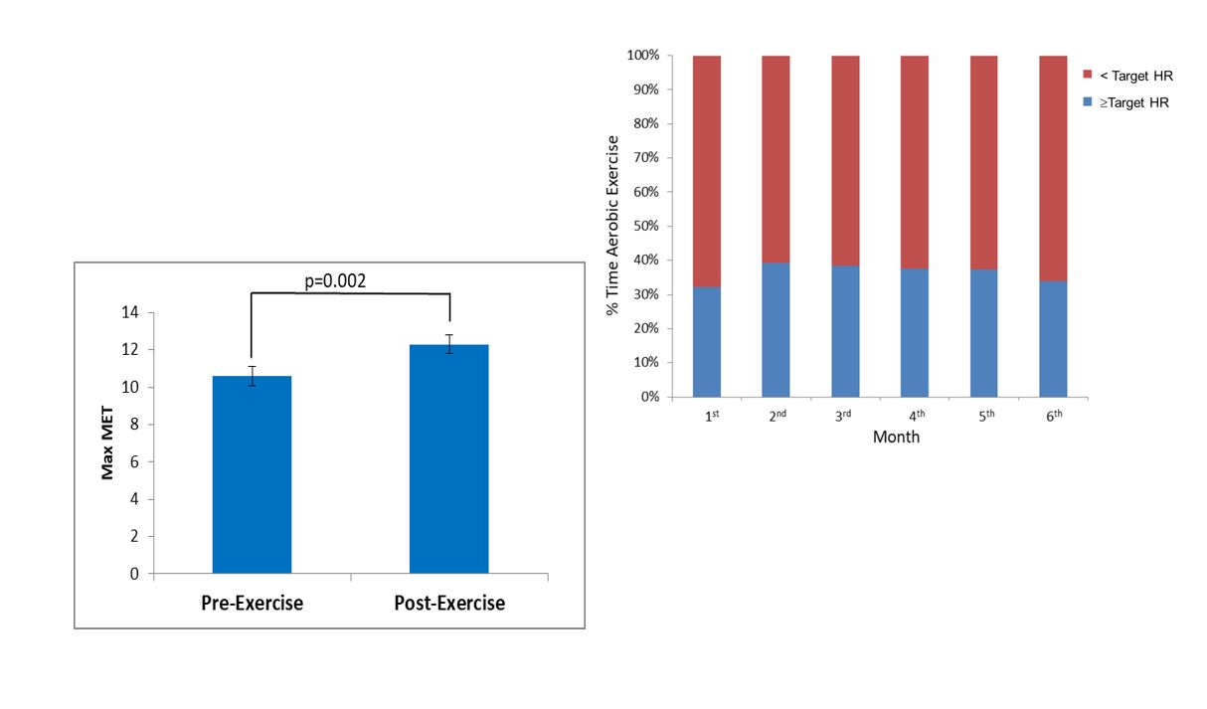

Figure 1. Pre and Post 6-Month Tele-CR intervention Metabolic Equivalents Changes.
Figure 3. Percentage of Time of Aerobic Exercise Bellow and at the Target HR Across 6Months

Recent Publications
- Nabutovsky I, Tesler R, Shapiro Y, Grabarnick A, Kolobov T., Harel-Fisch Y. (2018). Israeli health-promoting schools: The ecological approach to the implementation of a policy to promote an active and healthy lifestyle in an educational framework. Time for Education, 4. [In Hebrew, IF-NA, peer reviewed Journal]
- Nabutovsky I, Nachshon A, Klempfner R, Shapiro Y, Tesler R. (2019). Digital Cardiac Rehabilitation Programs: The Future of Patient-Centered Medicine. Telemedicine Journal and e-Health
- Tesler R, Fisch YH, Kolobov T, Shtainmetz N, Nabutovsky I, et al. (2017). Assessing the Relationship between Tobacco Control School Policies and Adolescent Smoking in Israel: A Multilevel Analysis. Journal of Addiction Research & Therapy, 5(1): 1028.



Biography

Irene Nabutovsky is a research leader at the Cardiac Prevention and Rehabilitation Institute in middle east’s biggest medical center, Tel HaShomer, Israel.
She is leading remote cardio rehabilitation study which heavily uses wearable devices, web and mobile applications.
Irene works closely and advising various Health-Tech startups.
She is in the middle of her Ph.D. study at Ariel University.
Irene published several papers and presented her research in conferences.
Email: irene.n@sheba.health.gov.il
- Full Name: Irene Nabutovsky
- Personal Email: k.irishke@gmail.com
- Mobile Number: +972546411261
- Linked In: https://www.linkedin.com/in/irene-nabutovsky-7aa3b6136/
- Facebook: https://www.facebook.com/irene.nabutovskywissotsky
- Session Name/ number: 34th World Cardiology Conference.
- Category: (Poster presentation)
- Date of Birth: 1980
- Postal Address: Ha-Oren 4 str. Beit Shemesh, israel

Notes or Comments:

