Cor Triatriatum Sinister and Patent Ductus Arteriosus in a 23 year-old Filipino
Aila V. Velasco, MD
Stephanie D. Gutierrez, MD
Brenda M. Espinosa, MD, FPCP, FPCC, FACP

Abstract
Cor triatriatum is a rare cardiac condition involving the left atrium, representing only 0.1-0.4% of all congenital heart diseases. It presents as one of the atrium being divided into two chambers by a fibromuscular membrane and classically appear on the left atrium.
We report the case of a 23-year old Filipino female with orofacial cleft, presenting with symptoms of decompensated heart failure. Clinical examination revealed the presence of diastolic murmur, 5/6, with accentuated pulmonary component of the second heart sound. Cardiomegaly was seen on chest x-ray and right ventricular hypertrophy on electrocardiogram. Transthoracic echocardiogram (TTE) shows Cor triatrium sinistrum; dilated left atrium divided by a membrane into a proximal and distal chamber; dilated right atrium; dilated right ventricle with right ventricular hypertrophy; dilated main pulmonary artery; and severe pulmonic regurgitation with severe pulmonary hypertension.
TTE should provide accurate and sufficient characterization of cardiac anatomy for optimal diagnosis but because of its rarity, can be missed. A transesophageal echocardiography (TEE) provides excellent resolution and offers invaluable assistance to surgical intervention. TEE was done upon follow up to rule out associated congenital abnormalities which only showed patent ductus arteriosus.
Surgery provides a satisfactory early and long term survival. Therefore, accurate evaluation of cor triatriatum is the key. Our report highlights early diagnosis and the utility of transesophageal echocardiography in the diagnosis of such congenital cardiac abnormalities and associated lesions.

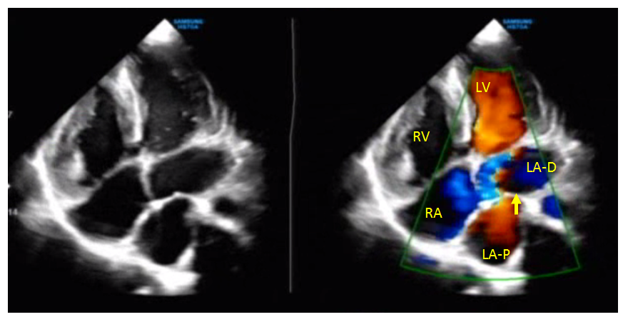
Figure 1. 4-chamber view with TTE showing dilated right atrium (RA); dilated right ventricle (RV). Turbulent color Doppler flow noted across a restrictive left atrial membrane.
LV- Left ventricle; RV- Right Ventricle; MV- Mitral valve; AV-Aortic valve; IVS- Interventricular septum

Recent Publications
- Perfecto, S.M., MD; W.L. Lopez, MD; M.L.S. Casas, MD; and A.P. Aventura, MD (2008) A Pseudo-Cor Triatriatum in a 5-year old. Philippine Heart Center Journal 2008; 14(1):61-66
- Saxena, P., FRACS, PhD; H.M. Burkhart, MD; H.V. Schaff, MD; R. Daly, MD; L.D. Joycs, M, PhD; and J.A. Dearani, MD (2014) Surgical Repair of Cor Triatriatum Sinister: The Mayo Clinic 50-year Experience. Annals of Thoracic Surgery 2014; 97:1659-1663
- Winnipeg, M.F. and O.N. Canada (March 21, 2018). Cor Triatriatum Sinister: An Unusual Cause of Atrial Fibirllation in Adults. Reports on Cardiology Vol. 20141
- Jacopo, S.; B. Angelo, M. Martina, B.G. Paolo; and B Claudio (September 24, 2108). Incidental Diagnosis of Non-obstructive Cor Triatriatum Sinister. EC Cardiology 5.10 (2018):698-706
- Dumani, S.; E. Likaj; E. Ruci; E. Bejko; and A. Refatlllari (March 24, 2018). A Very Rare Casse of CorTriatriatum with Severe Mitral Regurgitation. Open Access Macedonian Journal of Medical Sciences


Biography
Aila V. Velasco is a graduate of Doctor of Medicine at Saint Louis University last June 2017 and had recently passed the Physician Licensure Examination in the Philippines last September 2018. She is currently under the training program for Internal Medicine at Lorma Medical Center, an institution in Luzon, Philippines. Her experience for research was based on her pre-medicine course in the University of the Philippines and during her post graduate years; her skills for writing were honed during the four years of college that she was part of the University publication and had become editor during her senior year. Writing a medical paper in particular, is a continuous process, a rapidly expanding experience and a challenge and also an opportunity for scientific knowledge.
Email: avvelasco28@gmail.com

