Grading of LV systolic function by speckle tracking
Scientific background:
One of the most rapid and easy techniques for assessing LV systolic function is transthoracic echocardiography, but its main disadvantage is being a subjective method and needs high experience to get an accurate assessment of the global LV systolic function especially in patients with regional wall motion abnormalities. One of the new modalities of echocardiography is 2D speckle tracking which permits offline calculation of myocardial velocities and deformation so it gives more accurate and operator independent evaluation of the LV global systolic function.
Aim of work is to validate solid numbers of LV global strain value by 2D speckle tracking that correlates LV EF by simpson’s method for more accurate assessment of global LV systolic function especially in patients with regional wall motion abnormality.
Patient and method:
The study involved 120 individuals ; 20 with normal LV systolic function and 100 patients with LV systolic dysfunction and regional wall motion abnormality. All the cases had their LV systolic function assessed first simpson’s method by transthoracic echocardiography then speckle tracking for all of them had been done and correlation between results of EF by simpson’s method and LV global strain was done and statistical analysis was done.
Results:
Our study had shown that:
Global strain more negative than or equal to -16 is equal to EF more than or equal to 55% by transthoracic echo (normal LV systolic function).
Global strain more negative than or equal to -13% and less negative than -16 is equal to EF more than or equal to 45% and less than 54% (mild LV systolic dysfunction).
Global strain more negative than or equal to -9.8 % and less negative than -13% is equal to EF more than or equal to 30% and less than 45% (moderate LV systolic dysfunction).
Global strain less negative than -9.8% is equal to EF below 30% (severe LV systolic dysfunction).
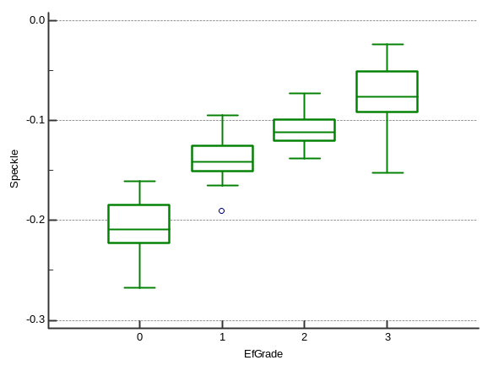
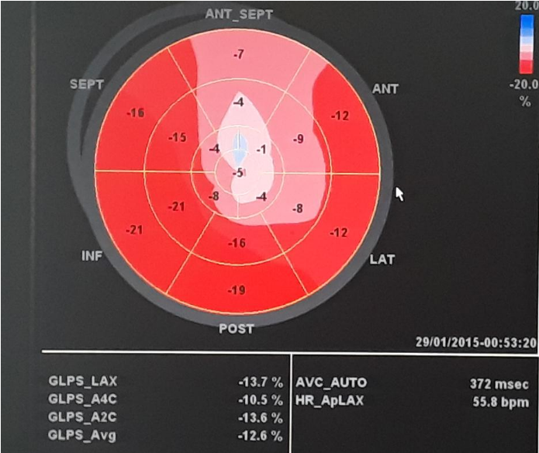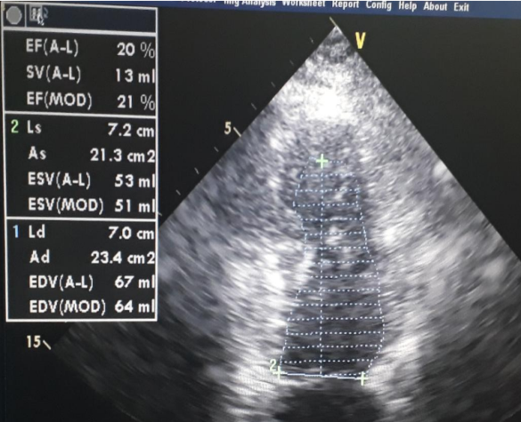
GS by 2D speckle tracking EF by simpson's method

Conclusion:
Speckle tracking provides an easy, accurate bed side modality for assessment of LV systolic function through calculation of LV global strain which is an operator independent technique.

