Dabigatran vs. Warfarin for Treatment of AtrialFibrillation
Joyce Oh & Nazish, Touro College of Pharmacy

Abstract (300 word limit)

Objective: To assess and compare the efficacy and safety of dabigatran with warfarin in patients with atrial fibrillation(AF) in preventing the recurrence of blood clot, lower risk of internal bleeding or hemorrhage in treated patients.

Background: Atrial Fibrillation is associated with heart related mortality and increased risk of stroke. Warfarin, a vitamin K antagonist had been the standard therapy for years since mid 20th century for AF and other blood coagulation disorders until recently the non- vitamin K antagonist, dabigatran came about as another option for prevention of stroke in patients with nonvalvular atrial fibrillation. The “net benefits” of this new oral anticoagulant are questioning with regards to its’ efficacy and safety outcomes. The “net benefits” of dabigatran must outweigh the disadvantages and benefits must be greater than the standard therapy for dabigatran to be considered primary treatment option for atrial fibrillation.

Methods: PubMed, Embase, and CINAHL were searched for studies pertaining to dabigatran, warfarin, and atrial fibrillation limited to human studies, observational studies, randomized clinical trials, controlled clinical trials, and clinical trials.

Results: Dabigatran has been linked to reduced risk of stroke and life threatening bleeding, all-cause mortality and intracranial hemorrhage compared to warfarin. The high dose regimen of dabigatran demonstrated better safety and efficacy than the low dose demonstrated.

Conclusion: Dabigatran may be superior to warfarin in patients with atrial fibrillation.

Image

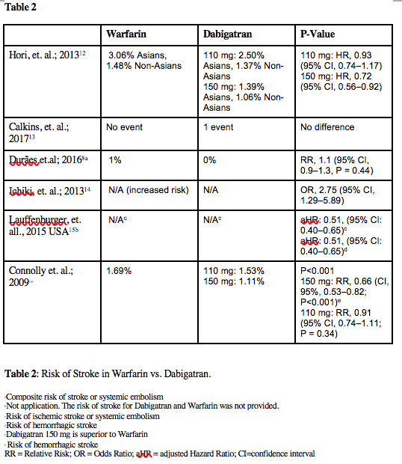
Recent Publications (minimum 5)
- Keller KL, Kuilema LG, Lee N, Yoon J, Mascaro B, Combes A-L, Deutsch B, Sorte K, Halford JCG. The impact of food branding on children’s eating behavior and obesity: a presentation given at the Society for the Study of Ingestive Behavior Annual Meeting. Physiol Behav. 2012;106(3):379-86.
- Yoon, J. and Yoon, J. (2012). Interoperating DNA Gene Sequences and Nutrition Provisions for Personalized Wellness. BIONETICS, pp.325-333.
- Yoon J, Deutsch BJ, Keller K. Can fast food brand logos be used to improve children’s dietary choices? pilot study findings. Obesity. 19:S1;2011.
- Deutsch BJ, Yoon J, Keller K. Use of a stroop task to test whether overweight children have a cognitive bias toward food brands. Obesity. 19:S1;2011.

Biography (150 word limit)
Joyce Oh is passionate in medicine and pharmaceutical research. She has years of experience working in the pharmaceutical industry. She received her M.S. degree in Nutrition from Columbia University where she conducted research in children’s obesity, which was presented at the Annual Obesity Conference and published in Physiology & Behavior. She is currently continuing her education in Doctor of Pharmacy at Touro College of Pharmacy.

Email: joyce.narae.oh@gmail.com
Phone: +1-917-957-3066

Notes/Comments:

