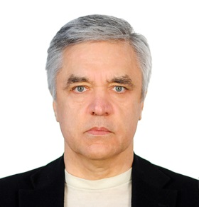
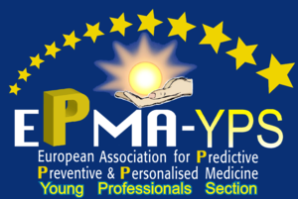
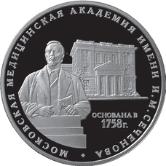

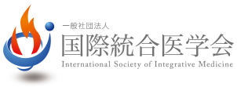


PM (Personalized Medicine) as the Newest Healthcare and Wellness Model
and a Unique Way to Control and Secure Health State

Sergey Suchkov

Moscow Engineering Physical Institute (MEPhI)
I.M.Sechenov First Moscow State Medical University
A.I.Evdokimov Moscow State Medical & Dental University,
ISPM, Tokyo, Japan
PMC, Washington, DC, USA
EPMA, Brussels, EU
AHA, Houston, TX, USA

A new systems approach to diseased states and wellness result in a new branch in the healthcare services, namely, personalized medicine (PM). To achieve the implementation of PM concept into the daily practice including clinical cardiology, it is necessary to create a fundamentally new strategy based upon the subclinical recognition of bioindicators (biopredictors and biomarkers) of hidden abnormalities long before the disease clinically manifests itself.
Each decision-maker values the impact of their decision to use PM on their own budget and well-being, which may not necessarily be optimal for society as a whole. It would be extremely useful to integrate data harvesting from different databanks for applications such as prediction and personalization of further treatment to thus provide more tailored measures for the patients and persons-at-risk resulting in improved outcomes whilst securing the healthy state and wellness, reduced adverse events, and more cost effective use of health care resources. One of the most advanced areas in cardiology is atherosclerosis and cardiovascular and coronary disorders. A lack of medical guidelines has been identified by the majority of responders as the predominant barrier for adoption, indicating a need for the development of best practices and guidelines to support the implementation of PM into the daily practice of cardiologists!
Implementation of PM requires a lot before the current model “physician-patient” could be gradually displaced by a new model “medical advisor-healthy person-at-risk”. This is the reason for developing global scientific, clinical, social, and educational projects in the area of PM to elicit the content of the new branch.

Biography
Sergey Suchkov was born in the City of Astrakhan, Russia, in a dynasty medical doctors, graduated from Astrakhan State Medical University and was awarded with MD. Then maintained his PhD and Doctor Degree. And later was working for Helmholtz Eye Research Institute in Moscow, Moscow Clinical Research Institute (MONIKI). Dr Suchkov was a Secretary-in-Chief of the Editorial Board, Biomedical Science, an international journal published jointly by the USSR Academy of Sciences and the Royal Society of Chemistry, UK. At present, Dr Sergey Suchkov is a Chair of Dept of Personalized Medicine, I.M.Sechenov First Moscow State Medical University, and Secretary General, United Cultural Convention (UCC), Cambridge, UK; a member of the: New York Academy of Sciences, American Chemical Society (ACS), American Heart Association (AHA), AMEE, Dundee, UK; EPMA, Brussels, EU; PMC, Washington, DC, USA and ISPM, Tokyo, Japan.

