Alarms in Epidemiological Trends of Cardiovascular Diseases
Niloofar Peykari, Farshad Farzadfar, Sahar Saeedi Moghadam, Shirin Djalalinia, Bagher Larijani, Iran

Background:
Cardiovascular diseases (CVDs) have been the leading cause of death in recent decades. There is great concern about CVDs’ epidemiological trends that needs evidence based health policies. The aim of this study was to compare the CVDs’ epidemiological measures and their trends in Iran and its neighbors from 1990 to 2015.

Methods:
We used Global Burden of Diseases study’s data (2015) for comparison incident, prevalent, death, Disability-Adjusted Life Years (DALYs), Years of Life Lost (YLLs), and Years Lived with Disability (YLDs) between Iran and its neighbors. These countries are; Afghanistan, Armenia, Azerbaijan, Bahrain, Iraq, Kazakhstan, Kuwait, Oman, Pakistan, Qatar, Russia, Saudi Arabia, Turkey, Turkmenistan, and United Arab Emirates,

Results:
In 2015, CVDs caused more than 170 thousand deaths in Iran (108363 in Men and 67935 in Women). It is responsible to 45% of all deaths in Iran, and the number of death due to CVDs approximately doubled from 1990 to 2015.
In studied countries, the CVDs death rate (per 100 000) ranged from 185.4 in Qatar to 886.1 men in Afghanistan and among women from 150 in Turkey to 1182.2 women in Afghanistan.
Ischemic Heart Diseases (IHD) contained the most percent of death in both sex. It is remarkable; the percent of Rheumatic heart disease death in Pakistan is more than other countries.
Also, the percent of hypertensive heart disease DALYs’ rate in Iran was more than others. In comparison 1990 and 2015, the most increase of CVDs incidence rate allied to Iran (12.7%) and the most decrease related to turkey (-21%). In addition, the highest rates of cardiovascular diseases’ prevalence (per 100000) related to Oman (20536.1 in men and 13693.73 in women), and Iranian men (11965.2). In all considered countries, high systolic blood pressure was the first risk for cardiovascular diseases death, DALYs, YLL, and YLD. From life style related risk factors, diet high in sodium was the first risk for CVDs’ death in Iran and almost its neighbors.

Conclusion:
These findings have significant implications for effective prevention and control of cardiovascular diseases. In response to these alarming results, Iran developed national action plan for NCDs’ prevention and control. In context of national action plans, we could arrange feasible, scalable, affordable, and cost effective interventions to reduce cardiovascular diseases death, DALYs, and prevalence.

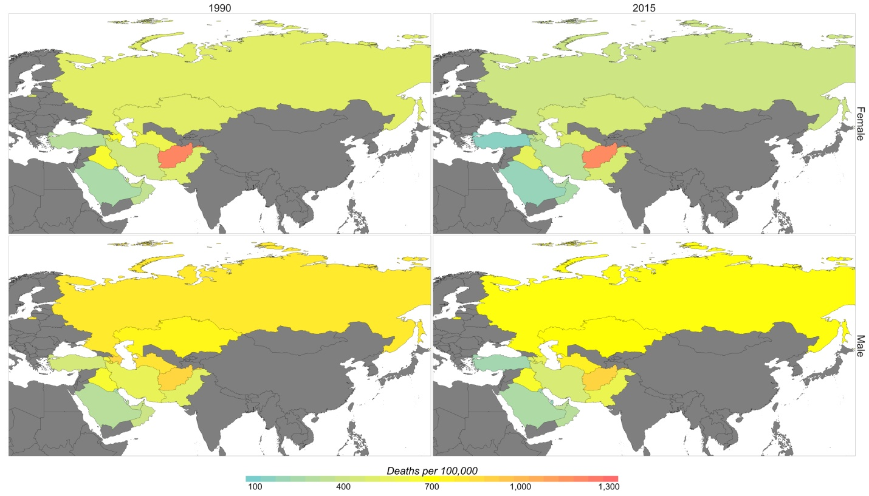
Figure1. Age-standardized rate due to cardiovascular diseases death rate by sex, 1990 and 2015

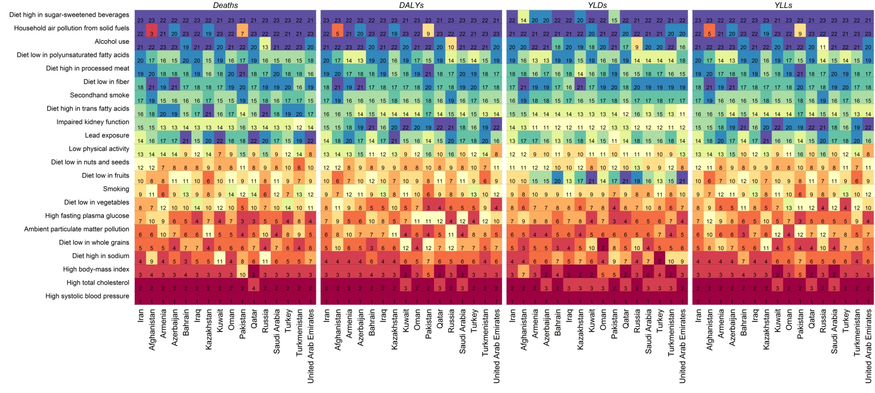
Figure 2. the heat map of cardiovascular diseases attributed death to all risk factors in Iran and its neighbors, 2015

Recent Publications
- NCD Risk Factor Collaboration (NCD-RisC). Worldwide trends in diabetes since 1980: a pooled analysis of 751 population-based studies with 4.4 million participants. (NCD-RisC). Lancet. 2016 Apr 9;387(10027):1513-30. doi: 10.1016/S0140-6736(16)00618-8. Epub 2016 Apr 6
- Peykari N, Djalalinia S, Qorbani M , et al. Socioeconomic inequalities and diabetes: A systematic review from Iran. J Diabetes Metab Disord. 2015 Feb 25;14:8.
- Peykari N, Sepanlou SG, Djalalinia S ,et al. National and sub-national prevalence, trend, and burden of metabolic risk factors (MRFs) in Iran: 1990 - 2013, study protocol.Arch Iran Med. 2014 Jan;17(1):54-61. doi: 0141701/AIM.009.
- Peykari N, Saeedi MS, Djalalinia S, et al.High Fasting Plasma Glucose Mortality Effect: A Comparative Risk Assessment in 25-64 Years Old Iranian Population.Int J Prev Med. 2016 May 19;7:75. doi: 10.4103/2008-7802.182732.
- NCD Risk Factor Collaboration (NCD-RisC). Trends in adult body-mass index in 200 countries from 1975 to 2014: a pooled analysis of 1698 population-based measurement studies with 19·2 million participants. Lancet. 2016 Apr 2;387(10026):1377-1396. doi: 10.1016/S0140-6736(16)30054-X.

Biography
Niloofar Peykari has her expertise in Non-communicable Diseases epidemiology. She is researcher of non-communicable diseases research center of EMRI, TUMS and assistant professor of Ministry of Health and Medical Education of IRAN.
Email: ​n.peykari@behdasht.gov.ir
Phone: +98-21-81452912

