An Early Repolarization Syndrome in a 39 year-old male presenting with
Sudden Cardiac Death and treated with ICD: A Case Report

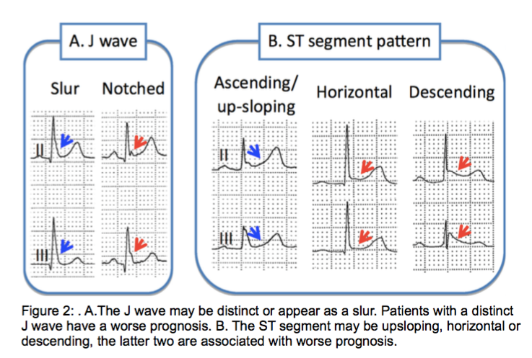
Jennilyn O’yek, PHILIPPINES

Abstract

An Early Repolarization Syndrome is a rare clinical entity and is a significant cause of idiopathic ventricular fibrillation responsible for sudden cardiac death. We presented a case of a 39 year-old male with no known co-morbidities who had ventricular fibrillation-related cardiac arrest. A 12-lead electrocardiography showed a notched J wave with downsloping ST segment on lead II,III,aVF and V4-V6. Echocardiography showed preserved left ventricular systolic function with no regional wall motion abnormalities, and coronary angiography showed normal coronaries. A Type 2 Early Repolarization Syndrome was diagnosed, and an implantable cardioverter defibrillator was inserted. Early repolarization syndrome is associated with J point elevation, and the more leads involved and a downsloping ST segment pattern as seen in our patient is a predictor of an increase risk for arrhythmogenicity. In summary, we report a case of a Type 2 early repolarization syndrome induced idiopathic ventricular fibrillation treated with ICD.
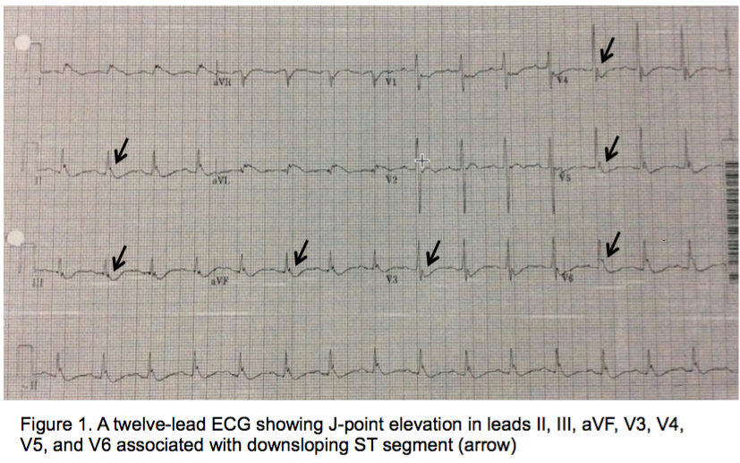

IMAGE

REFERENCES
1. Antzelevitch C, Yan GX, Ackerman MJ et al. J-wave syndromes expert consensus conference report: Emerging concepts and gaps in knowledge. Heart Rhythm 2016.
Oct 13;13(10):e295-324.
2. Klatsky AL, Oehm R, Cooper RA, Udaltsova N, Armstrong MA. The early repolarization normal variant electrocardiogram: correlates and consequences.
Am J Med 2003;115:171–177.
3. Tikkanen JT, Anttonen O, Junttila MJ et al. Long-term outcome associated with early repolarization on electrocardiography. N Engl J Med 2009;361:2529–2537.
4. Haissaguerre M, Derval N, Sacher F et al. Sudden cardiac arrest associated with early repolarization. N Engl J Med. 2008;358:2016–2023.
5. Nam GB, Kim YH, Antzelevitch C. Augmentation of J waves and electrical storms in patients with early repolarization. N Engl J Med. 2008;358:2078–2079.
6. Tikkanen JT, Junttila MJ, Anttonen O et al. Early repolarization: electrocardiographic phenotypes associated with favorable long-term outcome. Circulation. 2011;123:2666–2673
7. Mahida S, Derval N, Sacher F et al. History and clinical significance of early repolarization syndrome. Heart Rhythm. 2015;12:242–9



BIOGRAPHY

Jennilyn O’yek has completed doctor of medicine at University of the East Ramon Magsaysay Medical Center and finished her Internal Medicine training at Capitol Medical Center. She is currently on her 2nd year cardiology fellowship at Philippine Heart Center.
Email: jen_oyek@yahoo.com Phone: 63-9205275757/ 63-9778513394

