Stent assisted Coil Embolization of a Large, Saccular, Suprarenal Aortic Aneurysm with Walled off Rupture: A Case Report
Alinaya Cordero MD and Fabio Enrique Posas, MD*, Philippines

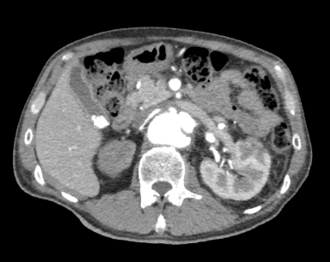
Abstract

Background/ Introduction: Suprarenal and thoracoabdominal aortic aneurysms portray significant surgical challenges given their anatomical locations and associated difficulties with surgical procedure. In patients with suitable anatomy, or prohibitive surgical risk, endovascular aneurysm repair offers a less invasive alternative. Special strategies are needed to attain favorable repair outcome. Objectives: We report a case of a 59 year old male with a large, suprarenal, saccular aortic aneurysm with probable walled off rupture who underwent aneurysm repair with stent assisted coil embolization technique. Surgical repair in this case otherwise required thoracoabdominal incisions, intensive dissection and cross-clamp above the celiac trunk. Materials and Methods: Stent assisted coil embolization is a novel approach in the management of complex, life threatening abdominal aortic disease such as this case. Results: On follow-up, patient remains asymptomatic with evidence of sac thrombus on follow-up CT Angiogram of the abdomen, two months after the procedure. Conclusions: Stent assisted coil embolization of saccular, suprarenal aortic aneurysm is a promising technique of abdominal aneurysm repair for patients with difficult and complex surgical anatomy. The long-term impact will be defined via serial CT-scan follow-up.

Image

Figure 1. CT scan of the abdominal aorta showing the axial image of aneurysm, A) measuring 4.0 x 3.7 x 5.9 cm arising from the medial aspect of the proximal abdominal aorta at the levels of the superior mesenteric and right renal artery.
LRA
LK

RRA A
RK

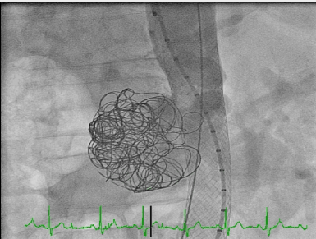

Figure 2. Notice the installed stent in the aorta, together with total of 12 coils

Recent Publications
1. Zipes, D. P.et.al. (2012). Braunwald’s heart disease: A Textbook of Cardiovascular Medicine. Philadelphia, USA: Elsevier Inc.
2. Wiebers, D. et.al., (2004). Pathogenesis, natural history, and treatment of unruptured intracranial aneurysms. Mayo Clinic Proceedings, 79(12):1572.
3. Taylor, B. and Kalman, P. (1999). Saccular Aortic Aneurysms. Annals of Vascular Surgery, 13 (6): 555–559.
4. Shang, E., et.al. (2012). A modern experience with saccular aortic aneurysms. Journal of Vascular Surgery, 57 (1).
5. Vorp, D., et.al. (1998). Mechanical wall stress in abdominal aortic aneurysm: influence of diameter and asymmetry. Journal of Vascular Surgery,27(4):632-9.
6. Fillinger MF, Racusin J, Baker R, Cronenwett JL, Teutelink A, Schermerhorn ML, et al. (2004). Anatomic characteristics of ruptured abdominal aortic aneurysm on conventional CT scans: implications for rupture risk. Journal of Vascular Surgery 39:1243-52.
7. Nathan DP, Xu C, Pouch AM, Chandran KB, Desjardins B, Gorman JH 3rd, et al. (2011). Increased wall stress of saccular versus fusiform aneurysms of the descending thoracic aorta. Annals of Vascular Surgery 25:1129-37.
8. Kim, KR, et.al. (2000). A case report demonstrating coil embolization and stent placement as a safe and effective alternative treatment modality to the traditional open aneurysmectomy and revascularization. Journal of Vascular Surgery, 32: 684-8.
9. Kalva, S., Wu, S., and Irani, Z. (2011). Endovascular Treatment of Renal Artery Aneurysms. Endovascular Today.10. Gillard, M. et.al. (2012). Registry of Transcatheter Aortic-Valve Implantation in High-Risk Patients. The New England Journal of Medicine, 366(18):1705-15.

 Biography
Alinaya Cordero is an incoming senior and chief cardiology fellow in St. Luke’s Medical Center, Global City, Philippines. She is planning to pursue studies in echocardiography.
Email: alinayacordero@gmail.com
Phone: +639178688975

