Hybrid, Transcatheter Aortic Valve Implantation (TAVI) and Total Arterial Off-Pump Coronary Artery Bypass (OPCAB) in a Patient with Severe Aortic Valve Regurgitation – A Case Report
Alinaya Cordero, MD, Fontini Carbon, MD, Erwin Ybañez, MD and Fabio Enrique Posas, MD*, Philippines

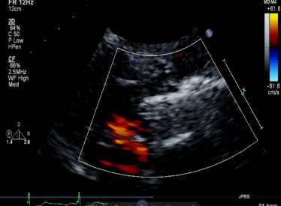

Abstract

Background: Transcatheter aortic valve implantation (TAVI) has been shown to be an effective growing strategy for severe, symptomatic aortic valve stenosis (AS) in patients who are either not candidates or who are at intermediate or high surgical risk for surgical aortic valve replacement (SAVR). Hybrid tanscatheter aortic valve implantation and off-pump coronary artery bypass graft (OPCAB) has been previously reported in high-risk patients with severe AS and coronary artery disease. TAVI data for severe aortic valve regurgitation (AR) is limited and currently considered an off-label application. Reports on hybrid TAVI for severe AR and OPCAB in patients with severe co-morbid CAD are limited. Objective: We report a hybrid TAVI and OPCAB in a 64-year-old, female, with severe AR, severe left ventricular systolic dysfunction and coronary artery disease with low take off of the left main (LM) and porcelain aorta. Case Report: Patient is a 64 year-old morbidly obese, Filipino female with porcelain aorta and post-percutaneous coronary intervention (PCI) with drug-eluting stent (DES) implantation for multivessel coronary artery disease with LM involvement and was admitted for a refractory heart failure. Her 2D echo demonstrated a dilated left ventricle with 19% left ventricular ejection fraction (LVEF) and severe aortic regurgitation. Computed tomography angiography (CTA) demonstrated porcelain aorta, low take off of the left main with good femoral access. Hybrid TAVI with 26 mm Corevalve was done via the trans femoral approach after OPCAB of left internal mammary artery (LIMA) to left anterior descending (LAD) artery. Valve in valve was required due to low valve implantation and severe paravalvular leak (PVL). Follow-up echo at 22 months demonstrated no PVL, 1.6cm2 effective orifice aortic valve area (AVA), 12.4 mmHg mean gradient, and 50% LVEF. She remains asymptomatic and in functional class I. Conclusions: Hybrid TAVI and OPCAB in patients with severe valvar AR, porcelain aorta and CAD represents a feasible and effective option of care. There are few reports in the literature documenting the effectiveness nor feasibility of this approach for such patients.
Image

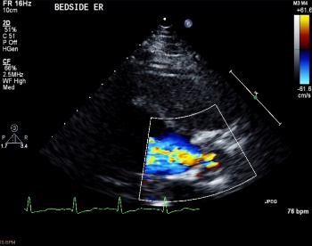
Figure 1. (A) PLAX view of the left ventricle showing severe aortic regurgitation on color flow Doppler, pre TAVI. (B) PLAX view of the left ventricle showing bioprosthetic valve with no regurgitation on color flow Doppler, post TAVI.
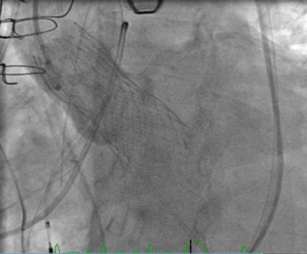
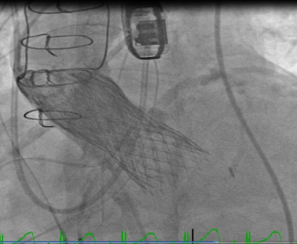

Figure 2. (A) Deployment of the first bioprosthetic aortic valve with significant paravalvar leak. (B) A second bioprosthetic aortic valve was placed now showing mild paralvalvar leak on aortogram.

Recent Publications
1. Kobayashi J, et.al. (2016). Early Results of Simultaneous Transaortic Transcatheter Aortic Valve Implantation and Total Arterial Off-Pump Coronary Artery Revascularization in High-Risk Patients. Circulation Journal, 80(9):1946-50.

2. Franzone, A., et.al. (2016). Transcatheter Aortic Valve Replacement for the Treatment of Pure Native Aortic Valve Regurgitation. Journal of the American College of Cardiology: Cardiovascular Interventions, 9:2308–17.

3. Testa, L., et.al. (2014). CoreValve implantation for severe aortic regurgitation: a multicentre registry. EuroIntervention. (6):739-45.

4. Roy D.A. et.al. (2012). Transcatheter aortic valve implantation for pure severe native aortic valve regurgitation. Journal of the American College of Cardiology, 61(15):1577-84.

5. Goel, S., et.al. (2013). Severe aortic stenosis and coronary artery disease—implications for management in the transcatheter aortic valve replacement era: a comprehensive review. Journal American College of Cardiology. 62:1–10.

6. Huded, Chetan, MD and Samir R. Kapadia, MD. (2013). Decision-Making on the Treatment of CAD in the Age of TAVR. Expert Analysis. Journal American College of Cardiology.

7. Dewey, T., et.al. (2010). Effect of Concomitant Coronary Artery Disease on Procedural and Late Outcomes of Transcatheter Aortic Valve Implantation. Annals Thoracic Surgery.

8. Wiegerinck, E., et.al. (2013). Hybrid coronary artery bypass grafting and transaortic transcatheter aortic valve implantation. The Journal of Thoracic and Cardiovascular Surgery, 145:600-2.

9. Nishimura, RA., et al. (2014) AHA/ACC Guideline for the Management of Patients with Valvular Heart Disease. Circulation, 129:000–000.

10. Gillard, M. et.al. (2012). Registry of Transcatheter Aortic-Valve Implantation in High-Risk Patients. The New England Journal of Medicine, 366(18):1705-15.

11. Puskas, JD, et.al. (2009). Off-pump coronary artery bypass disproportionately benefits high-risk patients. Annals Thoracic Surgery, 88(4):1142-7.

 Biography
Alinaya Cordero is an incoming senior and chief cardiology fellow in St. Luke’s Medical Center, Global City, Philippines. She is planning to pursue studies in echocardiography.
Email: alinayacordero@gmail.com
Phone: +639178688975

