Real-world Outcomes Associated with Lomitapide Use in Patients with Homozygous Familial Hypercholesterolemia: A Retrospective Database Analysis

Authors: Ruo-Ding Tan¹, Qinghao.Peng¹, Christian Frois¹, Taylor Salinardi², Eliot A.Brinton³
¹Analysis Group, Boston, MA, USA; ²Aegerion (Novelion) Therapeutics, Boston, MA, USA; ³ Utah Lipid Center, Salt Lake City, UT, USA

Abstract (300 word limit)

Statement of the Problem: Homozygous familial hypercholesterolemia (HoFH) is ultra-rare and hard to treat, with high LDL-C and premature major adverse cardiovascular events (MACE). No randomized trials, few real-world studies, and no published lomitapide (LOM) studies address MACE in HoFH, despite LOM being indicated as an adjunct therapy to diet and other lipid-lowering treatments for HoFH. This study presents for the first time MACE rates in LOM-treated patients. Methodology & Theoretical Orientation: Optum claims data (2012-2016, ~25 million covered lives) were combined with LDL-C from Optum and a pharmaceutical patient support program. LDL-C, and rates of MACE and hospitalization were assessed in HoFH patients for 1 year before drug initiation, during LOM treatment, and 1 year after LOM discontinuation (in those who discontinued). Patients were stratified based on LDL-C response to LOM. Findings: 62 patients started LOM and had baseline and follow-up LDL-C. LOM use was associated with LDL-C reductions and a trend to lower hospitalizations and MACE rates. Nearly 2/3 of patients (40 of 62) had a sustained response to LOM (>10% LDL-C reduction for >60 days), of whom 27 later discontinued LOM, with the expected subsequent worsening of outcomes. Conclusion & Significance Consistent with clinical trials, LOM significantly reduces LDL-C in real-world HoFH patients. Although data are limited by the rarity of HoFH, there was clinically meaningful (albeit not statistically significant) decrease in MACE and hospitalization with LOM treatment, and, as expected, there was a trend toward loss of LDL-C and MACE/hospitalization benefits after LOM discontinuation.
Image
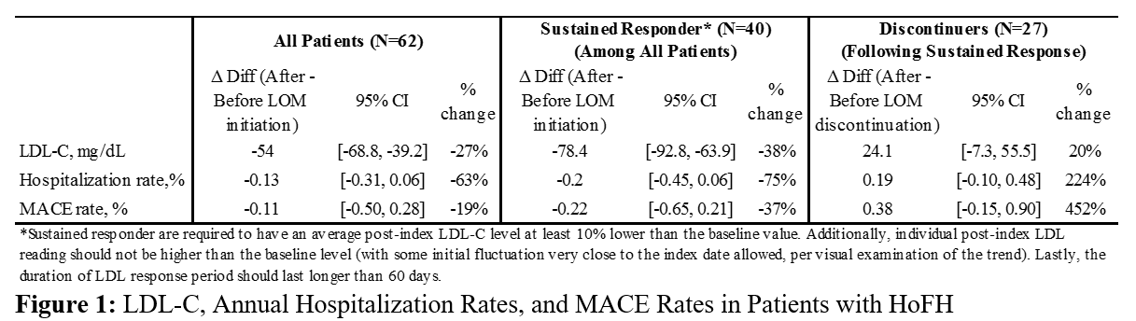
Recent Publications (minimum 5)
1. Blom D, Kastelein JJ, Larrey D, Makris L, Schwamlein C, Phillips H, Bloedon L, Underberg J (2015) Lomitapide Observational Worldwide Evaluation Registry (LOWER): One-Year Data. Circulation 132: A10818.
2. Underberg J, Cannon C, Larrey D, Makris L, Schwamlein C, Phillips H, Bloeden L, Blom D (2016) Global Real-World Data on the Use of Lomitapide in Treating Homozygous Familial Hypercholesterolemia: The Lomitapide Observational Worldwide Evaluation Registry (LOWER), Two-Year Data. Circulation 134:A12117.
3. Blom DJ, Fayad ZA, Kastelein JJ, Larrey D, Makris L, Schwamlein C, Bloeden L, Underberg J (2016) LOWER, a registry of lomitapide-treated patients with homozygous familial hypercholesterolemia: Rationale and design. Journal of Clinical Lipidology 10:273-282.
4. Cuchel M, Meagher EA, du Toit Theron H, Blom DJ, Marais AD, Hegele RA, Averna MR, Sirtori CR, Shah PK, Gaudet D, Stefanutti C, Vigna GB, Du Plessis AM, Propert KJ, Sasiela WJ, Bloedon LT, Rader DJ (2013) Efficacy and safety of a microsomal triglyceride transfer protein inhibitor in patients with homozygous familial hypercholesterolaemia: a single-arm, open-label, phase 3 study. Lancet 381:40-46.
5. Blom DJ, Averna MR, Meagher EA, du Toit Theron H, Sirtori CR, Hegele RA, Shah PK, Gaudet D, Stefanutti C, Vigna GB, Larrey D, Bloedon LT, Foulds P, Rader DJ, Cuchel M (2017). Long-Term Efficacy and Safety of the Microsomal Triglyceride Transfer Protein Inhibitor Lomitapide in Patients With Homozygous Familial Hypercholesterolemia. Circulation 126:332:335.

 Biography (150 word limit)
Eliot A. Brinton, MD is President of the Utah Lipid Center in Salt Lake City. He is a founding board member of the National Lipid Association and of the American Board of Clinical Lipidology, of which he is also Past-President. He is a fellow of the American Heart Association and of the National Lipid Association, and past chair of the Clinical Lipidology Committee of the AHA. Dr. Brinton is widely published in the field of lipoprotein metabolism, having published original research articles in the New England Journal of Medicine, JAMA, and Circulation. He is Associate Editor of the Journal of Clinical Lipidology and Assistant Editor of the Journal of Obesity, and has served on the editorial boards of the Journal of Clinical Endocrinology and Metabolism and the Journal of Managed Care Pharmacy. Dr. Brinton has served on the faculty of the Rockefeller University, Wake Forest University and the University of Utah. He has won several awards and has held numerous leadership and advisory positions in scientific and governmental organizations and in the pharmaceutical industry.
Email: eliot.brinton@utah.edu
Phone: +1-801-403-7530

Notes/Comments: This study was supported by Aegerion Pharmaceuticals, Inc. Aegerion is manufacturer of lomitapide. Aegerion was given opportunity to review and provide feedback on the abstract; authors had full editorial control and provided their final approval of all content.

