Bridging Collateral in LAD ( complete collaterals)
Ashish Sinha, MD, K K Nursing Home, Bhagalpur, Bihar, India

Abstract
Objective: The purpose of this abstract is to show that even a coronary CTO ( chronic total occlusion) with bridging collaterals can be opened up successfully without the retrograde approach. The only used hard ware is a hi torq 200 XT cross it wire with tip load of 4.7 grams.
In a part of country where the patient have to bear all the cost of the intervention this simple though a bit time consuming can decrease the financial burden to the already poor coronary artery patients in this state.

Collaterals:

The coronary arteries have been regarded as end arteries for decades. However, there are functionally relevant anastomotic vessels, known as collateral arteries, which interconnect epicardial coronary arteries. These vessels provide an alternative source of blood supply to the myocardium in cases of occlusive coronary artery disease. The relevance of these collateral arteries is a matter of ongoing debate, but increasing evidence indicates a relevant protective role in patients with coronary artery disease.

While their growth is often thought to be initiated by ischemia, collateral arteries are also present in individuals who do not have coronary disease

The prevalent view is that collateral circulation is generally not sufficient to meet myocardial demands during exercise and may not prevent myocardial ischemia during coronary occlusion.

Visual assesment influenced by blood pressure and the force of contrast injection as well as the duration of filming.

The biological composition of CTO changes over time. There is approximately an 80% reduction in the overall size of the vessel after six weeks

Conclusion & Significance: Few CTO with bridging collaterals can be opened up without the use of expensive paraphernalia’s in cath lab thereby decreasing cost to patients in this part of country.
Image
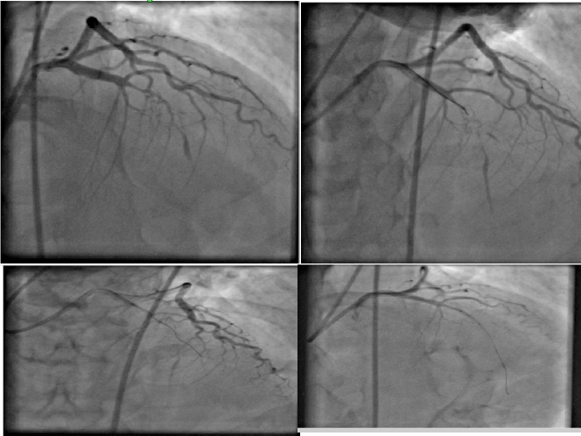
Figure1: Showing CTO of LAD with bridging collaterals, opened up with Cross IT 200 XT wire
Recent Publications
- Sinha A, Nanda NC, Khanna D et al. Live three-dimensional transthoracic echocardiographic delineation of patent ductus arteriosus. Echocardiography 2004; 21(5); 443-448
- Sinha A, Kasliwal R, Nanda NC et al. Live Three-Dimensional Transthoracic Echocardiographic Assessment of Isolated Cleft Mitral Valve. Echocardiography 2004; 21 (7); 657-661.
- Sinha A, Nanda NC et al. Live Three-Dimensional Transthoracic Echocardiographic Assessment of Transcatheter closure of atrial septal defect and patent foramen ovale. In vitro and In vivo studies. Echocardiography 2004;21:749-753
- Sinha A, Nanda NC, Khanna D et al. Live Three-Dimensional Transthoracic Echocardiographic Assessment Left Ventricular Thrombus. Echocardiography 2004; 21 (7); 649-655.
- Sinha A, Nanda NC, Panwar RB et al. Live three dimensional transthoracic echocardiographic assessment of left ventricular hydatid cyst. Echocardiography 2004; 219(8), 699-705

 Biography
Ashish Sinha , MD Medicine from Patna Medical College, India in 2002 and research fellowship in echocardiography from Univ of Alabama, Birmingham, USA. He is youngest Fellow of American College of Cardiology ( FACC ). A fellow of SCAI ( FSCAI) and European Society of Cardiology ( FESC) . He has published more than 18 international peer reviewed scientific paper in cardiology which are cross referred by many researcher abroad. His publication citations are more than 310.
He was Assistant Professor in Medicine in a medical college before opening up his own full fledged cath lab in Bhagalpur, Bihar in 2010 where he routinely does angiography, angioplasty and permanent pacemaker implantation. Presently working in under served part of this country.
Email: ashishsinha72@yahoo.com Ph- +91-9661048509

