5-Fluorouracil cardiotoxicity: Molecular mechanisms and protective effects of simvastatin

Mohammed R, Sallam N, El-Abhar H, Faculty of pharmacy, Cairo University, Egypt

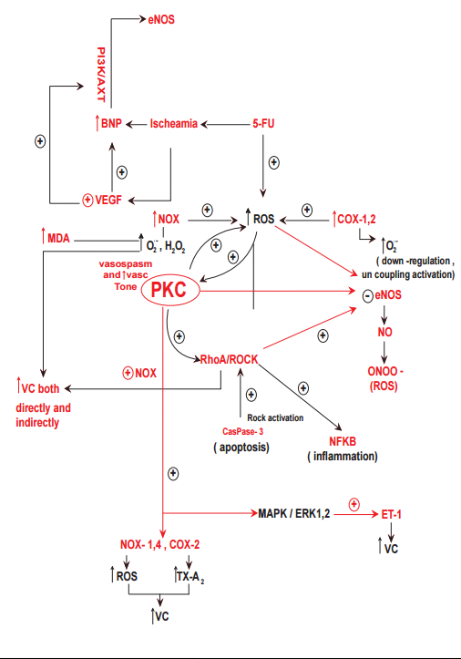
Abstract

Background: 5-fluorouracil (5-FU) is a chemotherapeutic agent widely used in the treatment of different solid tumors, especially colorectal cancer. Its use is associated with rare but potentially serious cardiovascular toxicity. This study aims to investigate molecular mechanisms underlying the cardiovascular toxicity of 5-FU and the potential protective effects of simvastatin. Methods: Adult male albino Wistar rats were randomly divided into four groups (15-20/group). The first group received normal saline (i.p) once weekly for six successive weeks. In the second group rats received 5-FU (50 mg/kg; i.p) once weekly for six successive weeks (cardiotoxic group). Rats of the third group received simvastatin (15 mg/kg/day, p.o.) daily for eight successive weeks. Finally, rats of the forth group received simvastatin daily a week before the first 5-FU injection, then concomitantly for six weeks, and continued alone for another week after the last dose of 5-FU. ECG recording was weekly carried out. Cardiac content of NADPH-oxidase, COX-2, NF-ƙB, p-eNOS and p-AKT in addition to aortic content of endothelin-1 and thromboxane-A2 were assessed by enzyme-linked immunosorbent assay. Protein expression of cardiac caspase-3 and Rho-kinase was evaluated by western blotting. Serum level of NT-proBNP and cardiac TBARS (thiobarbituric acid reactive substances) were also evaluated. Finally, histopathological evaluation of both cardiac and aortic tissues was carried out. Results: 5-FU caused histopathological changes in both myocardial and aortic tissues. Myocardial ischemia and QTc prolongation were confirmed by ECG recording. 5-FU increased myocardial NADPH-oxidase and COX-2 content, leading to increased ROS production. Oxidative stress, inflammation and associated apoptosis in the heart were indicated by elevated TBARS, caspase-3 protein expression and NF-ƙB content. Elevated aortic tissue content of endothelin-1 and thromboxane-A2, the two potent vasoconstrictors was observed. 5-FU significantly increased ROCK protein expression and p-AKT content, and suppressed p-eNOS level. Finally, elevated serum level of NT-proBNP was observed. Simvastatin was able to prevent most of these abnormalities. Conclusion: Direct myocardial injury and ischemia caused by endothelial dysfunction and activation of Rho/ROCK pathway are potential mechanisms of 5-FU cardiovascular toxicity. Inhibition of ROCK activity by simvastatin, a drug with potent antioxidant and pleiotropic properties, mitigates the cardiovascular toxicity of 5-FU.

Figure 1: The proposed molecular mechanisms that can account for 5-FU cardiotoxicity in the present study.

References:
- Vincent DT, Ibrahim YF, Espey MG, Suzuki YJ. The role of antioxidants in the era of cardio oncology. Cancer Chemother Pharmacol 2007;72: 1157-1168.
- Albini A, Pennesi G, Donatelli F, Cammarota R, De flora S, Noonan DM. Cardiotoxicity of anticancer drugs: the need for cardio-oncology and cardio-oncological prevention. J Natl Cancer Inst 2009;102:14-25.
- Focaccetti C, Bruno A, Magnani E, Bartolini D, Principi E, Dallaglio K, Bucci EO, Finzi G, Sessa F, Noonan DM, Albini A. Effects of 5-fluorouracil on morphology, cell cycle, proliferation, apoptosis, autophagy and ROS production in endothelial cells and cardiomyocytes. PLoS One 2015;10: e0115686.
- Jensen SA, Hasbak P, Mortensen J, Sørensen JB. Fluorouracil induces myocardial ischemia with increases of plasma brain natriuretic peptide and lactic acid but without dysfunction of left ventricle. J Clin Oncol 2010;28:5280-5286.
- Altieri P, Murialdo R, Barisione C, Lazzarini E, Garibaldi S, Fabbi P, Ruggeri C, Borile S, Carbone F, Armirotti A, Canepa M, Ballestrero A, Brunelli C, Montecucco F, Ameri P, Spallarossa P. 5-fluorouracil causes endothelial cell senescence: potential protective role of glucagon-like peptide 1. Br J Pharmacol 2017;doi: 10.1111/bph.13725.

