The value of “p”: Novel risk factors for Ischemic Stroke?

Introduction: The interatrial block (IAB) is a delay in atrial conduction defined as a wide p-wave (wpw) on electrocardiogram (ECG) but has low specificity for supraventricular tachycardia (SVA) and ischemic stroke (IS) prediction. New criteria for IAB appeared as the biphasic morphology of p wave in the inferior leads, which has increased its predictive value. The objective of this study is to find relationship between new IAB’s criteria (NIAB) and IS of undetermined cause (ISUC)
Method: retrospective study of 188 cases admitted to hospital for ISUC (A group) without prior arrhythmias, compared to 180 controls admitted for other causes (B group). NIAB finding on the ECG (biphasic p≥120ms in II, III and AVF) was assessed in both groups. Data analysis was made to find IAB differences between groups in relation to age (<75; ≥75) and comorbidities.
Results: 368 patients (47% women; mean age 72,7+15,2; Barthel index 79,5+24,9) were included. wpw and NIAB findings were significantly more prevalent in A group (p≤0.000), with no other differences observed. Significant differences were found considering age: stronger association wpw-IS vs NIAB-IS in the youngest group (OR 24,1(12,4-46,7) vs 20,5(4,8-87,3) in contrast with a stronger association NIAB-IS vs wpw-IS in the oldest group (OR 33,8(4,3-264,7 vs 7,4(2,1-26,8).
Conclusions: wpw and NIAB were significantly related to ISUC. Relevant differences were found considering age, being more prevalent the presence of wpw in younger with IS of UC and NIAB in elder. Although more studies are needed, these outcomes could justify primary prophylaxis with anticoagulation before SVA appears.

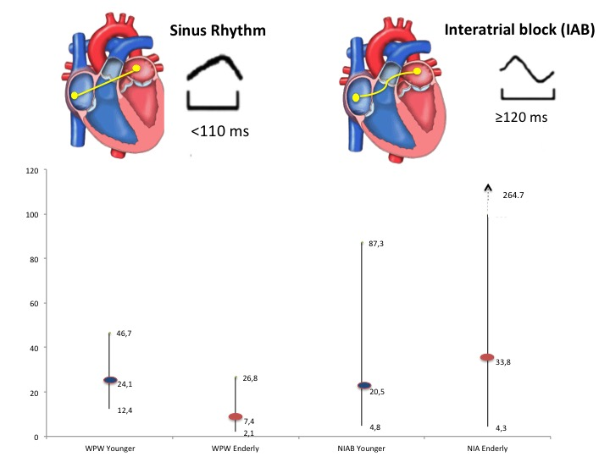
Image

Figure1: Comparative image of wide p wave and new interatrial block criteria as a risk factor for embolic strokes.

Biography:
- Hideki Hayashi, MD, PhDn, Minoru Horie, MD, PhD .Biphasic P wave in inferior leads and the development of atrial fibrillation. Journal of Arrhythmia 31 (2015) 376–380
- Diego Conde, Adrián Baranchuk. Bloqueo interauricular como sustrato anatómico-eléctrico de arritmias supraventriculares: síndrome de Bayés. Arch Cardiol Mex. 2014;84(1):32-40
- Bayés de Luna A, Platonov P, Cosio FG, et al. Interatrial blocks. A separate entity from left atrial enlargement: A consensus report. J Electrocardiol. 2012;45:445-51.
- Danai Kitkungvan, MD,a,⁎ David H. Spodick, Interatrial block: is it time for more attention? Journal of Electrocardiology 42 (2009) 687–692.
- Ariyarajah V, Fernandes J, Kranis M, et al. Prospective evalua- tion of atrial tachyarrhythmias in patients with interatrial block. Int J Cardiol. 2007;118:332-7.
- Ariyarajah V, Apiyasawat S, Najjar H, et al. Frequency of inter- atrial block in patients with sinus rhythm hospitalized for stroke and comparison to those without interatrial block. Am J Cardiol. 2007;99:49-52.
- Ariyarajah V, Puri P, Apiyasawat S, et al. Interatrial block: A novel risk factor for embolic stroke? Ann Noninvasive Electro- cardiol. 2007;12:15-20.

Biography:

Juan Jose Martinez Rivas is a fourth year Geriatric specialist resident with special interest in geriatric stroke and cardiovascular diseases. Graduate from University Los Andes in Merida, Venezuela with specialist rotation underway in Granollers Spain. Interested in medical innovation and research with 6 oral communications presented in the Geriatrics national conference of Spain during the residency.

