Abstract
E. Martin Kloosterman, MD, FACC, FHRS. Boca Raton, Fl., USA

Novel MRI Safe Mode Selection Algorithm: a standardized real-time solution for a variable time-dependent problem.
Statement of the Problem: MRI scans in patients with cardiac MRI conditional devices (pacemakers and ICDs) are exponentially growing. All devices require pre-scan interrogation and accordingly reprograming to an MRI safe mode. Today there is no medical or industry guideline about how to program an MRI safe mode.
The performance of this task is for the most part done by a field company representative whom should follow a “Cardiology Order” form. This workflow, across the US, is difficult to follow in its conceived fashion having significant limitations and compliance issues. Additionally, when the decision on safe mode is not done upon the scan performance, depending on the time interval the patient’s condition may have changed. Methodology & Theoretical Orientation: In order to simplify the decision-making process and streamline the service model a proprietary algorithm was conceived to provide an answer in real time to the most appropriate MRI safe mode programming upon performing the scan. The algorithm was used in 11 MRI centers and applied to a total of 246 cardiac devices, from 4 different companies. 232 Pacemakers (223 DDD/9 VVI); 14 ICDs (10 DDD/4 VVI). Sinus rhythm was the most common presenting underlying rhythm 93% and AF 7%. Most common presenting modes were: DDD 116, AAI-DDD 84, VVI 12, rate response was on in 50%. The most common MRI safe mode programmed were DOO 36%, followed by AOO 31%.
In no instance, a patient’s device interrogation wouldn’t fit the algorithm. There were no complications.
Conclusion & Significance: The clinical validation of the MRI safe mode selection using the MK-ALGORITHM© provides a standardize solution, that streamlines patient care, meant to be a resource for orders not only by the specialists but by other physicians involved in the patient care such as radiologists onsite at the MRI center performing the scan.
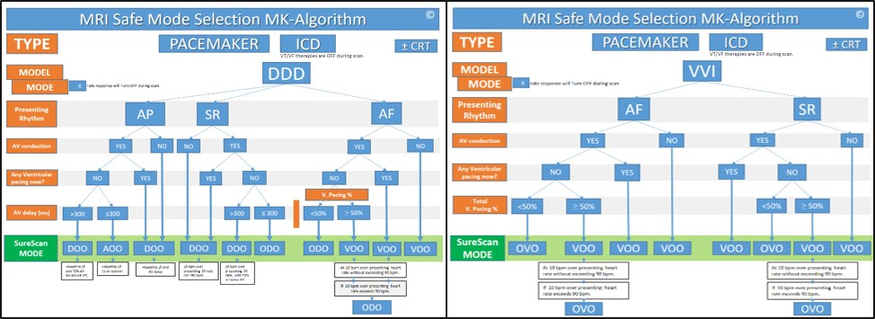

Figure 1: MRI Safe Mode selection MK-algorithm©

Recent Publications
- Greenspon AJ, Patel JD, Lau E et al. FACC Trends in Permanent Pacemaker Implantation in the United States From 1993 to 2009Increasing Complexity of Patients and Procedures. J Am Coll Cardiol 2012;60:1540-5.
- Duc H Do, MD; Noel G. Boyle, MB, BCH, MRI in Patients with Implanted Devices: Current Controversies. J Am Coll Cardiol Aug 01, 2016 .
- 2017 HRS expert consensus statement on magnetic resonance imaging and radiation exposure in patients with cardiovascular implantable electronic devices
- Robert J. Russo, M.D., Ph.D., et al. Assessing the Risks Associated with MRI in Patients with a Pacemaker or Defibrillator.
N Engl J Med 2017;376:755-64.
- E. Martin Kloosterman et al. Remote-Control of Pacemakers and ICDs, Interrogation and Reprogramming. Real-Time Clinical Application in the MRI Setting. Accepted Abstract. Asian Pacific Heart Rhythm Society Scientific Session. September 2017.

E. Martin Kloosterman, MD, FACC, FHRS. Director of the Lynn Heart and Vascular Institute
Boca Raton Regional Hospital / Florida Atlantic University. Florida, USA
At BRRH he performs an extensive variety of interventions related to cardiac devices implants and treatment of cardiac arrhythmias using the latest developments in the field including, transcatheter pacemaker, fluoroless ablations, cryoballoon and rotor mapping for the treatment of atrial fibrillation.
Dr. Kloosterman invented the “remote-K-viewer”, a system that enables physicians to communicate and guide reprogram cardiac devices remotely in real time. Dr. Kloosterman leads the largest volume service of CareLink Express in the US, with a tailored service protocol. "CareLink Express and Remote Viewer in the Cardiologist Office" Exploring A New Service Model; published in 2016. Leading new paradigm of: Remote Control of Cardiac Device in the MRI setting, abstract to be presented at Asian-Pacific HRS, 2017.
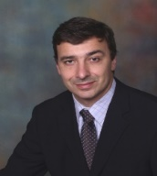

Notes/Comments:

Email: martin.kloosterman@yahoo.com
Phone: +1-954-261-3122

