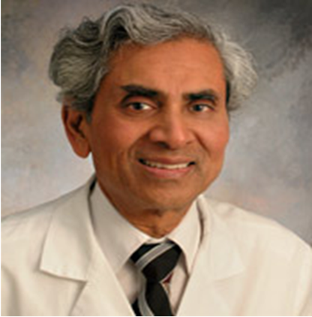

Paste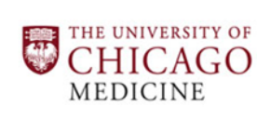 your Logo here
Paste your Photograph Here

Title: Sudden unexpected death in young athlete
Name: Brojendra Agarwala, MD, FACC

University of Chicago Comer children’s hospital

Competitive athletes are those who participates in an organized team or individual sports that requires regular competition against others. Athletic activities substantially increase the sympathetic drive resulting in surge in catecholamine level that increases blood pressure, heart rate, myocardial contractility and oxygen demand. This can cause myocardial ischemia and arrhythmia that may lead to sudden death in athletes with known and unrecognized heart conditions during athletic activities.
It is estimates that 1-2/100,000 SCD/year happens worldwide. According to the International Olympic Committee, SCD rate in athletes is ~ three times higher than in the normal population.
There are many structural and acquired heart conditions that are not clinically manifested. Many physicians are involved in medical clearance of children for participations in school sports activities. Physicians have to recognize them to protect athletes from catastrophic events. In order to prevent sudden cardiac death physicians should be aware of cardiac conditions that may cause problem. Also physicians should be familiar with general guidelines for evaluation of an athlete and clearance for participation in athletic activities.
Guidelines vary in different parts of the world. In this presentation I will discuss guidelines for European, Italian and in USA outlined by American heart Association.
In this presentation the causes of congenital and acquired heart conditions and arrhythmias that can cause sudden cardiac death will be discussed with authors experience and literature review.

Biography

Dr. Brojendra Agarwala has completed his MBBS at the age of 23 years from University of Kolkata, India and completed Pediatric cardiology fellowship from New York university medical center New York, NY, USA. He is a pediatric cardiologist and professor of Pediatrics at the University of Chicago. He has received best teacher award by the pediatric residents and the medical students. He has published 68 papers in reputed journals. He is named as one of the Top Doctors and Best pediatricians in Chicago magazine for many years.

