Serum galectin-3 as a prognostic factor in patients with diabetes mellitus
M. Gwechenberger¹, R. Pacher¹, M. Clodi², M. Resl², R. Wurm¹, G. Strunk³, J. Mascherbauer¹, M. Huelsmann¹

Background:
Patients with diabetes have an increased risk for developing cardiovascular disease. Serum Galectin-3 (Gal-3) is a novel biomarker and has been associated with diabetes and heart failure. However, data on the predictive value of Gal-3 on outcome are limited. We evaluated the prognostic role of Gal-3 for cardiovascular events in diabetic patients.
Methods:
Nine hundred one consecutive patients with type 2 diabetes were followed for cardiac
events. The primary endpoint was defined as a composite endpoint of unplanned
cardiac hospitalization and all-cause mortality. The secondary endpoints were defined as
a) unplanned hospitalization and b) all-cause mortality. Gal-3 was tested to predict
endpoints in the context of known other predictors, especially N-terminal pro-B-type
natriuretic peptide (NT-proBNP).
Results:
The mean age of the patients was 59.3±13.8 years (55.1% male), duration of diabetes was 12.5±12.1 years and the mean glycated hemoglobin (HbA1c) was 7.5 ±1.5%. The median Gal-3 and NT-proBNP serum levels were 25.7±19.0 ng/ml and 272.3±445.2 pg/ml respectively. After a mean follow up of 56.5 (IQR 60-61) months 23.2% of patients reached the primary endpoint. Kaplan-Meier analysis revealed a worse outcome in patients with elevated Gal-3. Elevated Gal-3 levels were predictive for the primary endpoint (p<0.0001). However, it was not predictive for outcome after adjustment for age, gender, NT-proBNP, body mass index (BMI) and glomerular filtration rate (GFR). The same observation was made for secondary endpoints. In contrast NT- proBNP was a significant predictor of all endpoints.
Conclusions:
Serum Gal-3 is associated with cardiovascular outcome in diabetic patients. However
when compared with established risk predictors like NT-proBNP, its value is limited.

Figure 1
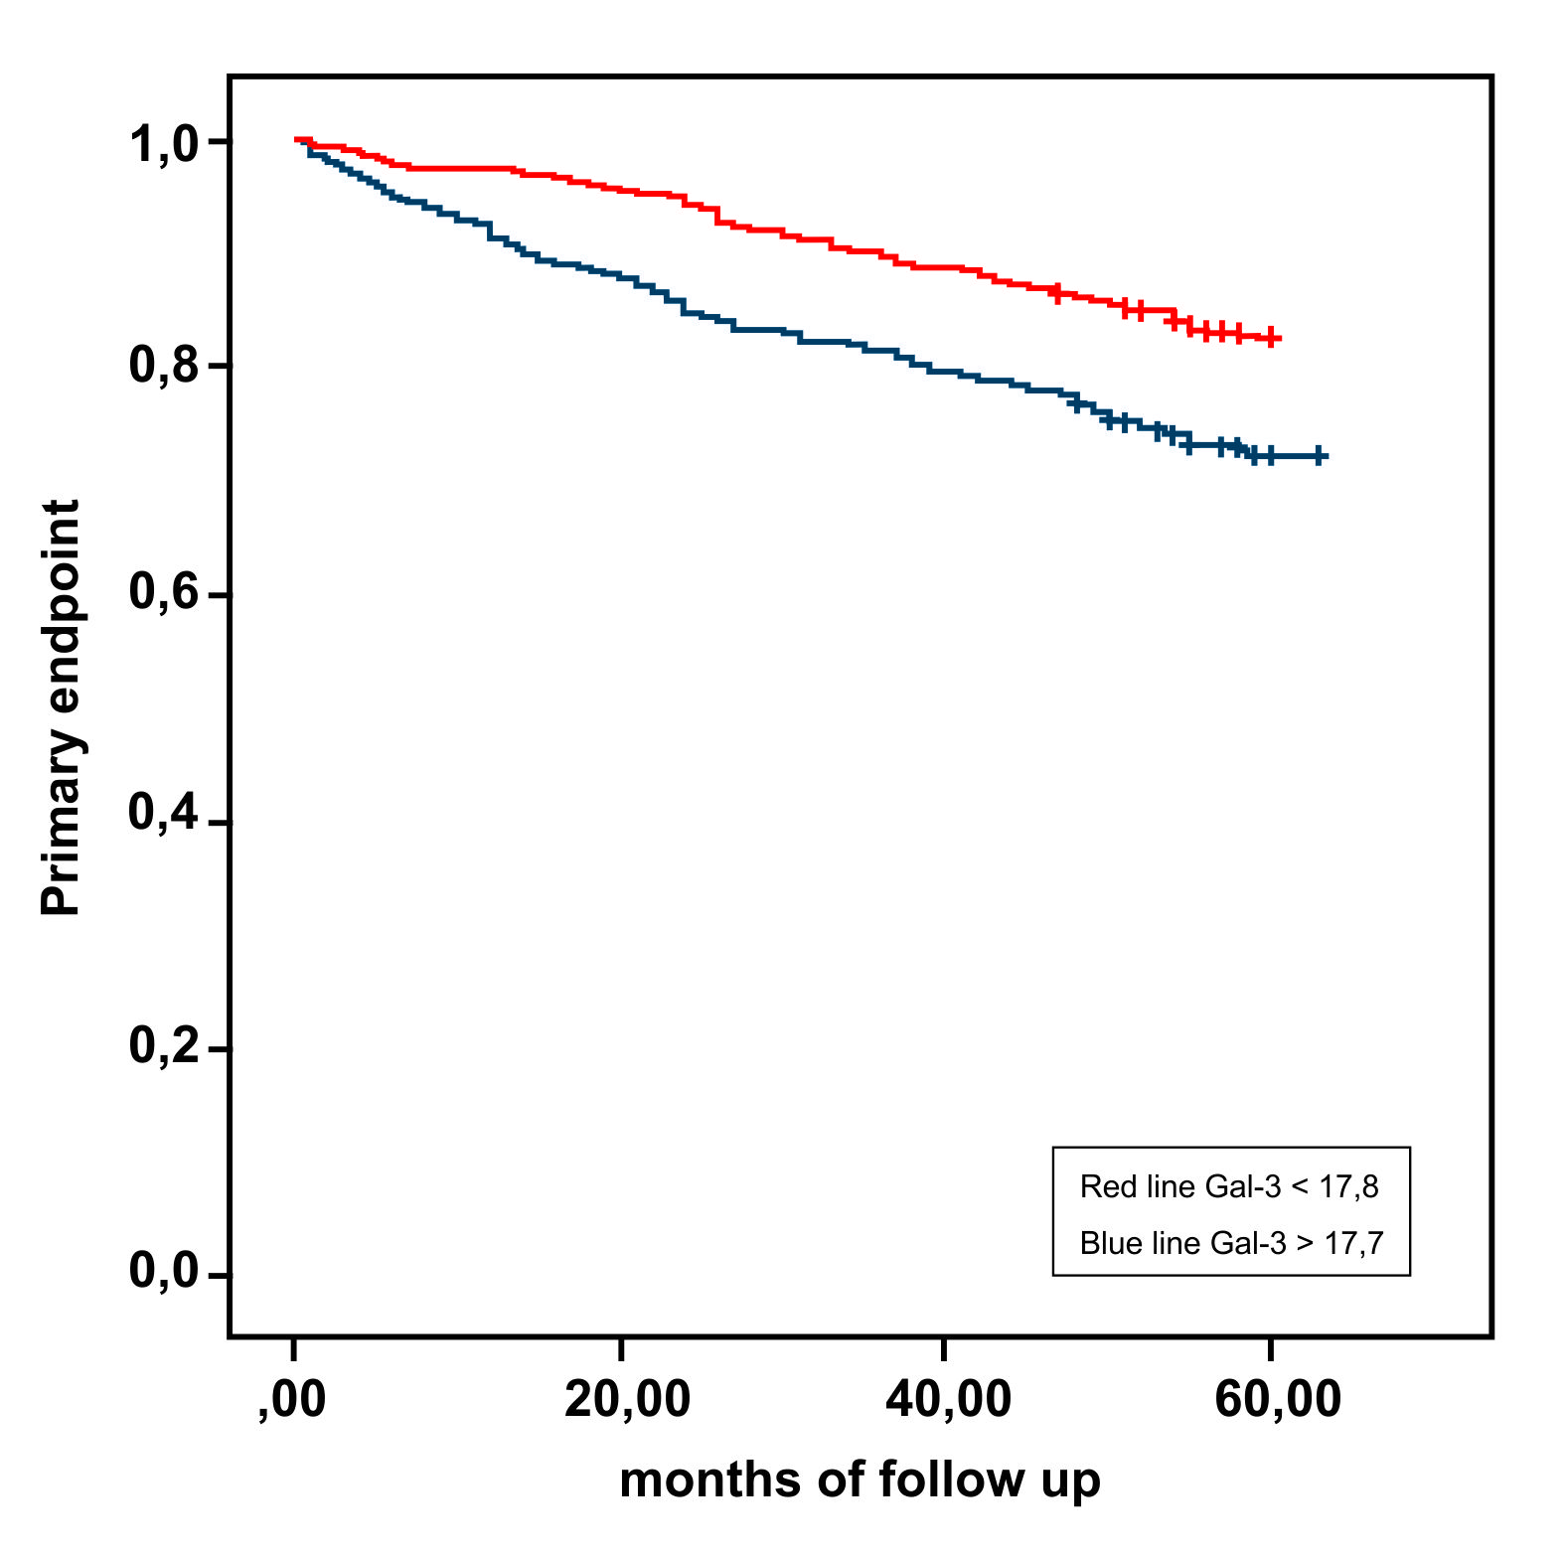
References
1. Tsai TH, Sung PH, Chang LT, Sun CK, Yeh KH, Chung SY, Chua S, Chen YL, Wu CJ, Chang HW, Ko SF, Yip HK. Value and level of galectin-3 in acute myocardial infarction patients undergoing primary percutaneous coronary intervention.
J Atheroscler Thromb. 2012;19(12):1073-82.
2. Ahmad T, Felker M. Galectin-3 in heart failure: More answers or more questions. J Am Heart Assoc. 2012 Oct;1(5):e004374.
3. de Boer RA, van Veldhuisen DJ, Gansevoort RT, Muller Kobold AC, van Gilst WH, Hillege HL, Bakker SJ, van der Harst P. The fibrosis marker galectin-3 and outcome in the general population. J Intern Med. 2012 Jul;272(1):55-64

4. Fermann GJ, Lindsell CJ, Storrow AB et al. Galectin 3 complements BNP in risk stratification in acute heart failure. Biomarkers 2012;17:706-713.

5. Djoussé L, Matsumoto C, Petrone A, Weir NL, Tsai MY, Gaziano JM. Plasma galectin 3 and heart failure risk in the Physicians' Health Study. Eur J Heart Fail. 2014 Mar;16(3):350-4.
6. Jin QH, Lou YF, Li TL, Chen HH, Liu Q, He XJ.Serum galectin-3: a risk factor for vascular complications in type 2 diabetes mellitus. Chin Med J (Engl). 2013;126(11):2109-15.
17. Kramer CM, Barkhausen J, Flamm SD, Kim RJ, Nagel E. Standardized cardiovascular magnetic resonance (cmr) protocols 2013 update. J Cardiovasc Magn Reson. 2013;15:91.

Biography:
Marianne Gwechenberger is specialized in cardiology, electrophysiology and heart failure.

