The genetics of familial hypercholesterolemia and its detection

Kerchev Viktor, I.M. Sechenov First Moscow State Medical University, Russian Federation
Larina Svetlana, I.M. Sechenov First Moscow State Medical University, Russian Federation
Shidlovskii Yulii, Institute of Gene Biology RAS, Russian Federation

Abstract

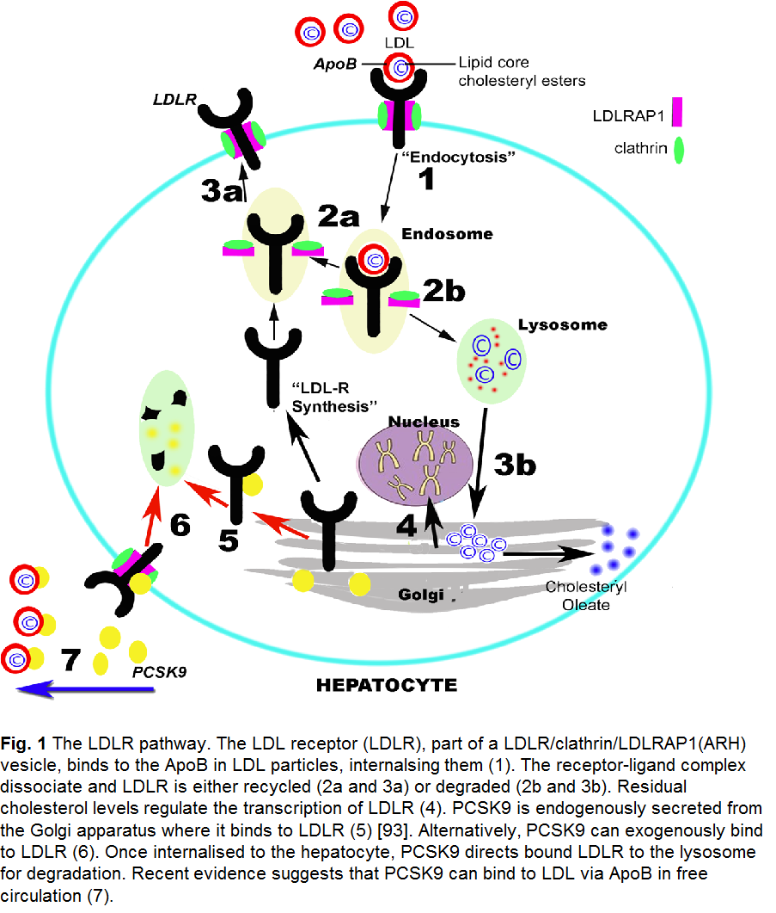
Familial Hypercholesterolaemia is an autosomal, dominant genetic disorder that leads to elevated blood cholesterol and a dramatically increased risk of atherosclerosis. It is perceived as a rare condition. However it affects 1 in 250 of the population globally, making it an important public health concern. In communities with founder effects, higher disease prevalences are observed. We discuss the genetic basis of familial hypercholesterolaemia, examining the distribution of variants known to be associated with the condition across the exons of the genes LDLR, ApoB, PCSK9 and LDLRAP1. We also discuss screening programmes for familial hypercholesterolaemia and their cost-effectiveness. Diagnosis typically occurs using one of the Dutch Lipid Clinic Network (DCLN), Simon Broome Register (SBR) or Make Early Diagnosis to Prevent Early Death (MEDPED) criteria, each of which requires a different set of patient data. New cases can be identified by screening the family members of an index case that has been identified as a result of referral to a lipid clinic in a process called cascade screening. Alternatively, universal screening may be used whereby a population is systematically screened. It is currently significantly more cost effective to identify familial hypercholesterolaemia cases through cascade screening than universal screening. However, the cost of sequencing patient DNA has fallen dramatically in recent years and if the rate of progress continues, this may change.
Image

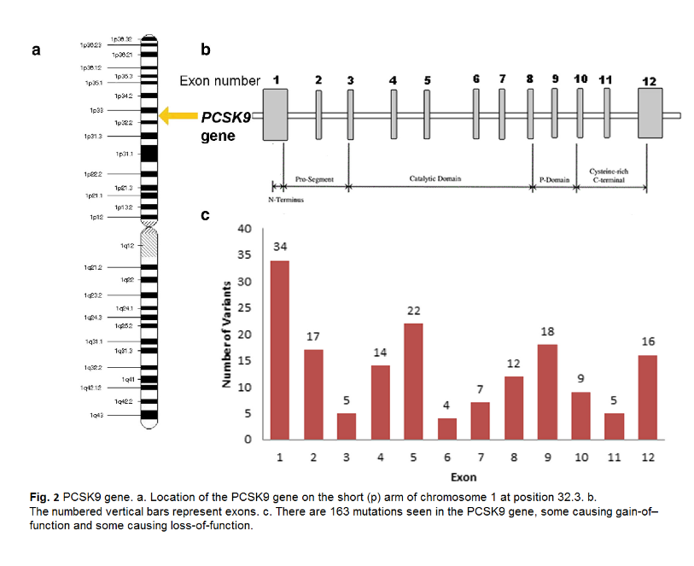

Recent Publications
1. Sjouke B, Kusters DM, et al. Homozygous autosomal dominant
hypercholesterolaemia in the Netherlands: prevalence, genotype-phenotype relationship, and clinical outcome. Eur Heart J. 2015;36(9):560.

2. Ademi Z, Watts GF, et al. Cascade screening based on genetic testing is cost-effective: evidence for the implementation of models of care for
familial hypercholesterolemia. J Clin Lipidol. 2014;8(4):390–400.

3. Nordestgaard BG, Chapman MJ, et al. Familial hypercholesterolaemia is
underdiagnosed and undertreated in the general population: guidance for clinicians to prevent coronary heart disease. Eur Heart J. 2013;34(45):3478–90.

4. Reiner Z. Management of patients with familial hypercholesterolaemia. Nat Rev Cardiol. 2015;12:565–75.

5. Cuchel M, Bruckert E, et al. Homozygous familial hypercholesterolaemia: new insights and guidance for clinicians to improve detection and clinical management. A position paper from the Consensus Panel on Familial Hypercholesterolaemia of the European Atherosclerosis Society. Eur Heart J. 2014;35 (32):2146–57.


Biography
Victor Kerchev and his co-authors has its own experience in evaluating and passion to improve the health and well-being of cardiological patients. The authors open and contextual assessment model based on reacting Constructivists creates new ways to improve the medical care of patients with the familial form of hypercholesterolemia. They created the model after many years of experience in research, evaluation and training in hospitals and schools. This approach responds to all parties concerned, and has a different focusing method.
Email: Vi_Dok@citydom.ru
Phone: +7-925-911-73-39

Notes/Comments:

