Tricuspid stenosis: an emerging disease in cardiac implantable electronic devices era. Case report and literature review

FAHAD T. RAJA
Heart Center, King Faisal Specialist Hospital and Research Center, Riyadh, KSA

Abstract (300-word limit)

Tricuspid valve dysfunction and in particular tricuspid stenosis is recently described secondary to cardiac implantable electronic devices. The valve is subjected to different mechanisms of injury related to the endocardial lead passing through its plane. The lead can form a loop or perforate one of the leaflet and initiate inflammatory response and fibrotic changes. Multimodality cardiac imaging is required to diagnose this clinical entity and decide on the best treatment plan. In here we present a case of a young female that developed tricuspid stenosis secondary to permanent pacemaker lead that was implanted 24 years before. We performed a review of all cases reported in the literature with a similar condition and various treatment approaches.

Image

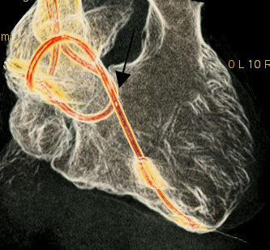

Figure (4): Contrast enhanced cardiac computed tomography of the heart (volume rendered image) demonstrates that atrial pacemaker lead forming a loop as it crosses down to the right ventricle and returning to the right atrium against the septal leaflet.

 Biography (150-word limit)

Dr. Fahad Raja completed his MBBS degree from Alfaisal University and is currently rotating as an intern at King Faisal Specialist Hospital and Research Center. He is pursuing a career in Emergency Medicine. He developed a passion for research through several research workshops and has participated in case reports, a clinical trial, and a retrospective study. His research interests are implantable cardiac devices, cardiac allograft vasculopathy, and recurrent infections in cystic fibrosis.

Email: fraja@alfaisal.edu
Phone: +966500024369

Notes/Comments:

- Please note that this abstract is submitted for poster presentation. It has also been submitted for oral presentation by a co-author.

- Category can either be “Cardiac electrophysiology & Device Therapy” or “Case Reports”

