Late presenting complete Heart block after pediatric cardiac surgical and catheter intervention
Nasib Kabbani, Hayan Altaweel*, Mohamed Kabbani*
*King Abdulaziz Medical City, National guard Hospital

Abstract

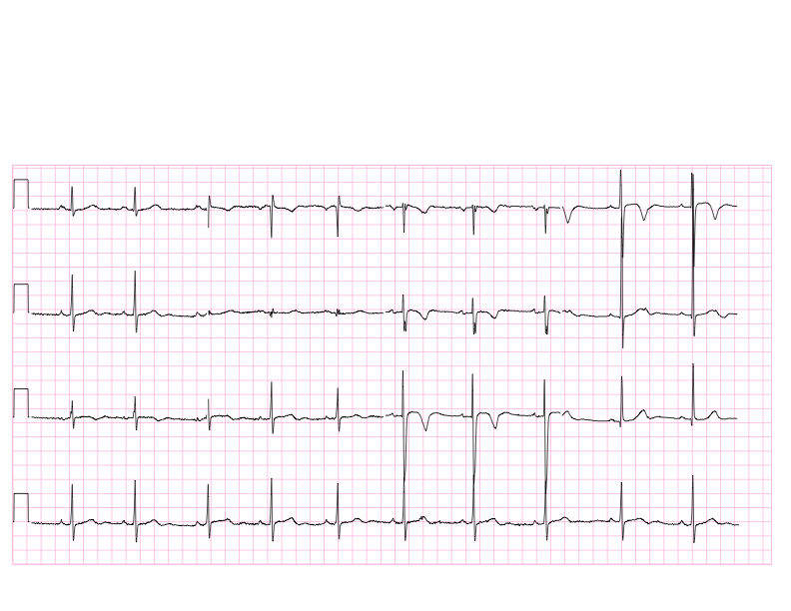
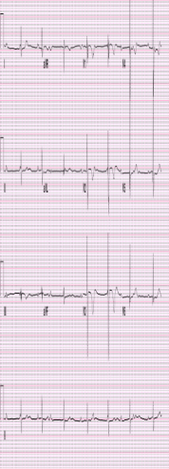
Children undergoing cardiac surgery or catheter intervention may develop brady arrhythmia and heart block immediately after intervention or surgery. Majority of the time, the slow cardiac rhythm is transitional and recovers within 1 to 2 weeks post intervention. If no recovered permanent pacemaker insertion is usually indicated. On rare occasions, there are children who develop late heart block after initial period of normal rhythm. This type of rare presentation is called late presenting heart block. We encountered 3 cases of late presenting heart block, 2 after AVSD repair appearing at 2 and 6 years post surgical repair respectively. The third case was life threatening complete heart block appearing one week after VSD device closure. All cases had a normal sinus rhythm when they were discharged home following initial surgery or intervention but subsequently developed late presenting heart block with significant clinical symptoms and in one case life threatening condition.
1 year old with AVSD repair and normal sinus rhythm post surgery (A). He subsequently developed CHB after 6 years of surgery (B).

A
B
This complication though rare but clinician need to be aware about it and may warrant follow up at least annual of the post surgical or interventional pediatric cardiac cases with periodic ECG screening for long term follow up.

Image

Recent Publications
- Gross GJ, Chiu CC, Hamilton RM, Kirsh JA, Stephenson EA. Natural history of postoperative heart block in congenital heart disease: implications for pacing intervention. Heart Rhythm. 2006 May;3(5):601-4. Epub 2006 Feb 28.
- Edwin F, Aniteye E, Tettey M, Sereboe L, Kotei D, Tamatey M, Entsua-Mensah K, Frimpong-Boateng K. Permanent complete heart block following surgical correction of congenital heart disease. Ghana Med J. 2010 Sep;44(3):109-14.
- Lin A, Mahle WT, Frias PA, Fischbach PS, Kogon BE, Kanter KR, Kirshbom PM. Early and delayed atrioventricular conduction block after routine surgery for congenital heart disease. J Thoracic Cardiovascular Surg 2010 Jul,140 (1):158-60.
- Liberman L, Pass RH, Hordof AJ, Spotnitz HM. Pediatr Cardiol. Late onset of heart block after open heart surgery for congenital heart disease. 2008 Jan;29(1):56-9. Epub 2007 Sep 1.


Biography:
Dr. Nasib Kabbani: is a fresh graduate from AlFaisal University.
Dr Hayan Altaweel: Associate consultant in pediatric Cardiac ICU- KAMC
Dr. Mohamed Kabbani: consultant intensives and serves as the head of the pediatric cardiac ICU from 2007-2014 in KAMC-Riyadh, Saudi Arabia. Dr. Kabbani has more than 30 publications in both pediatric and pediatric ICU

